UNITED STATES
SECURITIES AND EXCHANGE COMMISSION
Washington, D.C. 20549

SCHEDULE TO/A
Tender Offer Statement Pursuant to Section 14(d)(1) or 13(e)(1)
of the Securities Exchange Act of 1934
(Amendment No. 1)

Warner Bros. Discovery, Inc.
(Name of Subject Company (Issuer))
Prince Sub Inc.
(Offeror)
a direct wholly owned subsidiary of
Paramount Skydance Corporation
(Parent of Offeror)
(Names of Filing Persons (identifying status as offeror, issuer or other person))

Series A Common Stock, par value $0.01 per share
(Title of Class of Securities)
934423104
(CUSIP Number of Class of Securities)
Makan Delrahim
Chief Legal Officer
Paramount Skydance Corporation
1515 Broadway
New York, New York 10036
(212) 258-6000
(Name, Address and Telephone Number of Person Authorized to Receive Notices and Communications on Behalf of Filing Persons)

With a copy to:
Copies to:

Faiza J. Saeed  Andrew J. Pitts  C. Daniel Haaren  Daniel J. Cerqueira  Claudia J. Ricciardi  Alexander E. Greenberg  Cravath, Swaine & Moore LLP  Two Manhattan West  375 Ninth Avenue  New York, New York 10001  (212) 474-1000 |  | Ian Nussbaum  Max Schleusener  Latham & Watkins LLP  1271 Avenue of the Americas  New York, New York 10020  (212) 906-1200

☐ | Check the box if the filing relates solely to preliminary communications made before the commencement of a tender offer.
Check the appropriate boxes below to designate any transactions to which the statement relates:

 | ☒ | third-party tender offer subject to Rule 14d-1.
 | ☐ | issuer tender offer subject to Rule 13e-4.
 | ☐ | going-private transaction subject to Rule 13e-3.
 | ☐ | amendment to Schedule 13D under Rule 13d-2.
Check the following box if the filing is a final amendment reporting the results of the tender offer: ☐
If applicable, check the appropriate box(es) below to designate the appropriate rule provision(s) relied upon:

 | ☐ | Rule 13e-4(i) (Cross-Border Issuer Tender Offer)
 | ☐ | Rule 14d-1(d) (Cross-Border Third-Party Tender Offer)

This Amendment No. 1 to Schedule TO (together with any exhibits and annexes attached hereto, and as it may be amended or supplemented from time to time, this “Amendment”) is filed by (i) Prince Sub Inc., a Delaware corporation (the “Purchaser”) and a direct wholly owned subsidiary of Paramount Skydance Corporation, a Delaware corporation (“Paramount”), and (ii) Paramount and amends and supplements the Tender Offer Statement on Schedule TO filed with the U.S. Securities and Exchange Commission (the “SEC”) on December 8, 2025 (together with any amendments and supplements thereto, the “Schedule TO”) by the Purchaser and Paramount. This Schedule TO relates to the offer by the Purchaser to purchase all of the outstanding shares of Series A Common Stock, par value $0.01 per share (the “Shares”), of Warner Bros. Discovery, Inc., a Delaware corporation (“Warner Bros.”), at $30.00 per share, net to the seller in cash, without interest and less any required withholding taxes, upon the terms and subject to the conditions set forth in the Offer to Purchase, dated December 8, 2025 (as it may be amended or supplemented from time to time, the “Offer to Purchase”), a copy of which is attached as Exhibit (a)(1)(A) to the Schedule TO filed with the SEC on December 8, 2025, and in the related Letter of Transmittal (as it may be amended or supplemented from time to time, the “Letter of Transmittal,” and together with the Offer to Purchase, the “Offer”), a copy of which is attached as Exhibit (a)(1)(B) to the Schedule TO filed with the SEC on December 8, 2025.
Except as otherwise set forth in this Amendment, the information in Schedule TO remains unchanged and is incorporated herein by reference to the extent relevant to the items in this Amendment. Capitalized terms used but not defined herein have the meanings ascribed to them in the Schedule TO.

Item 12. Exhibits
Item 12 of the Schedule TO is also hereby amended and supplemented by adding the following exhibits.

(a)(5)(B) |  | Investor Presentation of Paramount, dated December 8, 2025
(a)(5)(C) |  | Transcript of Interview by David Ellison, Chairman and CEO of Paramount, dated as of December 8, 2025
(a)(5)(D) |  | Transcript of Analyst and Media Call by Paramount executives, dated as of December 8, 2025

SIGNATURE
After due inquiry and to the best of my knowledge and belief, I certify that the information set forth in this statement is true, complete and correct.
Dated: December 8, 2025

PARAMOUNT SKYDANCE CORPORATION
By: |  | /s/ Stephanie Kyoko McKinnon
 |  | Name: Stephanie Kyoko McKinnon
 |  | Title: General Counsel
PRINCE SUB INC.
By: |  | /s/ Stephanie Kyoko McKinnon
 |  | Name: Stephanie Kyoko McKinnon
 |  | Title: General Counsel

EXHIBIT INDEX

Index No.
(a)(5)(B) |  | Investor Presentation of Paramount, dated December 8, 2025
(a)(5)(C) |  | Transcript of Interview by David Ellison, Chairman and CEO of Paramount, dated as of December 8, 2025
(a)(5)(D) |  | Transcript of Analyst and Media Call by Paramount executives, dated as of December 8, 2025
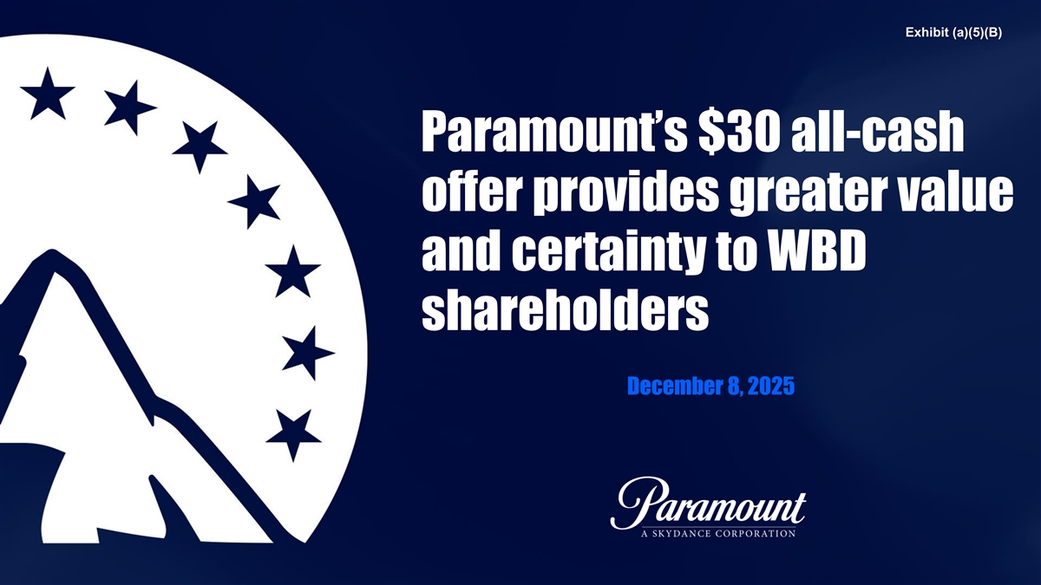
Exhibit (a)(5)(B) Paramount’s $30 all-cash offer provides greater value and certainty to WBD shareholders December 8, 2025

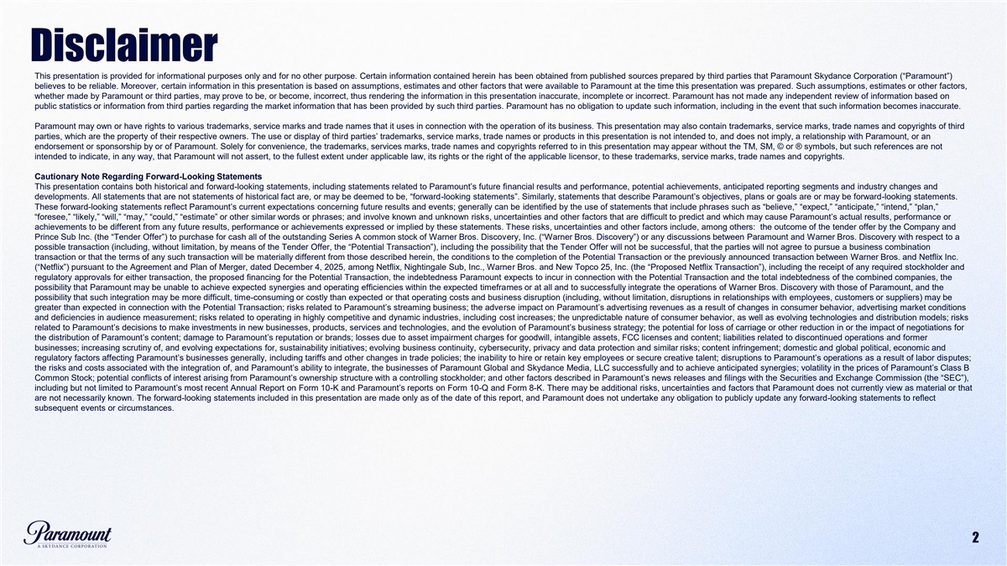
Disclaimer This presentation is provided for informational purposes only and for no other purpose. Certain information contained herein has been obtained from published sources prepared by third parties that Paramount Skydance Corporation (“Paramount”) believes to be reliable. Moreover, certain information in this presentation is based on assumptions, estimates and other factors that were available to Paramount at the time this presentation was prepared. Such assumptions, estimates or other factors, whether made by Paramount or third parties, may prove to be, or become, incorrect, thus rendering the information in this presentation inaccurate, incomplete or incorrect. Paramount has not made any independent review of information based on public statistics or information from third parties regarding the market information that has been provided by such third parties. Paramount has no obligation to update such information, including in the event that such information becomes inaccurate. Paramount may own or have rights to various trademarks, service marks and trade names that it uses in connection with the operation of its business. This presentation may also contain trademarks, service marks, trade names and copyrights of third parties, which are the property of their respective owners. The use or display of third parties’ trademarks, service marks, trade names or products in this presentation is not intended to, and does not imply, a relationship with Paramount, or an endorsement or sponsorship by or of Paramount. Solely for convenience, the trademarks, services marks, trade names and copyrights referred to in this presentation may appear without the TM, SM, © or ® symbols, but such references are not intended to indicate, in any way, that Paramount will not assert, to the fullest extent under applicable law, its rights or the right of the applicable licensor, to these trademarks, service marks, trade names and copyrights. Cautionary Note Regarding Forward-Looking Statements This presentation contains both historical and forward-looking statements, including statements related to Paramount’s future financial results and performance, potential achievements, anticipated reporting segments and industry changes and developments. All statements that are not statements of historical fact are, or may be deemed to be, “forward-looking statements”. Similarly, statements that describe Paramount’s objectives, plans or goals are or may be forward-looking statements. These forward-looking statements reflect Paramount’s current expectations concerning future results and events; generally can be identified by the use of statements that include phrases such as “believe,” “expect,” “anticipate,” “intend,” “plan,” “foresee,” “likely,” “will,” “may,” “could,” “estimate” or other similar words or phrases; and involve known and unknown risks, uncertainties and other factors that are difficult to predict and which may cause Paramount’s actual results, performance or achievements to be different from any future results, performance or achievements expressed or implied by these statements. These risks, uncertainties and other factors include, among others: the outcome of the tender offer by the Company and Prince Sub Inc. (the “Tender Offer”) to purchase for cash all of the outstanding Series A common stock of Warner Bros. Discovery, Inc. (“Warner Bros. Discovery”) or any discussions between Paramount and Warner Bros. Discovery with respect to a possible transaction (including, without limitation, by means of the Tender Offer, the “Potential Transaction”), including the possibility that the Tender Offer will not be successful, that the parties will not agree to pursue a business combination transaction or that the terms of any such transaction will be materially different from those described herein, the conditions to the completion of the Potential Transaction or the previously announced transaction between Warner Bros. and Netflix Inc. (“Netflix”) pursuant to the Agreement and Plan of Merger, dated December 4, 2025, among Netflix, Nightingale Sub, Inc., Warner Bros. and New Topco 25, Inc. (the “Proposed Netflix Transaction”), including the receipt of any required stockholder and regulatory approvals for either transaction, the proposed financing for the Potential Transaction, the indebtedness Paramount expects to incur in connection with the Potential Transaction and the total indebtedness of the combined companies, the possibility that Paramount may be unable to achieve expected synergies and operating efficiencies within the expected timeframes or at all and to successfully integrate the operations of Warner Bros. Discovery with those of Paramount, and the possibility that such integration may be more difficult, time-consuming or costly than expected or that operating costs and business disruption (including, without limitation, disruptions in relationships with employees, customers or suppliers) may be greater than expected in connection with the Potential Transaction; risks related to Paramount’s streaming business; the adverse impact on Paramount’s advertising revenues as a result of changes in consumer behavior, advertising market conditions and deficiencies in audience measurement; risks related to operating in highly competitive and dynamic industries, including cost increases; the unpredictable nature of consumer behavior, as well as evolving technologies and distribution models; risks related to Paramount’s decisions to make investments in new businesses, products, services and technologies, and the evolution of Paramount’s business strategy; the potential for loss of carriage or other reduction in or the impact of negotiations for the distribution of Paramount’s content; damage to Paramount’s reputation or brands; losses due to asset impairment charges for goodwill, intangible assets, FCC licenses and content; liabilities related to discontinued operations and former businesses; increasing scrutiny of, and evolving expectations for, sustainability initiatives; evolving business continuity, cybersecurity, privacy and data protection and similar risks; content infringement; domestic and global political, economic and regulatory factors affecting Paramount’s businesses generally, including tariffs and other changes in trade policies; the inability to hire or retain key employees or secure creative talent; disruptions to Paramount’s operations as a result of labor disputes; the risks and costs associated with the integration of, and Paramount’s ability to integrate, the businesses of Paramount Global and Skydance Media, LLC successfully and to achieve anticipated synergies; volatility in the prices of Paramount’s Class B Common Stock; potential conflicts of interest arising from Paramount’s ownership structure with a controlling stockholder; and other factors described in Paramount’s news releases and filings with the Securities and Exchange Commission (the “SEC”), including but not limited to Paramount’s most recent Annual Report on Form 10-K and Paramount’s reports on Form 10-Q and Form 8-K. There may be additional risks, uncertainties and factors that Paramount does not currently view as material or that are not necessarily known. The forward-looking statements included in this presentation are made only as of the date of this report, and Paramount does not undertake any obligation to publicly update any forward-looking statements to reflect subsequent events or circumstances. 2

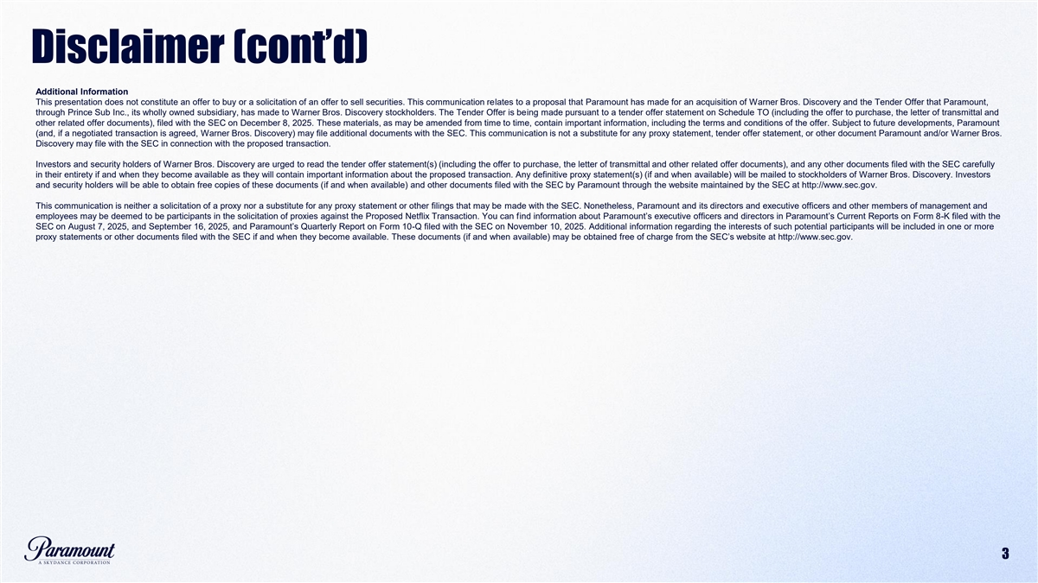
Disclaimer (cont’d) Additional Information This presentation does not constitute an offer to buy or a solicitation of an offer to sell securities. This communication relates to a proposal that Paramount has made for an acquisition of Warner Bros. Discovery and the Tender Offer that Paramount, through Prince Sub Inc., its wholly owned subsidiary, has made to Warner Bros. Discovery stockholders. The Tender Offer is being made pursuant to a tender offer statement on Schedule TO (including the offer to purchase, the letter of transmittal and other related offer documents), filed with the SEC on December 8, 2025. These materials, as may be amended from time to time, contain important information, including the terms and conditions of the offer. Subject to future developments, Paramount (and, if a negotiated transaction is agreed, Warner Bros. Discovery) may file additional documents with the SEC. This communication is not a substitute for any proxy statement, tender offer statement, or other document Paramount and/or Warner Bros. Discovery may file with the SEC in connection with the proposed transaction. Investors and security holders of Warner Bros. Discovery are urged to read the tender offer statement(s) (including the offer to purchase, the letter of transmittal and other related offer documents), and any other documents filed with the SEC carefully in their entirety if and when they become available as they will contain important information about the proposed transaction. Any definitive proxy statement(s) (if and when available) will be mailed to stockholders of Warner Bros. Discovery. Investors and security holders will be able to obtain free copies of these documents (if and when available) and other documents filed with the SEC by Paramount through the website maintained by the SEC at http://www.sec.gov. This communication is neither a solicitation of a proxy nor a substitute for any proxy statement or other filings that may be made with the SEC. Nonetheless, Paramount and its directors and executive officers and other members of management and employees may be deemed to be participants in the solicitation of proxies against the Proposed Netflix Transaction. You can find information about Paramount’s executive officers and directors in Paramount’s Current Reports on Form 8-K filed with the SEC on August 7, 2025, and September 16, 2025, and Paramount’s Quarterly Report on Form 10-Q filed with the SEC on November 10, 2025. Additional information regarding the interests of such potential participants will be included in one or more proxy statements or other documents filed with the SEC if and when they become available. These documents (if and when available) may be obtained free of charge from the SEC’s website at http://www.sec.gov. 3

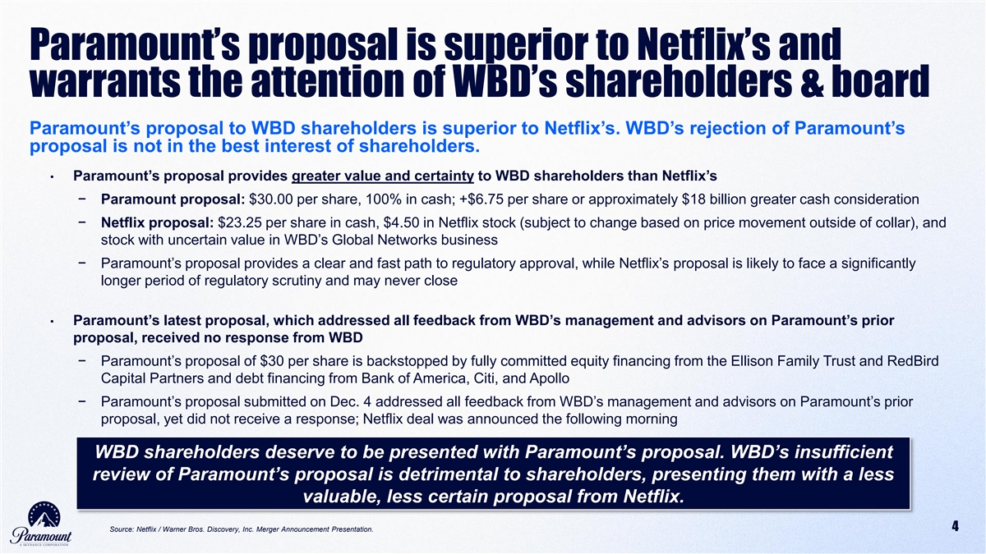
Paramount’s proposal is superior to Netflix’s and warrants the attention of WBD’s shareholders & board Paramount’s proposal to WBD shareholders is superior to Netflix’s. WBD’s rejection of Paramount’s proposal is not in the best interest of shareholders. • Paramount’s proposal provides greater value and certainty to WBD shareholders than Netflix’s 1 − Paramount proposal: $30.00 per share, 100% in cash; +$6.75 per share or approximately $18 billion greater cash consideration − Netflix proposal: $23.25 per share in cash, $4.50 in Netflix stock (subject to change based on price movement outside of collar), and stock with uncertain value in WBD’s Global Networks business 2 − Paramount’s proposal provides a clear and fast path to regulatory approval, while Netflix’s proposal is likely to face a significantly longer period of regulatory scrutiny and may never close • Paramount’s latest proposal, which addressed all feedback from WBD’s management and advisors on Paramount’s prior proposal, received no response from WBD 3 − Paramount’s proposal of $30 per share is backstopped by fully committed equity financing from the Ellison Family Trust and RedBird Capital Partners and debt financing from Bank of America, Citi, and Apollo − Paramount’s proposal submitted on Dec. 4 addressed all feedback from WBD’s management and advisors on Paramount’s prior proposal, yet did not receive a response; Netflix deal was announced the following morning WBD shareholders deserve to be presented with Paramount’s proposal. WBD’s insufficient review of Paramount’s proposal is detrimental to shareholders, presenting them with a less valuable, less certain proposal from Netflix. Source: Netflix / Warner Bros. Discovery, Inc. Merger Announcement Presentation. 4

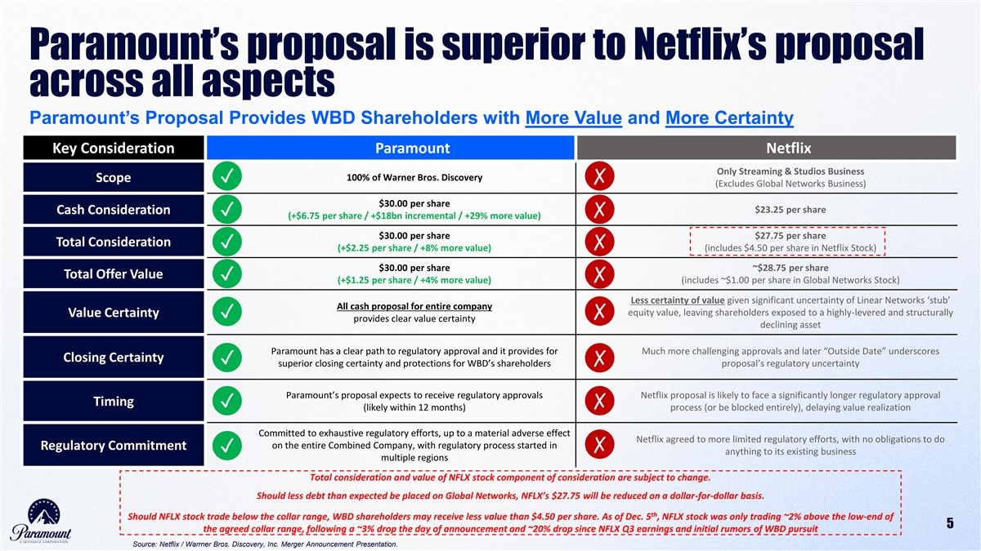
Paramount’s proposal is superior to Netflix’s proposal across all aspects Paramount’s Proposal Provides WBD Shareholders with More Value and More Certainty Key Consideration Paramount Netflix Only Streaming & Studios Business 100% of Warner Bros. Discovery Scope✓✗ (Excludes Global Networks Business) $30.00 per share $23.25 per share Cash Consideration ✓✗ (+$6.75 per share / +$18bn incremental / +29% more value) $30.00 per share $27.75 per share Total Consideration ✓✗ (+$2.25 per share / +8% more value) (includes $4.50 per share in Netflix Stock) $30.00 per share ~$28.75 per share Total Offer Value ✓✗ (+$1.25 per share / +4% more value) (includes ~$1.00 per share in Global Networks Stock) Less certainty of value given significant uncertainty of Linear Networks ‘stub’ All cash proposal for entire company equity value, leaving shareholders exposed to a highly-levered and structurally Value Certainty✗ ✓ provides clear value certainty declining asset Paramount has a clear path to regulatory approval and it provides for Much more challenging approvals and later “Outside Date” underscores Closing Certainty ✓✗ superior closing certainty and protections for WBD’s shareholders proposal’s regulatory uncertainty Paramount’s proposal expects to receive regulatory approvals Netflix proposal is likely to face a significantly longer regulatory approval Timing ✓✗ (likely within 12 months) process (or be blocked entirely), delaying value realization Committed to exhaustive regulatory efforts, up to a material adverse effect Netflix agreed to more limited regulatory efforts, with no obligations to do on the entire Combined Company, with regulatory process started in Regulatory Commitment ✗ ✓ anything to its existing business multiple regions Total consideration and value of NFLX stock component of consideration are subject to change. Should less debt than expected be placed on Global Networks, NFLX’s $27.75 will be reduced on a dollar-for-dollar basis. th Should NFLX stock trade below the collar range, WBD shareholders may receive less value than $4.50 per share. As of Dec. 5 , NFLX stock was only trading ~2% above the low-end of 5 the agreed collar range, following a ~3% drop the day of announcement and ~20% drop since NFLX Q3 earnings and initial rumors of WBD pursuit Source: Netflix / Warrner Bros. Discovery, Inc. Merger Announcement Presentation.

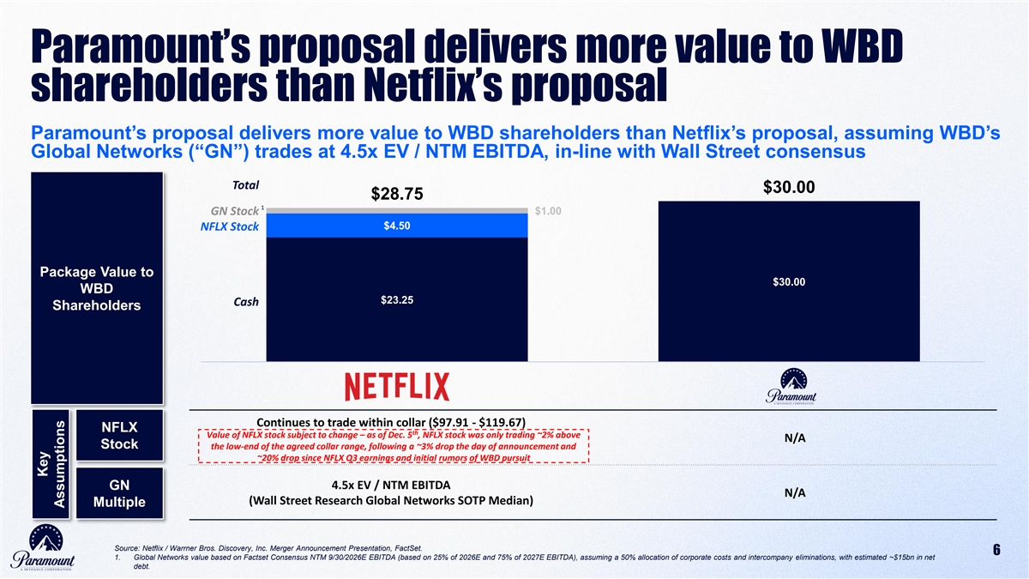
Paramount’s proposal delivers more value to WBD shareholders than Netflix’s proposal Paramount’s proposal delivers more value to WBD shareholders than Netflix’s proposal, assuming WBD’s Global Networks (“GN”) trades at 4.5x EV / NTM EBITDA, in-line with Wall Street consensus Total $30.00 $28.75 1 $1.00 GN Stock $4.50 NFLX Stock Package Value to $30.00 WBD $23.25 Cash Cash Shareholders Continues to trade within collar ($97.91 - $119.67) NFLX th Value of NFLX stock subject to change – as of Dec. 5 , NFLX stock was only trading ~2% above N/A Stock the low-end of the agreed collar range, following a ~3% drop the day of announcement and ~20% drop since NFLX Q3 earnings and initial rumors of WBD pursuit 4.5x EV / NTM EBITDA GN N/A (Wall Street Research Global Networks SOTP Median) Multiple Source: Netflix / Warrner Bros. Discovery, Inc. Merger Announcement Presentation, FactSet. 6 1. Global Networks value based on Factset Consensus NTM 9/30/2026E EBITDA (based on 25% of 2026E and 75% of 2027E EBITDA), assuming a 50% allocation of corporate costs and intercompany eliminations, with estimated ~$15bn in net debt. Key Assumptions

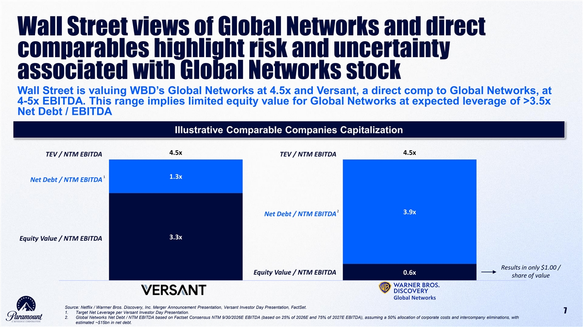
Wall Street views of Global Networks and direct comparables highlight risk and uncertainty associated with Global Networks stock Wall Street is valuing WBD’s Global Networks at 4.5x and Versant, a direct comp to Global Networks, at 4-5x EBITDA. This range implies limited equity value for Global Networks at expected leverage of >3.5x Net Debt / EBITDA Illustrative Comparable Companies Capitalization 4.5x 4.5x TEV / NTM EBITDA TEV / NTM EBITDA 1 1.3x Net Debt / NTM EBITDA 2 3.9x Net Debt / NTM EBITDA 3.3x Equity Value / NTM EBITDA Results in only $1.00 / Equity Value / NTM EBITDA 0.6x share of value Global Networks Source: Netflix / Warrner Bros. Discovery, Inc. Merger Announcement Presentation, Versant Investor Day Presentation, FactSet. 1. Target Net Leverage per Versant Investor Day Presentation. 7 2. Global Networks Net Debt / NTM EBITDA based on Factset Consensus NTM 9/30/2026E EBITDA (based on 25% of 2026E and 75% of 2027E EBITDA), assuming a 50% allocation of corporate costs and intercompany eliminations, with estimated ~$15bn in net debt.

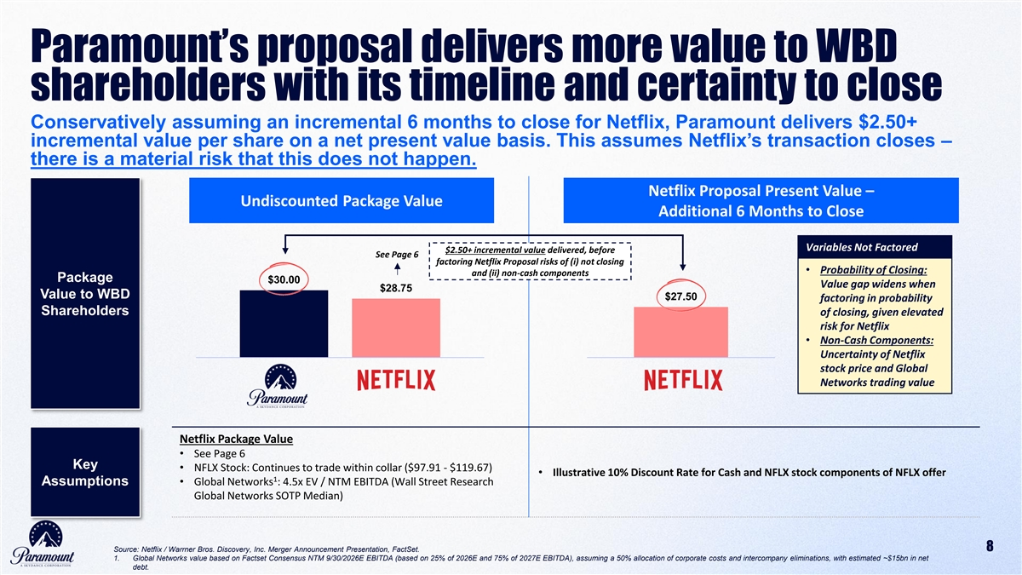
Paramount’s proposal delivers more value to WBD shareholders with its timeline and certainty to close Conservatively assuming an incremental 6 months to close for Netflix, Paramount delivers $2.50+ incremental value per share on a net present value basis. This assumes Netflix’s transaction closes – there is a material risk that this does not happen. Netflix Proposal Present Value – Undiscounted Package Value Additional 6 Months to Close Variables Not Factored $2.50+ incremental value delivered, before See Page 6 factoring Netflix Proposal risks of (i) not closing • Probability of Closing: and (ii) non-cash components Package $30.00 Value gap widens when $28.75 Value to WBD $27.50 factoring in probability Shareholders of closing, given elevated risk for Netflix • Non-Cash Components: Uncertainty of Netflix stock price and Global Networks trading value Netflix Package Value • See Page 6 Key • NFLX Stock: Continues to trade within collar ($97.91 - $119.67) • Illustrative 10% Discount Rate for Cash and NFLX stock components of NFLX offer 1 Assumptions • Global Networks : 4.5x EV / NTM EBITDA (Wall Street Research Global Networks SOTP Median) Source: Netflix / Warrner Bros. Discovery, Inc. Merger Announcement Presentation, FactSet. 8 1. Global Networks value based on Factset Consensus NTM 9/30/2026E EBITDA (based on 25% of 2026E and 75% of 2027E EBITDA), assuming a 50% allocation of corporate costs and intercompany eliminations, with estimated ~$15bn in net debt.

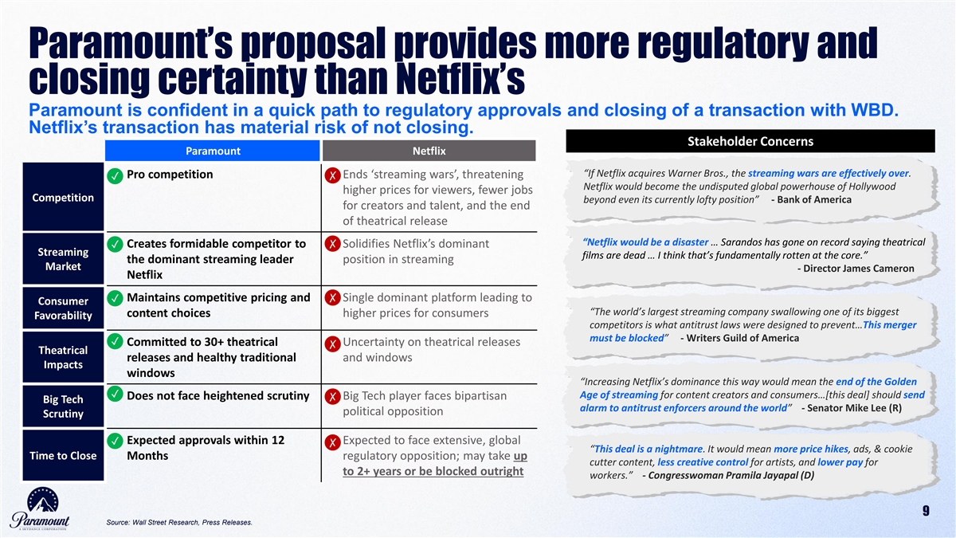
Paramount’s proposal provides more regulatory and closing certainty than Netflix’s Paramount is confident in a quick path to regulatory approvals and closing of a transaction with WBD. Netflix’s transaction has material risk of not closing. Stakeholder Concerns Paramount Netflix “If Netflix acquires Warner Bros., the streaming wars are effectively over. • Pro competition • Ends ‘streaming wars’, threatening ✓✗ Netflix would become the undisputed global powerhouse of Hollywood higher prices for viewers, fewer jobs Competition beyond even its currently lofty position” - Bank of America for creators and talent, and the end of theatrical release “Netflix would be a disaster … Sarandos has gone on record saying theatrical ✗ •✓ Creates formidable competitor to • Solidifies Netflix’s dominant Streaming films are dead … I think that’s fundamentally rotten at the core.” the dominant streaming leader position in streaming Market - Director James Cameron Netflix ✗ •✓ Maintains competitive pricing and • Single dominant platform leading to Consumer “The world’s largest streaming company swallowing one of its biggest content choices higher prices for consumers Favorability competitors is what antitrust laws were designed to prevent…This merger must be blocked” - Writers Guild of America ✓ • Committed to 30+ theatrical • Uncertainty on theatrical releases ✗ Theatrical releases and healthy traditional and windows Impacts windows “Increasing Netflix’s dominance this way would mean the end of the Golden ✓ Age of streaming for content creators and consumers…[this deal] should send • Does not face heightened scrutiny • Big Tech player faces bipartisan ✗ Big Tech alarm to antitrust enforcers around the world” - Senator Mike Lee (R) political opposition Scrutiny •✓ Expected approvals within 12 • Expected to face extensive, global ✗ “This deal is a nightmare. It would mean more price hikes, ads, & cookie Time to Close Months regulatory opposition; may take up cutter content, less creative control for artists, and lower pay for to 2+ years or be blocked outright workers.” - Congresswoman Pramila Jayapal (D) 9 Source: Wall Street Research, Press Releases.

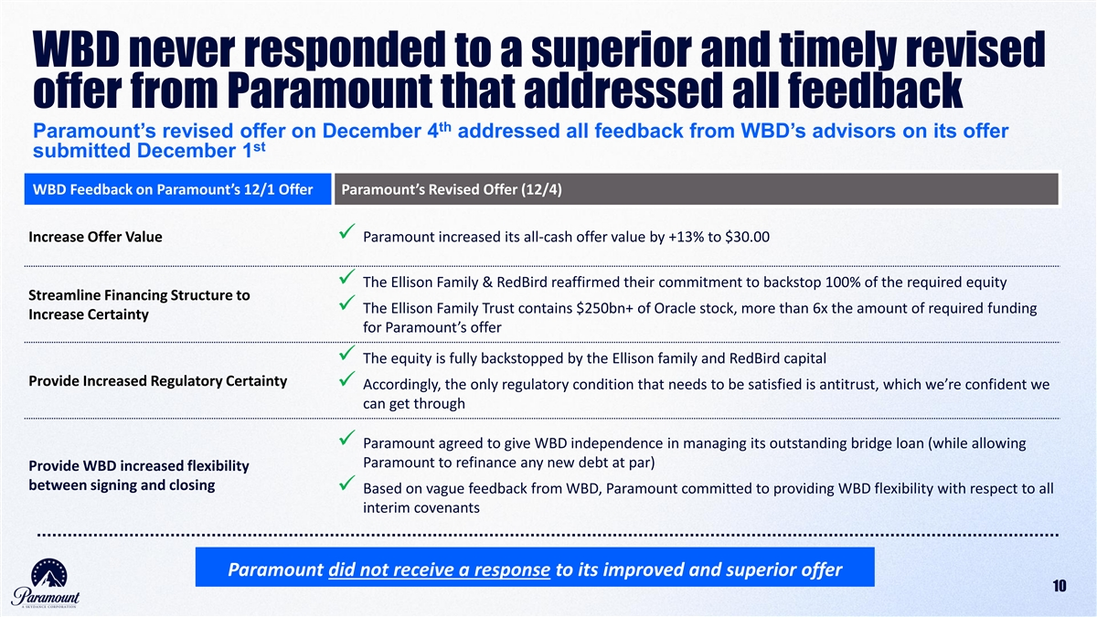
WBD never responded to a superior and timely revised offer from Paramount that addressed all feedback th Paramount’s revised offer on December 4 addressed all feedback from WBD’s advisors on its offer st submitted December 1 WBD Feedback on Paramount’s 12/1 Offer Paramount’s Revised Offer (12/4) Increase Offer Value✓ Paramount increased its all-cash offer value by +13% to $30.00 ✓ The Ellison Family & RedBird reaffirmed their commitment to backstop 100% of the required equity Streamline Financing Structure to ✓ The Ellison Family Trust contains $250bn+ of Oracle stock, more than 6x the amount of required funding Increase Certainty for Paramount’s offer ✓ The equity is fully backstopped by the Ellison family and RedBird capital Provide Increased Regulatory Certainty ✓ Accordingly, the only regulatory condition that needs to be satisfied is antitrust, which we’re confident we can get through ✓ Paramount agreed to give WBD independence in managing its outstanding bridge loan (while allowing Paramount to refinance any new debt at par) Provide WBD increased flexibility between signing and closing ✓ Based on vague feedback from WBD, Paramount committed to providing WBD flexibility with respect to all interim covenants Paramount did not receive a response to its improved and superior offer 10

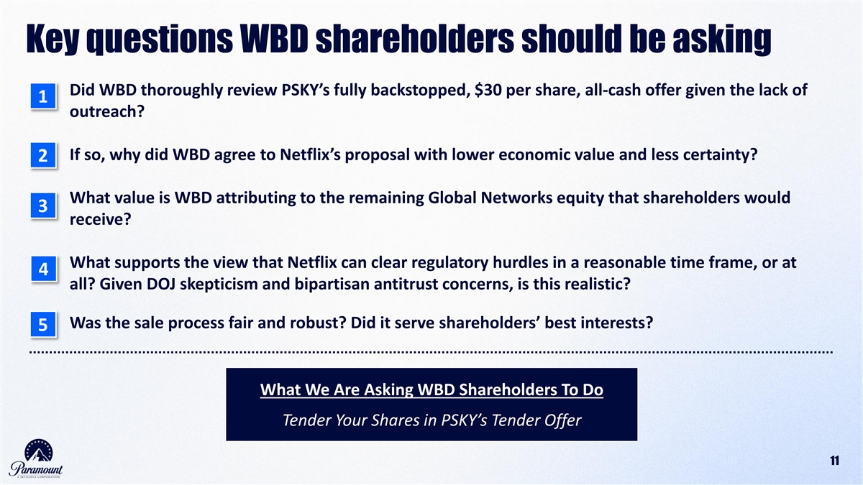
Key questions WBD shareholders should be asking Did WBD thoroughly review PSKY’s fully backstopped, $30 per share, all-cash offer given the lack of 1 outreach? If so, why did WBD agree to Netflix’s proposal with lower economic value and less certainty? 2 What value is WBD attributing to the remaining Global Networks equity that shareholders would 3 receive? What supports the view that Netflix can clear regulatory hurdles in a reasonable time frame, or at 4 all? Given DOJ skepticism and bipartisan antitrust concerns, is this realistic? Was the sale process fair and robust? Did it serve shareholders’ best interests? 5 What We Are Asking WBD Shareholders To Do Tender Your Shares in PSKY’s Tender Offer 11 11

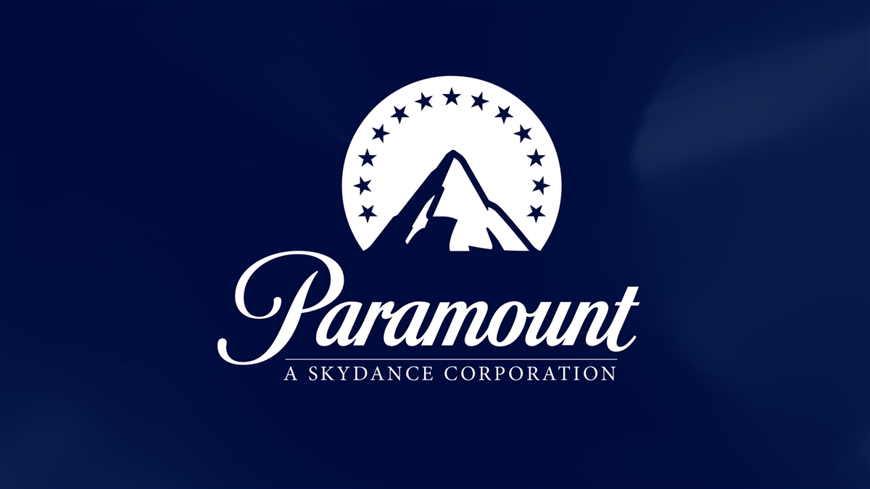
12

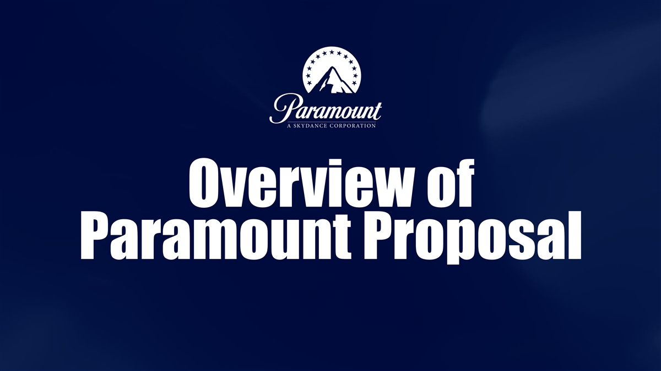
Overview of Paramount Proposal

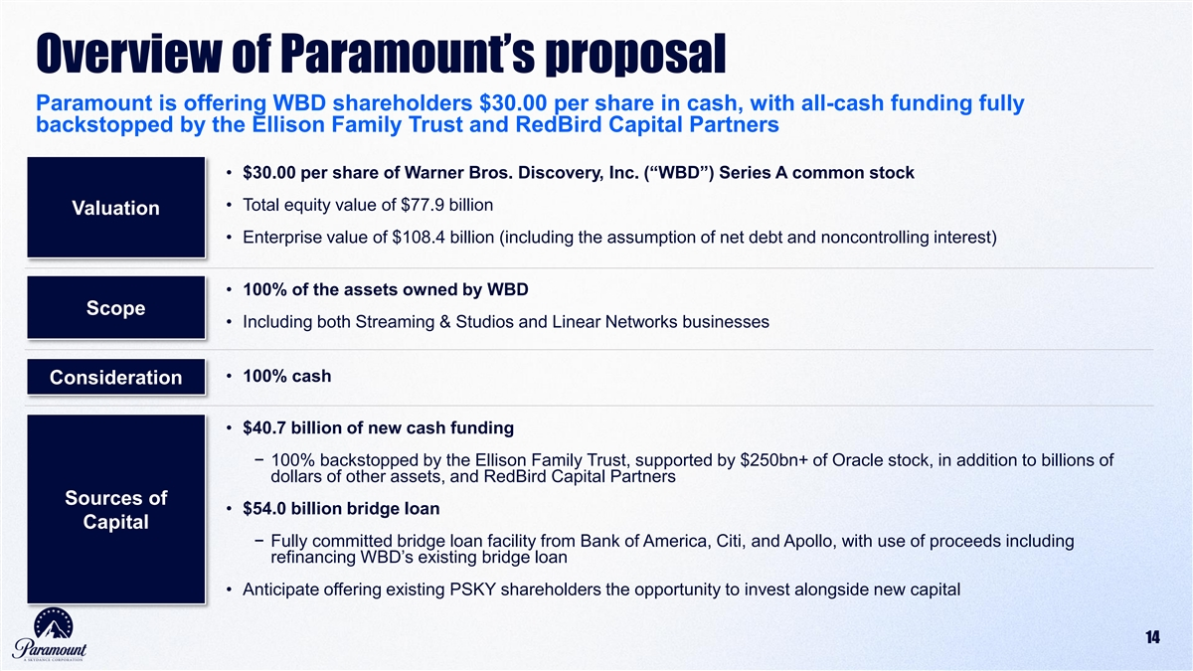
Overview of Paramount’s proposal Paramount is offering WBD shareholders $30.00 per share in cash, with all-cash funding fully backstopped by the Ellison Family Trust and RedBird Capital Partners • $30.00 per share of Warner Bros. Discovery, Inc. (“WBD”) Series A common stock • Total equity value of $77.9 billion Valuation • Enterprise value of $108.4 billion (including the assumption of net debt and noncontrolling interest) • 100% of the assets owned by WBD Scope • Including both Streaming & Studios and Linear Networks businesses • 100% cash Consideration • $40.7 billion of new cash funding − 100% backstopped by the Ellison Family Trust, supported by $250bn+ of Oracle stock, in addition to billions of dollars of other assets, and RedBird Capital Partners Sources of • $54.0 billion bridge loan Capital − Fully committed bridge loan facility from Bank of America, Citi, and Apollo, with use of proceeds including refinancing WBD’s existing bridge loan • Anticipate offering existing PSKY shareholders the opportunity to invest alongside new capital 14

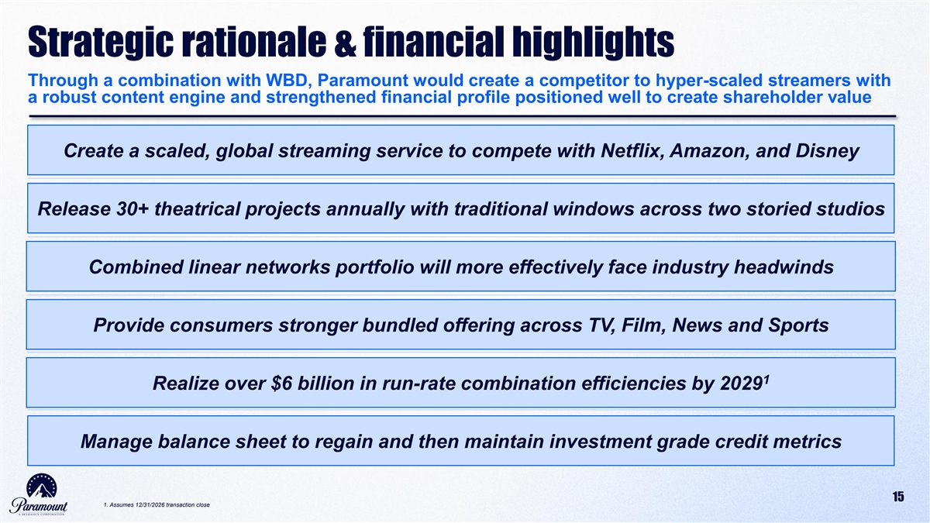
Strategic rationale & financial highlights Through a combination with WBD, Paramount would create a competitor to hyper-scaled streamers with a robust content engine and strengthened financial profile positioned well to create shareholder value Create a scaled, global streaming service to compete with Netflix, Amazon, and Disney Release 30+ theatrical projects annually with traditional windows across two storied studios Combined linear networks portfolio will more effectively face industry headwinds Provide consumers stronger bundled offering across TV, Film, News and Sports 1 Realize over $6 billion in run-rate combination efficiencies by 2029 Manage balance sheet to regain and then maintain investment grade credit metrics 15 1. Assumes 12/31/2026 transaction close

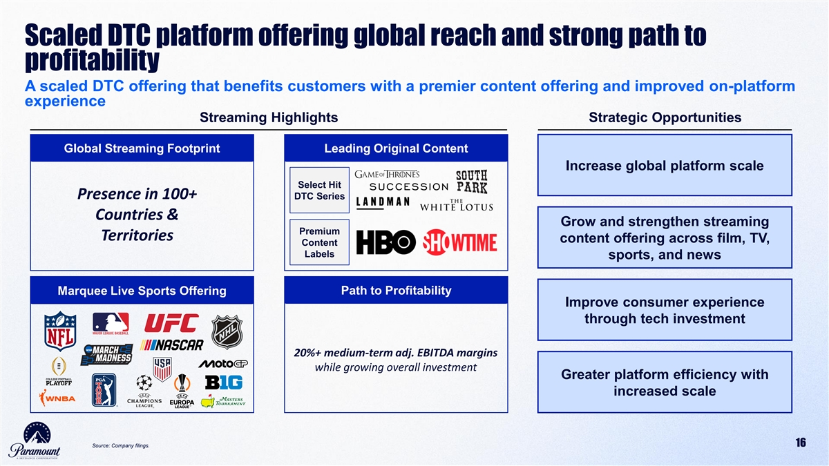
Scaled DTC platform offering global reach and strong path to profitability A scaled DTC offering that benefits customers with a premier content offering and improved on-platform experience Streaming Highlights Strategic Opportunities Global Streaming Footprint Leading Original Content Increase global platform scale Select Hit Presence in 100+ DTC Series Countries & Grow and strengthen streaming Premium Territories content offering across film, TV, Content Labels sports, and news Path to Profitability Marquee Live Sports Offering Improve consumer experience through tech investment 20%+ medium-term adj. EBITDA margins while growing overall investment Greater platform efficiency with increased scale 16 Source: Company filings.

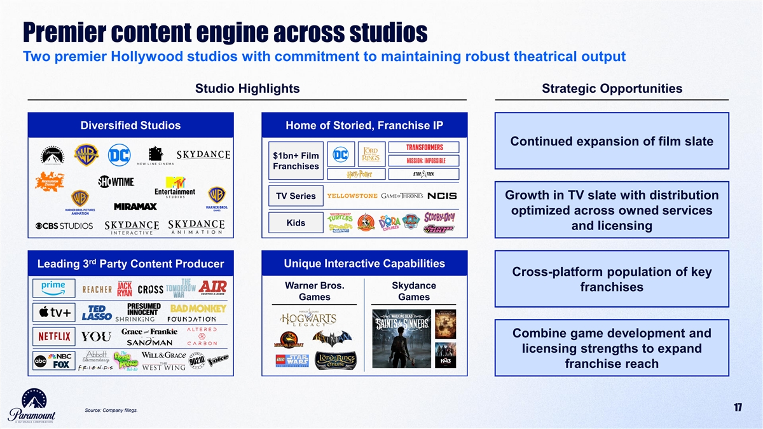
Premier content engine across studios Two premier Hollywood studios with commitment to maintaining robust theatrical output Studio Highlights Strategic Opportunities Diversified Studios Home of Storied, Franchise IP Continued expansion of film slate $1bn+ Film Franchises TV Series Growth in TV slate with distribution optimized across owned services Kids and licensing rd Leading 3 Party Content Producer Unique Interactive Capabilities Cross-platform population of key Warner Bros. Skydance franchises Games Games Combine game development and licensing strengths to expand franchise reach 17 Source: Company filings.

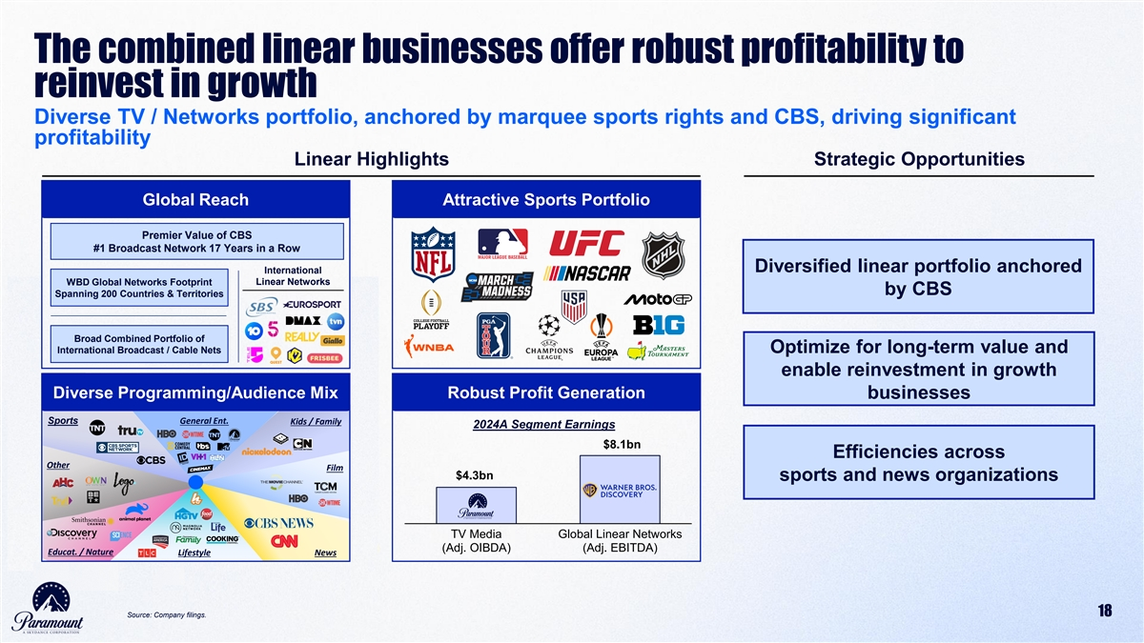
The combined linear businesses offer robust profitability to reinvest in growth Diverse TV / Networks portfolio, anchored by marquee sports rights and CBS, driving significant profitability Linear Highlights Strategic Opportunities Global Reach Attractive Sports Portfolio Premier Value of CBS #1 Broadcast Network 17 Years in a Row Diversified linear portfolio anchored International Linear Networks WBD Global Networks Footprint by CBS Spanning 200 Countries & Territories Broad Combined Portfolio of International Broadcast / Cable Nets Optimize for long-term value and enable reinvestment in growth Diverse Programming/Audience Mix Robust Profit Generation businesses Sports General Ent. Kids / Family 2024A Segment Earnings $8.1bn Efficiencies across Other Film $4.3bn sports and news organizations TV Media Global Linear Networks (Adj. OIBDA) (Adj. EBITDA) Educat. / Nature Lifestyle News 18 Source: Company filings.

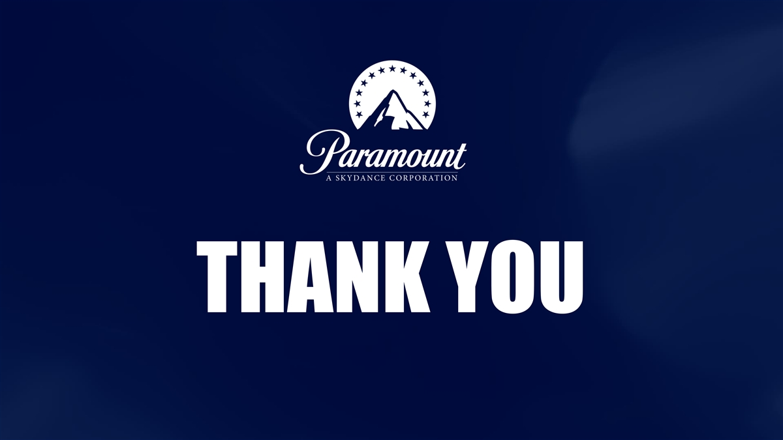
THANK YOU

Cautionary Note Regarding Forward-Looking Statements
This communication contains both historical and forward-looking statements, including statements related to Paramount’s future financial results and performance, potential achievements, anticipated reporting segments and industry changes and developments. All statements that are not statements of historical fact are, or may be deemed to be, “forward-looking statements”. Similarly, statements that describe Paramount’s objectives, plans or goals are or may be forward-looking statements. These forward-looking statements reflect Paramount’s current expectations concerning future results and events; generally can be identified by the use of statements that include phrases such as “believe,” “expect,” “anticipate,” “intend,” “plan,” “foresee,” “likely,” “will,” “may,” “could,” “estimate” or other similar words or phrases; and involve known and unknown risks, uncertainties and other factors that are difficult to predict and which may cause Paramount’s actual results, performance or achievements to be different from any future results, performance or achievements expressed or implied by these statements. These risks, uncertainties and other factors include, among others: the outcome of the tender offer by Paramount and Prince Sub Inc. (the “Tender Offer”) to purchase for cash all of the outstanding Series A common stock of WBD or any discussions between Paramount and WBD with respect to a possible transaction (including, without limitation, by means of the Tender Offer, the “Potential Transaction”), including the possibility that the Tender Offer will not be successful, that the parties will not agree to pursue a business combination transaction or that the terms of any such transaction will be materially different from those described herein, the conditions to the completion of the Potential Transaction or the previously announced transaction between Warner Bros. and Netflix Inc. (“Netflix”) pursuant to the Agreement and Plan of Merger, dated December 4, 2025, among Netflix, Nightingale Sub, Inc., Warner Bros. and New Topco 25, Inc. (the “Proposed Netflix Transaction”), including the receipt of any required stockholder and regulatory approvals for either transaction, the proposed financing for the Potential Transaction, the indebtedness Paramount expects to incur in connection with the Potential Transaction and the total indebtedness of the combined companies, the possibility that Paramount may be unable to achieve expected synergies and operating efficiencies within the expected timeframes or at all and to successfully integrate the operations of WBD with those of Paramount, and the possibility that such integration may be more difficult, time-consuming or costly than expected or that operating costs and business disruption (including, without limitation, disruptions in relationships with employees, customers or suppliers) may be greater than expected in connection with the Potential Transaction; risks related to Paramount’s streaming business; the adverse impact on Paramount’s advertising revenues as a result of changes in consumer behavior, advertising market conditions and deficiencies in audience measurement; risks related to operating in highly competitive and dynamic industries, including cost increases; the unpredictable nature of consumer behavior, as well as evolving technologies and distribution models; risks related to Paramount’s decisions to make investments in new businesses, products, services and technologies, and the evolution of Paramount’s business strategy; the potential for loss of carriage or other reduction in or the impact of negotiations for the distribution of Paramount’s content; damage to Paramount’s reputation or brands; losses due to asset impairment charges for goodwill, intangible assets, FCC licenses and content; liabilities related to discontinued operations and former businesses; increasing scrutiny of, and evolving expectations for, sustainability initiatives; evolving business continuity, cybersecurity, privacy and data protection and similar risks; content infringement; domestic and global political, economic and regulatory factors affecting Paramount’s businesses generally, including tariffs and other changes in trade policies; the inability to hire or retain key employees or secure creative talent; disruptions to Paramount’s operations as a result of labor disputes; the risks and costs associated with the integration of, and Paramount’s ability to integrate, the businesses of Paramount Global and Skydance Media, LLC successfully and to achieve anticipated synergies; volatility in the prices of Paramount’s Class B Common Stock; potential conflicts of interest arising from Paramount’s ownership structure with a controlling stockholder; and other factors described in Paramount’s news releases and filings with the Securities and Exchange Commission (the “SEC”), including but not limited to Paramount’s most recent Annual Report on Form 10-K and Paramount’s reports on Form 10-Q and Form 8-K. There may be additional risks, uncertainties and factors that Paramount does not currently view as material or that are not necessarily known. The forward-looking statements included in this communication are made only as of the date of this report, and Paramount does not undertake any obligation to publicly update any forward-looking statements to reflect subsequent events or circumstances.
Additional Information
This communication does not constitute an offer to buy or a solicitation of an offer to sell securities. This communication relates to a proposal that Paramount has made for an acquisition of WBD and the Tender Offer that Paramount, through Prince Sub Inc., its wholly owned subsidiary, has made to WBD stockholders. The Tender Offer is being made pursuant to a tender offer statement on Schedule TO (including the offer to purchase, the letter of transmittal and other related offer documents), filed with the SEC on December 8, 2025. These materials, as may be amended from time to time, contain important information, including the terms and conditions of the offer. Subject to future developments, Paramount (and, if a negotiated transaction is agreed, WBD) may file additional documents with the SEC. This communication is not a substitute for any proxy statement, tender offer statement, or other document Paramount and/or WBD may file with the SEC in connection with the proposed transaction.
Investors and security holders of WBD are urged to read the tender offer statement(s) (including the offer to purchase, the letter of transmittal and other related offer documents), and any other documents filed with the SEC carefully in their entirety if and when they become available as they will contain important information about the proposed transaction. Any definitive proxy statement(s) (if and when available) will be mailed to stockholders of WBD. Investors and security holders will be able to obtain free copies of these documents (if and when available) and other documents filed with the SEC by Paramount through the website maintained by the SEC at http://www.sec.gov.
This communication is neither a solicitation of a proxy nor a substitute for any proxy statement or other filings that may be made with the SEC. Nonetheless, Paramount and its directors and executive officers and other members of management and employees may be deemed to be participants in the solicitation of proxies against the Proposed Netflix Transaction. You can find information about Paramount’s executive officers and directors in Paramount’s Current Reports on Form 8-K filed with the SEC on August 7, 2025, and September 16, 2025, and Paramount’s Quarterly Report on Form 10-Q filed with the SEC on November 10, 2025. Additional information regarding the interests of such potential participants will be included in one or more proxy statements or other documents filed with the SEC if and when they become available. These documents (if and when available) may be obtained free of charge from the SEC’s website at http://www.sec.gov.
Exhibit (a)(5)(C)
CNBC Transcript: Paramount Skydance Chairman & CEO David Ellison Speaks with CNBC’s David Faber on “Squawk on the Street” Today
DAVID FABER: Welcome back to “Squawk on the Street.” I’m David Faber. And I am here now with David Ellison, the chairman and CEO of Paramount, which this morning has launched a $30 all cash tender offer to acquire Warner Bros. Discovery. A company that I believe you bid, at the last count, six times for.
DAVID ELLISON: Correct.
FABER: But did not come up with the prize that you sought, hence this morning’s news. David, why are you doing this?
ELLISON: So, look, we’re really here to finish what we started. Like, just to kind of take you through the road in terms of how we got here. On December 1st, we made an offer to acquire Warner Bros. Discovery to their board, had a conversation with David Zaslav. He came back with a bunch of issues. We then, on December 4th, sent in a bid that addressed every single one of them that is superior to the bid that they signed up. Our offer is $30 a share, all cash, $41 billion in equity that’s backstopped by the Ellison family and RedBird, $54 billion in debt with commitments from Citi, Bank of America and Apollo. We have faster regulatory certainty to close and our deal is pro-consumer. It’s pro-creative talent. It’s pro-competition. And we believe that when you actually to further contextualize the our $30 in cash, or, sorry, $30 a share is basically $17.6 billion in cash, more than the $23 a share that they signed up. We will—
FABER: Right. Well, you’re not obviously paying, you’re paying for global networks. Their deal doesn’t involve paying for global networks, which were traded, it’s a public company. Which, by the way, also figures very prominently here in trying to determine what the overall value of the respective deals are, because they’re a $27.75, including obviously the stock portion of their deal.
ELLISON: Correct.
FABER: But it also includes, well what’s global networks. Is it a $2 stock. Is it a $4 stock. What do you see? Because that can go a long way in terms of at least determining why the board may have said, no, we think Netflix is superior.
ELLISON: So, respectfully, we think that basically that’s valued at $1 a share. I think if you look—
FABER: Why $1?
ELLISON: So, if you look at Versant and where the median of all of this is, it’s about four and a half times. You have to get to five times equity value or more to basically get to the, you know, kind of $3 plus that you’re claiming. But again, I think the most important thing to go back here is, look, we’re sitting on Wall Street where cash is still king. We are offering shareholders $17.6 billion more cash than the deal that they currently have signed up with Netflix. And we believe when they see what is currently in our offer, that that’s what they’ll vote for.
FABER: Were you told during the process that cash is king?
ELLISON: Yes, absolutely. What we were told repeatedly was that they wanted all cash. We delivered all cash. We were, we were asked if they wanted it to be fully backstopped by the Ellison family and RedBird. We delivered it fully backstopped by the Ellison family and RedBird. And when you look at the scale of the companies, right, look at the scale of Netflix, 310 million global subscribers. When you combine the number one streamer with the number three streamer, that creates a company that has

unprecedented market power north of 400 million subscribers. The next largest competitor is Disney, with just under 200 million. That’s bad for Hollywood. That’s bad for the creative community. That’s bad for consumers. And look at how the market is reacting to this deal. We are literally seeing talent talking about the death of movie theaters. We’ve all heard Ted Sarandos’ comments about how he feels about the theatrical experience. And you’ve also seen, you know, and our deal is also offering more cash for shareholders.
FABER: Now, you’ve made that point. And, obviously, it is offering more cash. So, if they said cash is king and then they were willing to take stock, obviously only 14 or 15 percent of the overall consideration that Netflix is offering. Nonetheless, do you feel as though you were disadvantaged in this process? And if you were, what can you cite to prove, in fact, that somehow you were not on a level playing field in having your offer considered with their offer?
ELLISON: So, I do think there is an inherent bias towards us. If you look at it, we, fundamentally—
FABER: Towards them. An inherent bias towards them.
ELLISON: Correct.
FABER: Yes.
ELLISON: We put the company in play.
FABER: Yes.
ELLISON: We, you know, which, again, we don’t think was particularly taken well.
FABER: No, I think that actually starts you off on a potentially bad foot when you’re making an unsolicited bid for a company.
ELLISON: But look at what we did with our last offer. We literally submitted $30 a share in cash. Never got a phone call. Never got a single markup of basically our merger agreement. Never got a response. And that’s why we’re here today. We’re here to finish, to make sure that we can take directly to shareholders the offer that we sent to the board.
FABER: So you never got a response from that last—
ELLISON: Not one time.
FABER: And did you indicate that that was best and final at the time, or perhaps say that it wasn’t?
ELLISON: No. So, actually, the last communication that I had with David Zaslav is I made it incredibly clear in text message, this is all going to be public for everybody to see, that we addressed all of the issues that they asked for, and very specifically that our offer was not best and final. And so, when we literally delivered a $30 per share all cash offer, we never heard back.
FABER: You never, you never heard back from them at all. You know, a lot of this goes back, of course, and you mentioned it already, to the perceived risks of antitrust rejection. Certainly on the Netflix side. It’s still an issue as well for every deal, including your own perhaps, state A.G.s and the like. It comes back to Donald Trump oftentimes because of sort of his unique place in this administration. And he even indicated yesterday at the Kennedy Center he would be involved in this decision. Have you gotten any assurances from him in the sense of your own deal would pass antitrust muster and/or that Netflix’s transaction would not?

ELLISON: So, David, I think you have to look at this basically on the merits, right? We are trying to combine the number four streamer with the number five streamer. When you put Paramount and HBO Max together, you get round numbers, 200 million subscribers. That creates a streaming service that is competitive with Disney. When you put number one and number three together, you are handing Netflix unprecedented market power, which is anti-competitive in every single measure, every single metric you can measure. And we think that is bad. Again, it’s bad for the consumer. It’s bad for the creative community. This deal, if it is allowed to move forward, will actually be the death of the theatrical movie business in Hollywood. We’re sitting here today trying to save it.
FABER: Understood. It’s going to be a little while. This is going to be a fight that stretches, perhaps until the shareholder vote, until shareholders are heard from, unless their voices are heard prior and Warner Bros. makes a different decision. I am curious, though. You know, you’re going to war here, so to speak, with Netflix, an incredibly well-endowed company that has the ability, it would seem, to choose to raise its offer even more. Why bother when they conceivably could simply come back and raise their offer if they need to?
ELLISON: So, again, I think when you actually look at what the highest offer that is currently on the table, $30 in cash, the last time I checked, beats $23 in cash. And that’s $17.6 billion in cash more so, as we’ve said. We believe we have the superior offer. We’re taking that directly to shareholders. And we think that’s what they’re going to vote for.
FABER: I know, but that’s not a fair comparison. I mean there is stock. Netflix stock is worth right, it’s in, within the collar, it’s worth at least 3.50 a share to the deal. I mean saying our cash versus theirs doesn’t seem a fair comparison, David.
ELLISON: So, respectfully, I disagree. I mean, look, I mean, look, those shareholders can basically go buy Netflix cash on the, sorry, Netflix stock in the open market if they want to, and they’re going to be sitting there with a linear stub that’s valued at $1 a share, which is a business that’s in secular decline that without the synergies that’s basically created by our deal, they will ultimately be holding something that is not worth anything. By every metric you can look at, we believe that our offer is superior to shareholders.
FABER: Right, and again, we’re going to get a lot of debate around the value of that stub, because even though it’s an incremental, let’s call it difference of a $2 it can go to the to the value judgment. Let me ask you about Paramount though, if in fact, you are successful here. You’re taking on a lot of debt, right? I mean, it’s and you’re diluting your own shareholders significantly through an inclusion of what $41 billion in equity. Isn’t that correct?
ELLISON: Yeah. But look one, we’re the largest shareholder of the, of basically the Paramount Class B common stock.
FABER: We being?
ELLISON: We being the Ellison family, we will also be the largest investor in this deal. We’re literally sitting here today because we are fighting for our shareholders, and we’re also fighting for the shareholders of Warner Bros. Discovery. And from that standpoint, this deal is accretive to our shareholders. You know, when you look at what the combined business would be with the synergies that you put through it, round numbers, $70 billion in top line revenue, we get to $16 billion in EBITDA very quickly, and it generates $10 billion in cash flow. What we’re creating by putting these two companies together is a real competitor to Netflix, a real competitor to Amazon, a real competitor to Disney, not something that is so anti-competitive. There will be no more competition in Hollywood if this deal is allowed to come to pass.

FABER: Is it an existential issue for you though, if you don’t succeed here, David?
ELLISON: Look, as we’ve said in our on our earnings call, we believe in our standalone business. We have a great plan. But very simply, we made the highest offer for the company, $30 in cash is more than $23.
FABER: Right, but when it comes to Paramount itself, if you aren’t successful here, you have confidence that you still have the scale? I mean, we’ve had this conversation before.
ELLISON: Yeah, yeah.
FABER: I would assume that you’re going to try and figure something else out because there is a sense that you don’t have the scale to compete in this world.
ELLISON: As we’ve said, we can absolutely this is a buy versus build. We absolutely have a path to be able to build. But again, we actually sit here today having put forth the most value for shareholders for Warner Bros. Discovery, we believe that they need to be able to evaluate that offer, and that’s why we’re taking it directly to the shareholders.
FABER: I asked you about the President, but I’d love to come back to that. I mean, do you sense that he is in your corner here?
ELLISON: What I would say is I’m incredibly grateful for the relationship that I have with the President, and I also believe he believes in competition. And when you fundamentally look at the marketplace, allowing the number one streaming service to combine with the number three streaming service is anti-competitive, and this whole notion of category ambiguity, forgive me, David, you’ve been doing this a long time.
FABER: Yes, I have.
ELLISON: Like I don’t, I don’t buy it.
FABER: You don’t buy it. In other words, their argument, John Malone made this argument with me. It’s not about streamers, it’s about TikTok and Instagram and YouTube.
ELLISON: I’m sorry this is that’s that’s, let’s follow that analogy for a second, right? Okay, that’s like saying Coke can buy Pepsi, that they’re both beverages because Budweiser is a substitute for Coke. That’s not a realistic argument. Now let’s actually look at it from the talent community, the greatest showrunners in the world. David Benioff is not going to take the next Game of Thrones to basically TikTok or to Instagram. They’re going to take it to Netflix. They’re going to take it to Amazon. They’re going to take it to Apple, they’re going to take it to HBO Max. They’re going to take it to Paramount Plus. That’s not actually how the ecosystem works. If this deal is allowed to come to pass, it is anti-competitive, and it is a horrible deal for Hollywood. And as someone who spent the last 15 years of my life producing movies and television shows, this is an industry that I love, this is an existential moment for our business, and we believe that what we are offering is better for Hollywood. It’s better for the customers and it’s pro-competitive.
FABER: You know, I wonder we were having this conversation on the desk a moment ago. It may be better for Hollywood than Netflix owning it, but will it be better in and of itself? I mean, you’re talking about huge cost synergies, for example. It’s not clear or can you make it clear that, in fact, Hollywood will actually benefit, and there won’t be reductions overall still in the amount of productions and jobs.

ELLISON: Absolutely it will be beneficial for Hollywood. I mean, one, everyone loves to contextualize the six legacy studios, right? But I think when you have to look at the new entries that have come into the place, Apple is now in the business, Netflix is now in the business, Amazon is now in the business. What we are, what we are buying by our basically acquisition of Warner Bros. Discovery is we are accelerating our path to scale. What Netflix is buying is unprecedented market power that will kill competition in the industry. What we are doing will create another scaled, healthy buyer for the creative community and for talent. We’ll put 30 movies a year in theaters, exclusively.
FABER: 30 movies, I mean, because right now at Paramount, you’re nowhere near—
ELLISON: But look at what we’re doing at Paramount. When we bought the company, eight movies a year. We’re going to release 15 movies a year, next year, and we’re going to grow that. We’ve said it publicly, that we want to grow it to 20. We believe that the number one way in the movie business to create valuable intellectual property is to release movies in theaters, not at home. We deeply believe in that experience. And when you think about the generational heirlooms that have been passed down from generation to generation that are that’s filmed entertainment, those are movies that you saw in the theater.
FABER: You know, the news business comes up for a moment here. I mean, you’re going to own linear cable assets, obviously, CNN amongst them, if you are successful here. Thank you for the mention of Versant, by the way, and in a favorable light, but the business is in steep decline. There’s no way around that. Why do you want to own these assets given what are significant reductions? I think the plan that even came from Warner Bros. in the discussion with you talks about what 60% percent top line reduction over at least two years.
ELLISON: Absolutely so the reason why we believe basically in this combination is very simply, by putting the creative content engines of the companies together, we believe we can win in content. We’d have an IP portfolio that’s competitive with Disney by putting Paramount and Warner Bros. together. It accelerates our north star goal of getting to scale and streaming, and we get to basically round numbers, 200 million subscribers as a result of this, which, again, from a competitive standpoint, is over 100 million below Netflix and Amazon. And then when you look at the linear portfolio, there are significant synergies. And when you look at what we can do with CBS, which is a crown jewel asset, and again, all linear is not equivalent, right? I mean, broadcast is an incredibly stable, healthy business. Cable is in secular decline, by the way, being replaced by streaming. Back to your why I don’t buy the category ambiguity conversation.
FABER: Right.
ELLISON: But basically, when we can combine it with our portfolio, we believe we can bend the linear curve, have that linear business be incredibly cash flow generative, which we can then take and invest into more content to grow the growth areas of our business, which is the movies we’re going to make, the streaming series we’re going to make, the sports we’re going to invest in. And again, this creates a scaled competitor, not something that is so anti-competitive. It’ll be the end of the industry, as we know it.
FABER: Why not just let the process run out and sit around and wait if you’re really so confident that Netflix can’t get antitrust?
ELLISON: So I think if you look at basically how long it’ll take them to go through antitrust and the $5.8 billion break fee—

FABER: Reverse break fee.
ELLISON: Yeah, yeah, but basically, if you think about that, if this takes two years, and I think, and you’ve seen reports on this, that this has basically been a defensive move by Netflix, and if they actually slow down our scale for the next two years, that’s a win for them. That, by nature, is anti-competitive.
FABER: Right, a couple of real quick things before we wrap up. I mean, CNN, I assume you would combine the news gathering operation with CBS’s, if, in fact, you did own that asset.
ELLISON: Yeah. So look, we’ve been really clear since by the last time we’re here, what we want to do with news, which is, we want to build a scaled news service that is basically, fundamentally in the trust business, that is in the truth business, and that speaks to the 70% of Americans that are in the middle. And we believe that by doing so that is for us, kind of doing well while doing good. And we believe in that business model, and we believe it’s essential.
FABER: And do you, do you think the President embraces the idea of you being the owner of CNN, given his criticism, obviously, for that network in the past?
ELLISON: By the way, we’ve had great conversations with the President about this, but I think, what, but I don’t want to speak for him in any way, shape or form.
FABER: Mid east investors have figured into some of the reporting here. Are they a part of that $41 billion in equity?
ELLISON: Look, we absolutely have strategic partners in this deal, but I want to be really clear, the last deal that we submitted was fully backstop the equity by the Ellison family and RedBird. There has never been a financing condition in any deal that we submitted to the board of Warner Bros. Discovery, and we are standing behind them.
FABER: So when I hear from the other side that they were uncertain as to who potentially to come after in terms of the entities that were submitting the bid, if, in fact, you didn’t close, that was an argument that I’ve heard. What’s your response?
ELLISON: It just happens to be categorically false. Again, this is all now public. The last offer that we submitted to the board the equity $41 billion was fully backstopped by the Ellison family and RedBird Capital Partners. We had debt commitments from Bank of America, Citi and Apollo for the full $54 billion so the notion of that claim is just categorically false. It’s fiction.
FABER: And does it go back to then your contention that somehow you didn’t get a fair shake?
ELLISON: Well, I think when you actually look at this on the merits, it’s what we, it’s what it’s what I started with, $30 a share in cash is more than $23. This is a better deal for shareholders, and it also has a clear path to close. Very simply, our deal basically, is more value, it’s more certainty, and it’s more speed to close, and we think that’s what shareholders are going to vote on.
FABER: We got an opening bell that you and I can hear as well. I want to continue briefly for a bit more if we can. David, you know what happens from here? What are your expectations now that you’re obviously going to be speaking directly to shareholders as to what may happen?
ELLISON: Well, I mean, I think when shareholders actually see the offer that we put on the table. I mean, look, we still haven’t gotten a response from the Warner board for the $30 in cash that we offered, and that’s the highest offer that’s currently on the table. And we again, as we said, we believe that’s what shareholders are going to pay.

FABER: You know, again, coming back to this highest offer on the table. I mean, they would argue that $27.75, which it’s currently worth right now, because the stock is staying in the collar, plus, what their argument would be is, let’s call it three bucks for global networks, equals a higher number than your number.
ELLISON: It’s, again, I think, if you actually look at that, and if you, if you look at the math and the amount of debt, I mean, basically on what we could extrapolate from the information we looked at, that linear business is going to have $15 billion of debt on it. It’s an entirely a cable portfolio that is in secular decline, and every single day it’s worth less money than it is right now. Our deal basically provides a significant amount of synergies and sports rights that will be able to obviously perfect protect those linear properties, having that sit out there on their own, again, I think it’s gonna be worth a lot less than people are claiming.
FABER: David, what do you think if you’re correct, and again, this is yet to be determined, but if you’re correct that you were somehow disadvantaged in this process after starting it in an unsolicited fashion and making bid after bid after bid, why, why do you think if you’re correct in that assumption that that was the case?
ELLISON: Again, let’s just, let’s just go back to the facts right? The day before the deal was announced, we submitted a bid to the Warner Bros., to Warner Bros., that was $30 a share, all cash that delivered the 100% cash that they asked for, that delivered higher value, that delivered basically regulatory, you know, obviously faster path to regulatory certainty, and we never heard back. We’re here to finish the process.
FABER: Right, no, I know that. The reason I’m asking you never heard back. Do you think, why? Why, why in your you have to have thought about this. Why are we somehow being disadvantaged? What’s the answer?
ELLISON: Look, we’ve been asking ourselves that same question, which is why we’re taking this directly to shareholders.
FABER: So you don’t know the answer.
ELLISON: Look, we do believe that there has been an inherent bias in this process, because, again, to make a $30 all cash offer and to literally text the CEO that our offer is not best and final, and then to not hear back. What do you think the answer is?
FABER: But you know, I’ve been trying to understand it as well and trying to fully understand how many board members because they have a lot of very talented board members at this company were completely informed of everything that had occurred. And I’ve heard the idea that somehow you were told that your deal wasn’t perfected. Is that correct?
ELLISON: So by the way, we’ve heard that but, but again, it just, it has no basis in reality. It’s why I keep going back to the $41 billion in equity was fully backstopped by the Ellison family and RedBird.
FABER: Is your father selling Oracle stock, by the way, to finance that, or just margining it? How is that actually working?
ELLISON: So, so we obviously have investors that we’re partnering with as well. But again, we’re fully, we have all the capital necessary to complete this transaction.

FABER: Well, when you say that, though, is there, is there a way that they could perhaps doubt that, because it doesn’t involve selling stock and actually having the money on hand?
ELLISON: David, come on, please. Like, I think, I think kind of calling that into question is, is I don’t think there’s any merit to that.
FABER: No, I think, I think that’s a fair point on your part, but they might ask it. I mean, you know, maybe they already have.
ELLISON: Again, the equity was fully backstopped.
FABER: David, you know, it’s going to be an interesting fight, obviously, as it stretches out conceivably, over these next few months. And we certainly appreciate your taking time. I guess you’re going to continue to communicate, and or your team will continue to communicate the merits of your deal. Do you ever see raising your offer overall?
ELLISON: Again right now, I think our offer is currently the highest on the table, and we’re still waiting to hear back from that offer. David, appreciate you taking the time.
FABER: Thank you.
ELLISON: Thank you.

Cautionary Note Regarding Forward-Looking Statements
This communication contains both historical and forward-looking statements, including statements related to Paramount’s future financial results and performance, potential achievements, anticipated reporting segments and industry changes and developments. All statements that are not statements of historical fact are, or may be deemed to be, “forward-looking statements”. Similarly, statements that describe Paramount’s objectives, plans or goals are or may be forward-looking statements. These forward-looking statements reflect Paramount’s current expectations concerning future results and events; generally can be identified by the use of statements that include phrases such as “believe,” “expect,” “anticipate,” “intend,” “plan,” “foresee,” “likely,” “will,” “may,” “could,” “estimate” or other similar words or phrases; and involve known and unknown risks, uncertainties and other factors that are difficult to predict and which may cause Paramount’s actual results, performance or achievements to be different from any future results, performance or achievements expressed or implied by these statements. These risks, uncertainties and other factors include, among others: the outcome of the tender offer by Paramount and Prince Sub Inc. (the “Tender Offer”) to purchase for cash all of the outstanding Series A common stock of WBD or any discussions between Paramount and WBD with respect to a possible transaction (including, without limitation, by means of the Tender Offer, the “Potential Transaction”), including the possibility that the Tender Offer will not be successful, that the parties will not agree to pursue a business combination transaction or that the terms of any such transaction will be materially different from those described herein, the conditions to the completion of the Potential Transaction or the previously announced transaction between Warner Bros. and Netflix Inc. (“Netflix”) pursuant to the Agreement and Plan of Merger, dated December 4, 2025, among Netflix, Nightingale Sub, Inc., Warner Bros. and New Topco 25, Inc. (the “Proposed Netflix Transaction”), including the receipt of any required stockholder and regulatory approvals for either transaction, the proposed financing for the Potential Transaction, the indebtedness Paramount expects to incur in connection with the Potential Transaction and the total indebtedness of the combined companies, the possibility that Paramount may be unable to achieve expected synergies and operating efficiencies within the expected timeframes or at all and to successfully integrate the operations of WBD with those of Paramount, and the possibility that such integration may be more difficult, time-consuming or costly than expected or that operating costs and business disruption (including, without limitation, disruptions in relationships with employees, customers or suppliers) may be greater than expected in connection with the Potential Transaction; risks related to Paramount’s streaming business; the adverse impact on Paramount’s advertising revenues as a result of changes in consumer behavior, advertising market conditions and deficiencies in audience measurement; risks related to operating in highly competitive and dynamic industries, including cost increases; the unpredictable nature of consumer behavior, as well as evolving technologies and distribution models; risks related to Paramount’s decisions to make investments in new businesses, products, services and technologies, and the evolution of Paramount’s business strategy; the potential for loss of carriage or other reduction in or the impact of negotiations for the distribution of Paramount’s content; damage to Paramount’s reputation or brands; losses due to asset impairment charges for goodwill, intangible assets, FCC licenses and content; liabilities related to discontinued operations and former businesses; increasing scrutiny of, and evolving expectations for, sustainability initiatives; evolving business continuity, cybersecurity, privacy and data protection and similar risks; content infringement; domestic and global political, economic and regulatory factors affecting Paramount’s businesses generally, including tariffs and other changes in trade policies; the inability to hire or retain key employees or secure creative talent; disruptions to Paramount’s operations as a result of labor disputes; the risks and costs associated with the integration of, and Paramount’s ability to integrate, the businesses of Paramount Global and Skydance Media, LLC successfully and to achieve anticipated synergies; volatility in the prices of Paramount’s Class B Common Stock; potential conflicts of interest arising from Paramount’s ownership structure with a controlling stockholder; and other factors described in Paramount’s news releases and filings with the Securities and Exchange Commission (the “SEC”), including but not limited to Paramount’s most recent Annual Report on Form 10-K and Paramount’s reports on Form 10-Q and Form 8-K. There may be additional risks, uncertainties and factors that Paramount does not currently view as material or that are not necessarily known. The forward-looking statements included in this communication are made only as of the date of this report, and Paramount does not undertake any obligation to publicly update any forward-looking statements to reflect subsequent events or circumstances.
Additional Information
This communication does not constitute an offer to buy or a solicitation of an offer to sell securities. This communication relates to a proposal that Paramount has made for an acquisition of WBD and the Tender Offer that Paramount, through Prince Sub Inc., its wholly owned subsidiary, has made to WBD stockholders. The Tender Offer is being made pursuant to a tender offer statement on Schedule TO (including the offer to purchase, the letter of transmittal and other related offer documents), filed with the SEC on December 8, 2025. These materials, as may be amended from time to time, contain important information, including the terms and conditions of the offer. Subject to future developments, Paramount (and, if a negotiated transaction is agreed, WBD) may file additional documents with the SEC. This communication is not a substitute for any proxy statement, tender offer statement, or other document Paramount and/or WBD may file with the SEC in connection with the proposed transaction.
Investors and security holders of WBD are urged to read the tender offer statement(s) (including the offer to purchase, the letter of transmittal and other related offer documents), and any other documents filed with the SEC carefully in their entirety if and when they become available as they will contain important information about the proposed transaction. Any definitive proxy statement(s) (if and when available) will be mailed to stockholders of WBD. Investors and security holders will be able to obtain free copies of these documents (if and when available) and other documents filed with the SEC by Paramount through the website maintained by the SEC at http://www.sec.gov.
This communication is neither a solicitation of a proxy nor a substitute for any proxy statement or other filings that may be made with the SEC. Nonetheless, Paramount and its directors and executive officers and other members of management and employees may be deemed to be participants in the solicitation of proxies against the Proposed Netflix Transaction. You can find information about Paramount’s executive officers and directors in Paramount’s Current Reports on Form 8-K filed with the SEC on August 7, 2025, and September 16, 2025, and Paramount’s Quarterly Report on Form 10-Q filed with the SEC on November 10, 2025. Additional information regarding the interests of such potential participants will be included in one or more proxy statements or other documents filed with the SEC if and when they become available. These documents (if and when available) may be obtained free of charge from the SEC’s website at http://www.sec.gov.
Exhibit (a)(5)(D)
Paramount Skydance Corporation
NasdaqGS:PSKY
M&A Call
Monday, December 8, 2025 3:30 PM GMT

COPYRIGHT © 2025 S&P Global Market Intelligence, a division of S&P Global Inc. All rights reserved.  spglobal.com/marketintelligence |  | 1

Contents

Table of Contents

Call Participants |  |  | 3
Presentation |  |  | 4
Question and Answer |  |  | 8

COPYRIGHT © 2025 S&P Global Market Intelligence, a division of S&P Global Inc. All rights reserved.  spglobal.com/marketintelligence |  | 2

PARAMOUNT SKYDANCE CORPORATION M&A CALL DEC 08, 2025

Call Participants
EXECUTIVES
Andrew M. Gordon
Chief Strategy Officer, COO & Director
David Ellison
Chairman & CEO
Kevin Creighton
EVP of Corporate Finance & Investor
Relations
ANALYSTS
Benjamin Daniel Swinburne
Morgan Stanley, Research Division
Jessica Jean Reif Ehrlich Cohen
BofA Securities, Research Division
Richard Scott Greenfield
LightShed Partners, LLC
Robert S. Fishman
MoffettNathanson LLC
Steven Lee Cahall
Wells Fargo Securities, LLC, Research
Division
Unknown Analyst

Copyright © 2025 S&P Global Market Intelligence, a division of S&P Global Inc. All Rights reserved.  spglobal.com/marketintelligence |  | 3

PARAMOUNT SKYDANCE CORPORATION M&A CALL DEC 08, 2025

Presentation
Operator
Good morning. My name is Nadia, and I’ll be the conference operator today. At this time, I would like to welcome everyone to Paramount management call to discuss the launch of their all-cash tender offer to acquire Warner Bros. Discovery. [Operator Instructions] I would now like to turn the call over to Kevin Creighton, Paramount’s EVP of Investor Relations. You may now begin your conference call.
Kevin Creighton
EVP of Corporate Finance & Investor Relations
Good morning, and thank you for taking the time to join us today. I’m Kevin Creighton, EVP of Corporate Finance and Investor Relations. Joining me today is our Chairman and Chief Executive Officer; David Ellison; and our Chief Strategy and Operating Officer, Andy Gordon.
As a reminder, we will be making forward-looking statements today. The forward-looking statements include statements concerning the proposed transaction between Paramount and Warner Bros. Discovery, including with respect to the expected timing, the completion and the effects thereof.
All forward-looking statements involve known and unknown risks, uncertainties and other factors that are difficult to predict and which may cause Paramount’s actual results, performance or achievements to be different from any future results, performance or achievements expressed or implied by these statements. Additional information is available in our SEC filings. Additionally, we will be posting materials to our IR website at the conclusion of this call.
With that, I’ll turn it over to David.
David Ellison
Chairman & CEO
Hello, everyone. Thank you all for joining us today, especially on such short notice. This morning, we advanced our proposal to acquire Warner Bros. Discovery by filing a tender offer, and we will submit our HSR filing here in the U.S., and we are also getting ready for the regulatory processes started internationally.
Consistent with the formal proposal we delivered to the Warner Bros. Discovery Board on December 4, we are offering $30 per share, all cash fully backstopped by my family, RedBird Capital Partners and our partners at Bank of America, Citi Bank and Apollo.
As part of our offer, the Ellison family and RedBird would remain the majority shareholders with an owner-operator ethos and discipline. Our offer represents approximately $18 billion in additional cash, certainty beyond Netflix’s offer, which is a cash consideration of $23.25 per share, as we offer far greater certainty, both in terms of the regulatory path and the economics of an all- cash transaction.
On Thursday, we submitted our fully financed superior offer, an offer that directly addressed every concern with our previous bid that they laid out, yet we did not receive a single call back. That brings us here today. We want to bring our proposal directly to WBD shareholders to evaluate a clearly superior proposal across both economic value and regulatory certainty. And we believe they deserve that choice. We’re here to fight for value for our shareholders and for WBD shareholders.
The motivation for this effort is simple. It’s the same reason we pursued Warner Bros. Discovery from the start. We love the movie and entertainment business. We believe deeply in its future, and we want to help preserve and strengthen it.
Movies are one of America’s greatest exports, and we want to lean into that legacy, not diminish it. By bringing together the complementary strengths of Paramount and Warner Bros. Discovery, we can unlock greater scale, reach and create a potential, telling even better stories and sharing them with a broader global audience.
This transaction is about building more, not cutting back, more opportunity for the industry, more choice for consumers, more value for shareholders and more support for creative talent. Our focus is on expanding creative output, not dominating the sector as Netflix envisions. Our goal is to make Hollywood stronger in a way that benefits the entire ecosystem.

Copyright © 2025 S&P Global Market Intelligence, a division of S&P Global Inc. All Rights reserved.  spglobal.com/marketintelligence |  | 4

PARAMOUNT SKYDANCE CORPORATION M&A CALL DEC 08, 2025

We’re taking our offer directly to shareholders because they deserve transparency and the ability to make an informed decision. Our proposal is superior to Netflix’s in every dimension, higher headline value, increased certainty in that value, greater regulatory certainty and a pro-Hollywood, pro-consumer and pro competition future. We’re confident that once shareholders have the opportunity to choose for themselves, they’ll choose Paramount.
Now we’ll take a few minutes to talk through some slides that highlight some key points. These will be made available on the IR website at the conclusion of this call.
As we just discussed, the proposal we put forth has superior economic value. It’s $30 per share, all cash. To contextualize that is approximately $18 billion more in cash than the Netflix offer. Netflix offer is also uncertain. It leaves shareholders with stock in a highly levered Global Networks business. It exposes shareholders to volatile Netflix shares that could drive value below headline levels and has a highly uncertain regulatory outlook.
Our offer at Paramount provides regulatory — provides certainty of value, fully backstopped financing package supported by the Ellison family and RedBird and more regulatory certainty. We addressed every concern WBD raised to us in terms of increasing value, strengthening our financing and enhanced regulatory commitments. Yet in spite of doing all of that, we received no response from WBD prior to the announcement of the Netflix deal, which is why we’re here today.
Next slide, please. Paramount’s proposal is superior across every dimension. We’re proposing a full company acquisition, not a carve- out. The Netflix deal leaves shareholders with a highly levered declining global network stub, creating value uncertainty.
For value, our offer is $30 a share, all cash. $6.75 more per share or 29% more cash than Netflix. Including Netflix’s stock component, their total value is $27.75, still $2.25 below our offer. Even after assigning value to the global network stub, total value to WD shareholders in the Netflix deal does not exceed $30 per share, and ours is in 100% cash.
Uncertainty, Paramount provides a cleaner regulatory path, stronger closing protections and an expected approval timeline of 12 months, which is materially faster than Netflix’s. Paramount is also committed to broader and more comprehensive regulatory efforts to get this transaction done, a level of commitment that goes well beyond what Netflix’ offering.
Andy, over to you.
Andrew M. Gordon
Chief Strategy Officer, COO & Director
Yes. Thanks, David. It was interesting to us that neither Warner Bros. nor Netflix gave any indication as to the value of the spun-off stub. For Netflix’s proposal to exceed our $30 all-cash offer, Global Networks would need to trade above 5x forward EBITDA, a level above where the nearest competitor, Versant is expected to trade.
Using a 4.5x EBITDA multiple in line with Wall Street consensus for WBD’s Global Networks business, Netflix mix of cash and stock equates to $28.75 per share, only $1 above their stated value offer. Across any reasonable valuation framework, our offer delivers greater value with greater certainty in all respects.
To further go through the analysis, we are centering the linear networks valuation of $1 per share, implying a total Netflix offer at $28.75, as I already mentioned. Our view is anchored again on Wall Street’s consensus estimate for Global Networks of 4.5x.
Wall street also values Global Networks direct competitor, Versant, Comcast Cable Networks spinout and the closest peer to WBD’s Global Networks; at 4 to 5x forward EBITDA. Based on the global networks expected 3.5x net debt-to-EBITDA ratio and a 4.5x enterprise value multiple, one can imply there is less than 1x EBITDA of value in the business for equity holders, of roughly $1 a share.
Versant is also expected to be far better capitalized with materially lower leverage than WBD’s global networks. Their expected 1.25x net debt-to-EBITDA ratio leaves 3x EBITDA value in the business for equity holders versus 1x for Global Networks — for Warner Bros. Discovery.
It’s again, they have not disclosed how it’s valuing the stub despite its significance to the economics of the Netflix proposal. Netflix has not only cash but two pieces of paper, their stock and WBD Global Network stock.
In addition, the purchase price adjustment based on leverage that can shift between studios and streaming versus Global Networks, whereas our bridge financing will fully finance the existing bridge loan and backstops the full debt of WBD.

Copyright © 2025 S&P Global Market Intelligence, a division of S&P Global Inc. All Rights reserved.  spglobal.com/marketintelligence |  | 5

PARAMOUNT SKYDANCE CORPORATION M&A CALL DEC 08, 2025

How is it they didn’t explain the mechanism by which debt between Global Networks and studios and streaming would be allocated to the extent that the banks and the market cannot fully finance the Global Networks business? This is a risk in the Netflix proposal.
Paramount’s proposal delivers more value to WBD’s shareholders with its timeline and certainty to close, as we’ve already mentioned. Timing matters because it directly affects the value shareholders actually receive. Netflix’s proposal is expected to take meaningfully longer to close, which reduces its present value, which is important relative to when shareholders can get their money.
6 months of additional time to close versus Paramount’s proposal lowers the value of the cash and Netflix stock components of their offer by roughly $1.25 per share. That’s if it’s only 6 months beyond what we’ve committed to, to close, taking it from $28.75 to about $27.50 on a present value basis. And that is again, only 6 months after when we believe our deal will close on the outside date.
There’s also additional risks tied to closing certainty in the noncash elements of Netflix proposal, including, as I’ve already mentioned, the Global Networks value.
Let’s talk about regulatory certainty, and I’ll start here, and then I’ll hand it over to David.
Netflix’s proposal would solidify streaming domination and the end of streaming wars, combining Netflix and HBO Max would give a 43% share of all global SVOD subscribers and over 30% of U.S. subscribers. With HBO Max 125 million subscribers and Netflix’s over 300 million, it would be the largest streaming service platform on the planet by far, with over 400 million subscribers and even greater number of subscribers at the planned closing, which is 2 years from today.
The deal will be harmful to the film and TV industry, undermine creative talent, threaten higher prices for consumers and threaten the future of theatrical releases. Numerous constituencies, including the Writers Guild of America, has already issued a statement that the deal must be blocked. Hollywood legends like James Cameron and Jane Fonda have spoken out, describing the deal as a disaster for theatrical films.
Paramount’s proposal provides vastly superior certainty and projections for WBD shareholders and the Hollywood community protections. PSKY and Warner Bros. Discovery is pro-competitive and procreative talent. It creates a more robust streaming platform to compete with the dominant tech giants like Netflix and others.
Paramount is committed to growing the film and TV output of both businesses, including a theatrical slate of 30-plus theatrical releases per year. We’re going to satisfy the needs of the moviegoing public. Our proposal offers greater regulatory certainty and a faster path to the required approvals, which I’ll now turn it over to Dave.
David Ellison
Chairman & CEO
Before going into that, I want to get into a little bit of the timeline as well. On December 3, WBD provided feedback to the proposal we submitted on December 1. Within 24 hours, we quickly submitted a revised offer addressing all of their feedback. In value, we increased our cash offer by 13% to $30 per share. On financing structure, we met their ask of having the Ellison family and RedBird reaffirm our commitment to backstop 100% of the equity.
And for clarity, the Ellison Family Trust holds well over $250 billion in Oracle stock, which is more than 6x the needed equity for this deal. We also offer greater regulatory certainty as the equity is fully backstopped by the Ellison family and RedBird. And the only regulatory condition that we need to satisfy is antitrust, which we are confident we can get through.
We also offer them flexibility between signing and closing. We agreed to give WBD full independence in managing their outstanding bridge loan facility, so long as PSKY is able to refinance any new debt at par. We also committed to providing broad interim covenant flexibility based on the guidance given to us from WBD.
Despite addressing every concern, we did not receive a response to our improved and superior offer, and a deal with Netflix was announced the next day. And we’re here because we want to bring what we believe is a far superior offer directly to shareholders.
We think the key questions WBD shareholders should be asking are: one, did WBD thoroughly review our fully backstopped $30 per share all-cash offer? If so, why did they choose Netflix’s offer with lower economic value and less certainty?
The Netflix proposal leaves shareholders with stock in WBD’s Global Networks business, which is saddled with debt. How is WBD attributing value to this equity? What supports the view that Netflix can clear regulatory hurdles in a reasonable time frame? And was the sale process fair and robust and did it serve shareholders’ best interest?
And with that, I’ll open it up to questions.

Copyright © 2025 S&P Global Market Intelligence, a division of S&P Global Inc. All Rights reserved.  spglobal.com/marketintelligence |  | 6

PARAMOUNT SKYDANCE CORPORATION M&A CALL DEC 08, 2025

Andrew M. Gordon
Chief Strategy Officer, COO & Director
All right. Before we jump into that, just — sorry, one second, Nadia. While we focus on the details driving us to launch the tender offer, on this call, we’ll be posting the slides to our website immediately after. And they will contain additional certain additional forward-looking views of the proposed combination of Paramount and Warner Bros. and how we’d expect to manage the combined business as well as some financial highlights. So I just wanted to flag that. With that, Nadia, we’ll go ahead and open it to questions, please.

Copyright © 2025 S&P Global Market Intelligence, a division of S&P Global Inc. All Rights reserved.  spglobal.com/marketintelligence |  | 7

PARAMOUNT SKYDANCE CORPORATION M&A CALL DEC 08, 2025

Question and Answer
Operator
[Operator Instructions] The first question goes to Ben Swinburne of Morgan Stanley.
Benjamin Daniel Swinburne
Morgan Stanley, Research Division
David, Andy, Kevin, I guess a question on process and then one on the synergy opportunity. You’ve launched a tender at $30, I believe, today, I haven’t gone through the full docs that expires early January.
Is the expectation that you’ll be building a position in WBD or how do you think about the sort of the next several months of process as you guys move forward? And then $6 billion plus cost savings, David, could you talk a little bit about, or Andy, where that opportunity comes from?
As you know, both Paramount and WBD had rounds of layoffs and cost cuts going back probably 3 years now for each of them, including a lot that you’ve laid out on Paramount’s Skydance. So where do you see such a sizable synergy opportunity across the combined entity would be helpful for us.
Andrew M. Gordon
Chief Strategy Officer, COO & Director
Ben, it’s Andy. Let me take the structure on the tender offer. And as you know, we are going direct to shareholders with our tender offer announcement today. That tender offer will be open for 20 business days. Warner Bros. Discovery will need to respond to our tender offer within 10 business days.
And after the 20 business days, we have the option to continue to extend that offer to keep it outstanding for as long as it makes sense for the Warner Bros. Discovery shareholders. Beyond that, there’s nothing more to say around that particular issue.
With regard to cost savings, why don’t I take the first part, and then I’ll turn it over to David? But this deal is about synergies between two of the largest entertainment companies in the country. And so unlike what we’ve done, which was improved efficiencies at Paramount, this is about duplicative operations across all aspects of the business.
What I would say to you is that we are very focused on maintaining the creative engines of the company, and so the costs really go to duplicative functions on back office, finance, corporate, legal, technology, infrastructure, et cetera.
And we feel confident in our $6 billion number after doing due diligence extensively with Warner Bros. with the help of our outside consultants at Bain, who guided us through the Paramount process and have allowed us to deliver on our earnings call, another $1.5 billion of efficiencies just at Paramount alone. David?
David Ellison
Chairman & CEO
Yes. No. I mean it’s — I mean I think Andy really obviously covered it on synergies. I mean, in regards to the process, I think what’s important to note and why we’re here today is we do believe we submitted shareholders with a superior proposal that has roughly $18 billion more in cash in it than the deal they signed up with Netflix.
And if you just walk through these higher process, every single offer we made had no financing conditions. And throughout the totality of the process, we never received a single markup of the documents. And upon our last offer, which we are now taking directly to shareholders, which, by the way, we did note directly to the CEO, David Zaslav, was not best and final; we never got a response to, even after we responded to all of their requests within a 24-hour period of time.
And given the fact that when you look at our $30 in cash versus their $23.25 in cash, we believe that shareholders will want the value, certainty and speed to close that we are offering, which is why we’re here today.
Operator
The next question goes to Robert Fishman of MoffettNathanson.

Copyright © 2025 S&P Global Market Intelligence, a division of S&P Global Inc. All Rights reserved.  spglobal.com/marketintelligence |  | 8

PARAMOUNT SKYDANCE CORPORATION M&A CALL DEC 08, 2025

Robert S. Fishman
MoffettNathanson LLC
Curious, how would this Warner Bros. Discovery deal accelerate the timing of achieving your own North Star priorities, especially when thinking about scaling your streaming strategy globally?
How would you use or plan to use HBO and Warner Brothers content differently within Paramount+, maybe even from pricing or tiering perspective to help reflect the premium content?
And then just a second one, if I can. Can you just talk about your confidence of ultimately winning a bidding war with Netflix, if they feel the need to raise their bid in the future?
David Ellison
Chairman & CEO
By the way, great question. And look, as we discussed on our — obviously, on our earnings call, basically, one of our core North Star priorities is obviously getting to scale in streaming. And we believe this acquisition accelerates that core goal.
Paramount+ today is 70, 79 million global subscribers. WBD has 122 million. When you basically dedupe that, you get to round numbers, 200 million global subs at close, which puts us on par with Disney, but still significantly below Netflix at 310 million or Amazon at about that number.
So again, we really view this as our deal is completely procompetitive, it’s pro creative talent, it’s pro consumer as opposed to the combination with Netflix would give them such a scale that it would be bad for Hollywood and bad for the consumer and is anticompetitive in every way that you can fundamentally look at it.
And so — and then when you talk about the offer we still have not received a response to our $30 all-cash offer, which is the most superior proposal that has been put on the table today. So until we hear back from that, that’s why we’re taking this directly to shareholders.
Operator
The next question goes to Steven Cahall of Wells Fargo.
Steven Lee Cahall
Wells Fargo Securities, LLC, Research Division
First, just a question on how you think about the regulatory process. You talked about a Netflix proposal could lead to streaming domination. When I look at things like Nielsen’s Gauge in total TV time, I think Paramount is a little bigger than Netflix is or pretty comparable anyway. So how do you think about the regulators looking at this market as a streaming market versus a TV market, since that seems to kind of matter for how the different scales pan out.?
And then just on a strategic basis, you talked about some of this consensus valuation around networks, which goes into a lot of this debate. How do you value that business? Some of your competitors in this process haven’t been interested in linear. You clearly are. So how do you think about the opportunity in that business? Maybe how it’s complementary to yours? Or why you think maybe it’s worth more than what consensus is putting on it?
David Ellison
Chairman & CEO
Yes. So look, I appreciate the question. And look, we’ve heard this category ambiguity argument a lot. And look, I think we’ve all been doing this long enough to where we respectfully don’t buy it. You know that a couple of things. And one is all linear is not equal, right? Broadcast is an incredibly stable business. Cable is in secular decline, being replaced by streaming, period. When you look at category ambiguity, saying that streaming is not a market, it’s a little bit like looking at the beverage market and saying that Coke and Pepsi can merge because Budweiser is a replacement to it. It’s just — it doesn’t make sense when you look at it, and it’s not the way regulators look at it.
In addition to that, look at it through the lens of the creative talent community. Basically, great showrunners are not saying “I’m going to take the next Game of Thrones to TikTok or Instagram.” They take it to streaming services.
And when you look at the consolidation of market share that would occur by combining Warner Bros. Discovery and Netflix, that is unprecedented market share. And so from that standpoint, we think that, that is deeply anticompetitive.

Copyright © 2025 S&P Global Market Intelligence, a division of S&P Global Inc. All Rights reserved.  spglobal.com/marketintelligence |  | 9

PARAMOUNT SKYDANCE CORPORATION M&A CALL DEC 08, 2025

And then in regards to the value of the network, we do value it at $1 a share. And when you look at the analysis of it — and again, one of the reasons why we are so interested in it and want to acquire it is because when you put together with our linear business, there are significant synergies, as we’ve discussed.
And it will also be highly cash flow generative. And we can use that cash flow to invest in our North Star principles and invest that into more movies, more television series. So we said we want to make 30 movies a year exclusively for theatrical. We want to make more original series, invest in sports and invest in our growth businesses.
And last thing I would say when you look at what the proposed combined company is, round numbers, it’s $70 billion in revenue, very quickly getting to [ $16 billion ] in EBITDA and generates $10 billion of cash flow.
Anything you want to add that?
Andrew M. Gordon
Chief Strategy Officer, COO & Director
No, I’d just say, Steve, look, on the linear networks — our linear networks and our broadcast business combined will actually create a much more interesting portfolio, both for our shareholders, but also for our large distributors, who still need our content to satisfy the needs of their customers.
And we think that we can actually do a really good job on the synergy potential that we talked about and helping with that customer constituency and have confidence now that we’ve owned the business for a bit and understanding what we can do with those brands. And let’s be clear, Global Networks has some really great brands.
Operator
The next question goes to Jessica Reif Ehrlich Cohen of Bank of America Securities.
Jessica Jean Reif Ehrlich Cohen
BofA Securities, Research Division
I guess one question on valuation. When you think about the — it’s success, like how — the money that’s raised to finance the — can you just talk about how that equity — like what value — how much equity will be raised — how much is equity? How much is that? And how you value and what value goes in? Like what — help us think through the dilution.
And secondly, the — in an event that the Warner Bros. Discovery shareholders reject your proposal, what is Plan B for your future growth?
Andrew M. Gordon
Chief Strategy Officer, COO & Director
Yes. Jessica, it’s Andy Gordon. Let me address sort of the sources of capital. I wanted to — so you understand it.
So we’re committing over $41 billion of equity from RedBird and the Ellison’s family is backstopped, including our partners. We have $54 billion in committed debt. Of the debt, approximately $17 billion is reserved to take out and extend the bridge that Warner Bros. Discovery has to date.
The equity account will be priced based on a fair market metric that our special committee has been setting for the last 3 weeks, and we’ll guide to make sure that all shareholders have the opportunity to invest alongside of us.
With regard to Plan B, I’m going to turn it over to David to address that.
David Ellison
Chairman & CEO
Yes. Again, as we said on our earnings call, we absolutely believe in our stand-alone plan and all of our North Star principles. But the reason why we’re here today is because we believe that we put a superior offer on the table for Warner Bros. Discovery. $30 a share, all cash, exact numbers, $17.6 billion more cash and is currently being offered in the Netflix deal; we never got a response to that offer, and so we’re taking it directly to shareholders.
Operator
The next question goes to Richard Greenfield of LightShed Partners.

Copyright © 2025 S&P Global Market Intelligence, a division of S&P Global Inc. All Rights reserved.  spglobal.com/marketintelligence |  | 10

PARAMOUNT SKYDANCE CORPORATION M&A CALL DEC 08, 2025

Richard Scott Greenfield
LightShed Partners, LLC
It’s one or two parts. You’re raising about $40 billion of, I believe, of Paramount equity to finance this. It sounds like forgetting about the backstop, but just what you’re actually raising. It sounds like about $40 billion of Paramount equity. It seems like $20 billion — sorry, $12 billion from the Ellison, $24 billion from the Middle East and the rest from RedBird and [ Affinity ]. Assuming I have that right, what will the leverage on the combined Paramount, Warner Bros. entity be?
And then just tied to this, in the filing, I see very clearly you’re saying there’s no CFIUS concerns since Abu Dhabi, Qatar and the Saudis are foregoing any governance on their equity checks. Just wondering if you could give us any color on why they’re investing so much with no governance, right? Like what’s the — is there any rationale you can provide?
Andrew M. Gordon
Chief Strategy Officer, COO & Director
Rich, it’s Andy. Let me deal on the net debt. Look, we expect that at closing, how the agencies will look at our pro forma capital structure will lead them to an investment-grade rating based on our deleveraging over a 2-year period post close.
So we will be below, call it, at closing with accounting for synergies around 4x. And we’ll delever quickly to below 3x and almost 2x over the convening 2 years to 2.5 years. So that’s where we are on leverage.
David Ellison
Chairman & CEO
Yes. And Rich, when you look at this from — again, I want to speak to this now as actually the largest equity holder Paramount Class Bs. And also as we will be the largest shareholder in the combined company. And when you look at this transaction, and basically the industrial logic of this, by putting Paramount’s content engine and Warner Bros. Discovery content engine together, you create a phenomenal IP portfolio that is competitive with Disney, which is truly best-in-class.
You immediately get to scale in terms of our streaming business at, round numbers, 200 million global subscribers. And you have a significant linear portfolio with significant synergies that will be highly cash flow generative. And when you look at that from a returns perspective, it’s incredibly attractive to — obviously, to all shareholders.
And from that standpoint, I think that’s why our partners obviously are here, is when you look at the returns, this is a good thing for our business. It’s obviously why we’re advocating for it so strongly here today. And that’s — I think that’s the lens that they’re incredibly sophisticated investors. They’ll look at it through the lens all investors do, which is how do they maximize value.
And one of the things that we always look at as the largest investor in this business is we are shoulder to shoulder with shareholders looking to maximize value for everybody involved in our company.
Operator
The final question goes to Peter Supino of Wolfe Research.
Unknown Analyst
This is Logan [ Angress ] on for Peter. Just one question for me. While it’s clear you want the entire asset, it seems a lot of the $6 billion synergy target is probably coming from the linear network side. I’m curious, in a world where your offer for all of Warner Bros. Discovery doesn’t work out, would you be interested in acquiring just the global linear networks stub? Or is it all or nothing when it comes to your Warner Bros. Discovery offer?
David Ellison
Chairman & CEO
Look, Peter, (sic) [ Logan ], I appreciate the question. Look, we put forth — what we’re interested in is the proposal we put forth, which was to acquire 100% of Warner Bros. Discovery at $30 a share in cash.
Kevin Creighton
EVP of Corporate Finance & Investor Relations
All right. With that, thank you, Nadia, and thank you all for joining.

Copyright © 2025 S&P Global Market Intelligence, a division of S&P Global Inc. All Rights reserved.  spglobal.com/marketintelligence |  | 11

PARAMOUNT SKYDANCE CORPORATION M&A CALL DEC 08, 2025

David Ellison
Chairman & CEO
Thank you.
Andrew M. Gordon
Chief Strategy Officer, COO & Director
Thank you.
Operator
Thank you. This now concludes today’s call. Thank you all for joining, and you may now disconnect your lines.

Copyright © 2025 S&P Global Market Intelligence, a division of S&P Global Inc. All Rights reserved.  spglobal.com/marketintelligence |  | 12

PARAMOUNT SKYDANCE CORPORATION M&A CALL DEC 08, 2025

Copyright © 2025 by S&P Global Market Intelligence, a division of S&P Global Inc. All rights reserved.
These materials have been prepared solely for information purposes based upon information generally available to the public and from sources believed to be reliable. No content (including index data, ratings, credit-related analyses and data, research, model, software or other application or output therefrom) or any part thereof (Content) may be modified, reverse engineered, reproduced or distributed in any form by any means, or stored in a database or retrieval system, without the prior written permission of S&P Global Market Intelligence or its affiliates (collectively, S&P Global). The Content shall not be used for any unlawful or unauthorized purposes. S&P Global and any third-party providers, (collectively S&P Global Parties) do not guarantee the accuracy, completeness, timeliness or availability of the Content. S&P Global Parties are not responsible for any errors or omissions, regardless of the cause, for the results obtained from the use of the Content. THE CONTENT IS PROVIDED ON “AS IS” BASIS. S&P GLOBAL PARTIES DISCLAIM ANY AND ALL EXPRESS OR IMPLIED WARRANTIES, INCLUDING, BUT NOT LIMITED TO, ANY WARRANTIES OF MERCHANTABILITY OR FITNESS FOR A PARTICULAR PURPOSE OR USE, FREEDOM FROM BUGS, SOFTWARE ERRORS OR DEFECTS, THAT THE CONTENT’S FUNCTIONING WILL BE UNINTERRUPTED OR THAT THE CONTENT WILL OPERATE WITH ANY SOFTWARE OR HARDWARE CONFIGURATION. In no event shall S&P Global Parties be liable to any party for any direct, indirect, incidental, exemplary, compensatory, punitive, special or consequential damages, costs, expenses, legal fees, or losses (including, without limitation, lost income or lost profits and opportunity costs or losses caused by negligence) in connection with any use of the Content even if advised of the possibility of such damages. S&P Global Market Intelligence’s opinions, quotes and credit-related and other analyses are statements of opinion as of the date they are expressed and not statements of fact or recommendations to purchase, hold, or sell any securities or to make any investment decisions, and do not address the suitability of any security. S&P Global Market Intelligence may provide index data. Direct investment in an index is not possible. Exposure to an asset class represented by an index is available through investable instruments based on that index. S&P Global Market Intelligence assumes no obligation to update the Content following publication in any form or format. The Content should not be relied on and is not a substitute for the skill, judgment and experience of the user, its management, employees, advisors and/or clients when making investment and other business decisions. S&P Global Market Intelligence does not act as a fiduciary or an investment advisor except where registered as such. S&P Global keeps certain activities of its divisions separate from each other in order to preserve the independence and objectivity of their respective activities. As a result, certain divisions of S&P Global may have information that is not available to other S&P Global divisions. S&P Global has established policies and procedures to maintain the confidentiality of certain nonpublic information received in connection with each analytical process.
S&P Global may receive compensation for its ratings and certain analyses, normally from issuers or underwriters of securities or from obligors. S&P Global reserves the right to disseminate its opinions and analyses. S&P Global’s public ratings and analyses are made available on its Web sites, www.standardandpoors.com (free of charge), and www.ratingsdirect.com and www.globalcreditportal.com (subscription), and may be distributed through other means, including via S&P Global publications and third-party redistributors. Additional information about our ratings fees is available at www.standardandpoors.com/usratingsfees. © 2025 S&P Global Market Intelligence.

Copyright © 2025 S&P Global Market Intelligence, a division of S&P Global Inc. All Rights reserved.  spglobal.com/marketintelligence |  | 13

Cautionary Note Regarding Forward-Looking Statements
This communication contains both historical and forward-looking statements, including statements related to Paramount’s future financial results and performance, potential achievements, anticipated reporting segments and industry changes and developments. All statements that are not statements of historical fact are, or may be deemed to be, “forward-looking statements”. Similarly, statements that describe Paramount’s objectives, plans or goals are or may be forward-looking statements. These forward-looking statements reflect Paramount’s current expectations concerning future results and events; generally can be identified by the use of statements that include phrases such as “believe,” “expect,” “anticipate,” “intend,” “plan,” “foresee,” “likely,” “will,” “may,” “could,” “estimate” or other similar words or phrases; and involve known and unknown risks, uncertainties and other factors that are difficult to predict and which may cause Paramount’s actual results, performance or achievements to be different from any future results, performance or achievements expressed or implied by these statements. These risks, uncertainties and other factors include, among others: the outcome of the tender offer by Paramount and Prince Sub Inc. (the “Tender Offer”) to purchase for cash all of the outstanding Series A common stock of WBD or any discussions between Paramount and WBD with respect to a possible transaction (including, without limitation, by means of the Tender Offer, the “Potential Transaction”), including the possibility that the Tender Offer will not be successful, that the parties will not agree to pursue a business combination transaction or that the terms of any such transaction will be materially different from those described herein, the conditions to the completion of the Potential Transaction or the previously announced transaction between Warner Bros. and Netflix Inc. (“Netflix”) pursuant to the Agreement and Plan of Merger, dated December 4, 2025, among Netflix, Nightingale Sub, Inc., Warner Bros. and New Topco 25, Inc. (the “Proposed Netflix Transaction”), including the receipt of any required stockholder and regulatory approvals for either transaction, the proposed financing for the Potential Transaction, the indebtedness Paramount expects to incur in connection with the Potential Transaction and the total indebtedness of the combined companies, the possibility that Paramount may be unable to achieve expected synergies and operating efficiencies within the expected timeframes or at all and to successfully integrate the operations of WBD with those of Paramount, and the possibility that such integration may be more difficult, time-consuming or costly than expected or that operating costs and business disruption (including, without limitation, disruptions in relationships with employees, customers or suppliers) may be greater than expected in connection with the Potential Transaction; risks related to Paramount’s streaming business; the adverse impact on Paramount’s advertising revenues as a result of changes in consumer behavior, advertising market conditions and deficiencies in audience measurement; risks related to operating in highly competitive and dynamic industries, including cost increases; the unpredictable nature of consumer behavior, as well as evolving technologies and distribution models; risks related to Paramount’s decisions to make investments in new businesses, products, services and technologies, and the evolution of Paramount’s business strategy; the potential for loss of carriage or other reduction in or the impact of negotiations for the distribution of Paramount’s content; damage to Paramount’s reputation or brands; losses due to asset impairment charges for goodwill, intangible assets, FCC licenses and content; liabilities related to discontinued operations and former businesses; increasing scrutiny of, and evolving expectations for, sustainability initiatives; evolving business continuity, cybersecurity, privacy and data protection and similar risks; content infringement; domestic and global political, economic and regulatory factors affecting Paramount’s businesses generally, including tariffs and other changes in trade policies; the inability to hire or retain key employees or secure creative talent; disruptions to Paramount’s operations as a result of labor disputes; the risks and costs associated with the integration of, and Paramount’s ability to integrate, the businesses of Paramount Global and Skydance Media, LLC successfully and to achieve anticipated synergies; volatility in the prices of Paramount’s Class B Common Stock; potential conflicts of interest arising from Paramount’s ownership structure with a controlling stockholder; and other factors described in Paramount’s news releases and filings with the Securities and Exchange Commission (the “SEC”), including but not limited to Paramount’s most recent Annual Report on Form 10-K and Paramount’s reports on Form 10-Q and Form 8-K. There may be additional risks, uncertainties and factors that Paramount does not currently view as material or that are not necessarily known. The forward-looking statements included in this communication are made only as of the date of this report, and Paramount does not undertake any obligation to publicly update any forward-looking statements to reflect subsequent events or circumstances.
Additional Information
This communication does not constitute an offer to buy or a solicitation of an offer to sell securities. This communication relates to a proposal that Paramount has made for an acquisition of WBD and the Tender Offer that Paramount, through Prince Sub Inc., its wholly owned subsidiary, has made to WBD stockholders. The Tender Offer is being made pursuant to a tender offer statement on Schedule TO (including the offer to purchase, the letter of transmittal and other related offer documents), filed with the SEC on December 8, 2025. These materials, as may be amended from time to time, contain important information, including the terms and conditions of the offer. Subject to future developments, Paramount (and, if a negotiated transaction is agreed, WBD) may file additional documents with the SEC. This communication is not a substitute for any proxy statement, tender offer statement, or other document Paramount and/or WBD may file with the SEC in connection with the proposed transaction.
Investors and security holders of WBD are urged to read the tender offer statement(s) (including the offer to purchase, the letter of transmittal and other related offer documents), and any other documents filed with the SEC carefully in their entirety if and when they become available as they will contain important information about the proposed transaction. Any definitive proxy statement(s) (if and when available) will be mailed to stockholders of WBD. Investors and security holders will be able to obtain free copies of these documents (if and when available) and other documents filed with the SEC by Paramount through the website maintained by the SEC at http://www.sec.gov.
This communication is neither a solicitation of a proxy nor a substitute for any proxy statement or other filings that may be made with the SEC. Nonetheless, Paramount and its directors and executive officers and other members of management and employees may be deemed to be participants in the solicitation of proxies against the Proposed Netflix Transaction. You can find information about Paramount’s executive officers and directors in Paramount’s Current Reports on Form 8-K filed with the SEC on August 7, 2025, and September 16, 2025, and Paramount’s Quarterly Report on Form 10-Q filed with the SEC on November 10, 2025. Additional information regarding the interests of such potential participants will be included in one or more proxy statements or other documents filed with the SEC if and when they become available. These documents (if and when available) may be obtained free of charge from the SEC’s website at http://www.sec.gov.

