UNITED STATES
SECURITIES AND EXCHANGE COMMISSION
Washington, D.C. 20549

SCHEDULE 14A
Proxy Statement Pursuant to Section 14(a) of the
Securities Exchange Act of 1934
(Amendment No.)

Filed by the Registrant ☒
Filed by a Party other than the Registrant ☐
Check the appropriate box:

☐ | Preliminary Proxy Statement

☐ | Confidential, for Use of the Commission Only (as permitted by Rule 14a-6(e)(2))

☐ | Definitive Proxy Statement

☒ | Definitive Additional Materials

☐ | Soliciting Material under §240.14a-12
Paramount Global
(Name of Registrant as Specified In Its Charter)
(Name of Person(s) Filing Proxy Statement, if other than the Registrant)
Payment of Filing Fee (Check all boxes that apply):

☒ | No fee required

☐ | Fee paid previously with preliminary materials

☐ | Fee computed on table in exhibit required by Item 25(b) per Exchange Act Rules 14a-6(i)(1) and 0-11

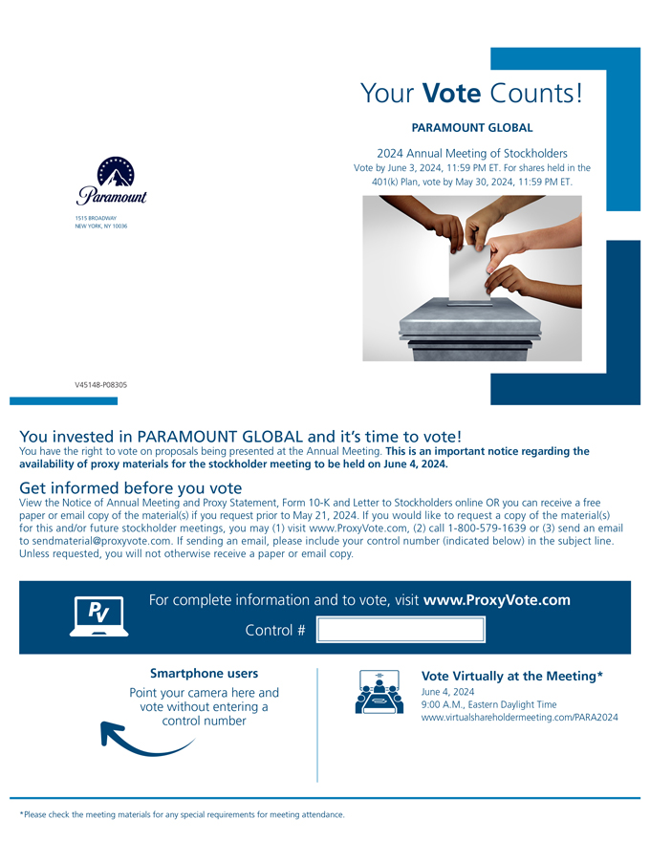
Your Vote Counts! PARAMOUNT GLOBAL 2024 Annual Meeting of Stockholders Vote by June 3, 2024, 11:59 PM ET. For shares held in the 401(k) Plan, vote by May 30, 2024, 11:59 PM ET. 1515 BROADWAY NEW YORK, NY 10036 V45148-P08305 You invested in PARAMOUNT GLOBAL and its time to vote! You have the right to vote on proposals being presented at the Annual Meeting. This is an important notice regarding the availability of proxy materials for the stockholder meeting to be held on June 4, 2024. Get informed before you vote View the Notice of Annual Meeting and Proxy Statement, Form 10-K and Letter to Stockholders online OR you can receive a free paper or email copy of the material(s) if you request prior to May 21, 2024. If you would like to request a copy of the material(s) for this and/or future stockholder meetings, you may (1) visit www.ProxyVote.com, (2) call 1-800-579-1639 or (3) send an email to sendmaterial@proxyvote.com. If sending an email, please include your control number (indicated below) in the subject line. Unless requested, you will not otherwise receive a paper or email copy. For complete information and to vote, visit www.ProxyVote.com Control # Smartphone users Point your camera here and vote without entering a control number Vote Virtually at the Meeting* June 4, 2024 9:00 A.M., Eastern Daylight Time www.virtualshareholdermeeting.com/PARA2024 *Please check the meeting materials for any special requirements for meeting attendance.

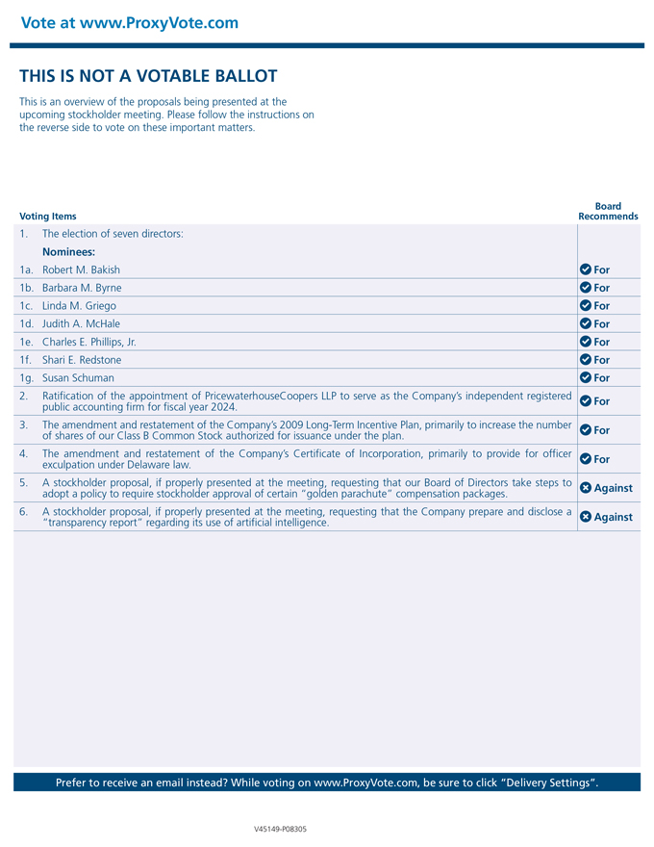
Vote at www.ProxyVote.com THIS IS NOT A VOTABLE BALLOT This is an overview of the proposals being presented at the upcoming stockholder meeting. Please follow the instructions on the reverse side to vote on these important matters. Voting Items 1. The election of seven directors: Nominees: 1a. Robert M. Bakish 1b. Barbara M. Byrne 1c. Linda M. Griego 1d. Judith A. McHale 1e. Charles E. Phillips, Jr. 1f. Shari E. Redstone 1g. Susan Schuman 2. Ratification of the appointment of PricewaterhouseCoopers LLP to serve as the Companys independent registered public accounting firm for fiscal year 2024. 3. The amendment and restatement of the Companys 2009 Long-Term Incentive Plan, primarily to increase the number of shares of our Class B Common Stock authorized for issuance under the plan. 4. The amendment and restatement of the Companys Certificate of Incorporation, primarily to provide for officer exculpation under Delaware law. 5. A stockholder proposal, if properly presented at the meeting, requesting that our Board of Directors take steps to adopt a policy to require stockholder approval of certain golden parachute compensation packages. 6. A stockholder proposal, if properly presented at the meeting, requesting that the Company prepare and disclose a transparency report regarding its use of artificial intelligence. Board Recommends For For For For For For For For For For Against Against Prefer to receive an email instead? While voting on www.ProxyVote.com, be sure to click Delivery Settings. V45149-P08305

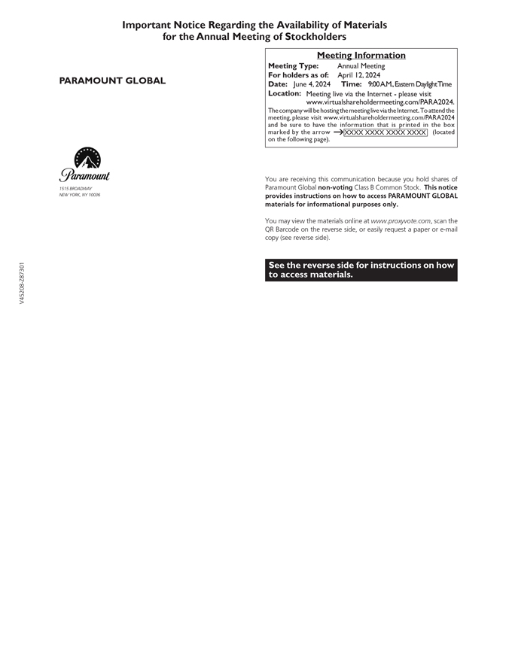
Important Notice Regarding the Availability of Materials for the Annual Meeting of Stockholders PARAMOUNT GLOBAL 1515 BROADWAY NEW YORK, NY 10036 Meeting Information Meeting Type: Annual Meeting For holders as of: April 12, 2024 Date: June 4, 2024 Time: 9:00A.M.,Eastern DaylightTime Location: Meeting live via the Internet - please visit www.virtualshareholdermeeting.com/PARA2024. The company will be hosting the meeting live via the Internet. To attend the meeting, please visit www.virtualshareholdermeeting.com/PARA2024 and be sure to have the information that is printed in the box marked by the arrow ?XXXX XXXX XXXX XXXX (located on the following page). You are receiving this communication because you hold shares of Paramount Global non-voting Class B Common Stock. This notice provides instructions on how to access PARAMOUNT GLOBAL materials for informational purposes only. You may view the materials online at www.proxyvote.com, scan the QR Barcode on the reverse side, or easily request a paper or e-mail copy (see reverse side). See the reverse side for instructions on how to access materials. V45208-Z87301

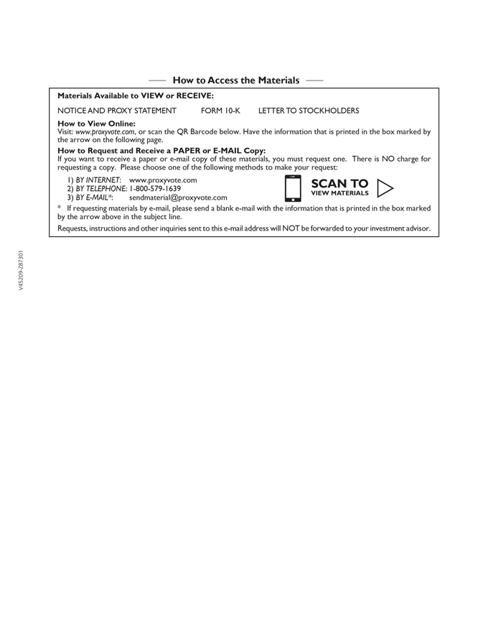
How to Access the Materials Materials Available to VIEW or RECEIVE: NOTICE AND PROXY STATEMENT FORM 10-K LETTER TO STOCKHOLDERS How to View Online: Visit: www.proxyvote.com, or scan the QR Barcode below. Have the information that is printed in the box marked by the arrow on the following page. How to Request and Receive a PAPER or E-MAIL Copy: If you want to receive a paper or e-mail copy of these materials, you must request one. There is NO charge for requesting a copy. Please choose one of the following methods to make your request: 1) BY INTERNET: www.proxyvote.com 2) BY TELEPHONE: 1-800-579-1639 3) BY E-MAIL*: sendmaterial@proxyvote.com SCAN TO VIEW MATERIALS w * If requesting materials by e-mail, please send a blank e-mail with the information that is printed in the box marked by the arrow above in the subject line. Requests, instructions and other inquiries sent to this e-mail address will NOT be forwarded to your investment advisor. V45209-Z87301

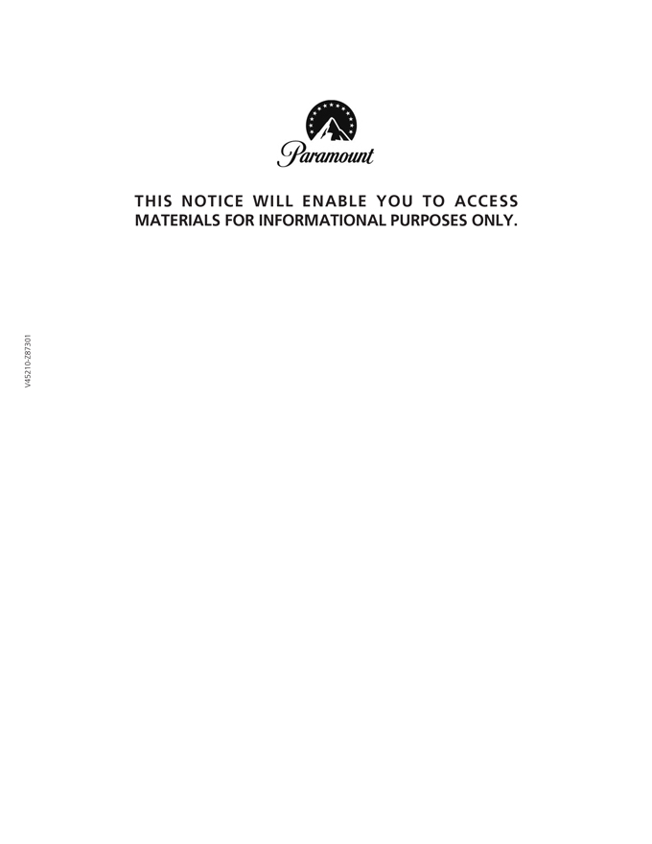
THIS NOTICE WILL ENABLE YOU TO ACCESS MATERIALS FOR INFORMATIONAL PURPOSES ONLY. V45210-Z87301


THIS PAGE WAS INTENTIONALLY LEFT BLANK. V45211-Z87301

