UNITED STATES

SECURITIES AND EXCHANGE COMMISSION
Washington, D.C. 20549

FORM 8-K

CURRENT REPORT

Pursuant to Section 13 or 15(d)
of the Securities Exchange Act of 1934

Date of Report (Date of earliest event reported): February 15, 2022

VIACOMCBS INC.

(Exact name of registrant as specified in its charter)

Delaware

001-09553

04-2949533

(State or other jurisdiction
of incorporation)

(Commission

File Number)

(IRS Employer
IdentificationNumber)

1515 Broadway

New York, New York

10036

(Address of principal executive offices)

(Zip Code)

Registrant’s telephone number, including area code: (212) 258-6000

Not Applicable

(Former name or former address, if changed since last report)

Check the appropriate box below if the Form 8-K filing is intended to simultaneously satisfy the filing obligation of the registrant under any of the following provisions:

- Written communications pursuant to Rule 425 under the Securities Act (17 CFR 230.425)

- Soliciting material pursuant to Rule 14a-12 under the Exchange Act (17 CFR 240.14a-12)

- Pre-commencement communications pursuant to Rule 14d-2(b) under the Exchange Act (17 CFR 240.14d-2(b))

- Pre-commencement communications pursuant to Rule 13e-4(c) under the Exchange Act (17 CFR 240.13e-4(c))

Securities registered pursuant to Section 12(b) of the Act:

Title of each class |  | Trading |  | Name of each exchange
 |  | Symbols |  | on which registered
Class A Common Stock, $0.001 par value |  | VIACA |  | The Nasdaq Stock Market LLC
Class B Common Stock, $0.001 par value |  | VIAC |  | The Nasdaq Stock Market LLC
5.75% Series A Mandatory Convertible |  | VIACP |  | The Nasdaq Stock Market LLC
Preferred Stock, $0.001 par value

Indicate by check mark whether the registrant is an emerging growth company as defined in Rule 405 of the Securities Act of 1933 (§230.405 of this chapter) or Rule 12b-2 of the Securities Exchange Act of 1934 (§240.12b-2 of this chapter).

Emerging growth company ☐

If an emerging growth company, indicate by check mark if the registrant has elected not to use the extended transition period for complying with any new or revised financial accounting standards provided pursuant to Section 13(a) of the Exchange Act. ☐

Item 2.02 Results of Operations and Financial Condition.

On February 15, 2022, ViacomCBS Inc. (the “Company”) issued a press release announcing earnings for the fourth quarter and year ended December 31, 2021. A copy of the press release is furnished herewith as Exhibit 99.1 and is incorporated by reference herein.

The information furnished pursuant to this Item 2.02, including Exhibit 99.1, shall not be deemed “filed” for purposes of Section 18 of the Securities Exchange Act of 1934, as amended (the “Exchange Act”), or otherwise subject to the liabilities under that Section and shall not be deemed to be incorporated by reference into any filing under the Securities Act of 1933, as amended (the “Securities Act”), or the Exchange Act.

Item 7.01 Regulation FD Disclosure.

Beginning in 2022, primarily as a result of the Company’s increased strategic focus on its direct-to-consumer businesses, the Company made certain changes to how it manages its businesses and allocates resources that resulted in a change to its operating segments.

The Company is providing supplemental unaudited historical financial information under the new segment presentation for the years ended December 31, 2021 and 2020, and for each quarter of the year ended December 31, 2021. The Company did not operate under this new segment structure for any of these prior periods and will begin to report results under the new segment structure with its Quarterly Report on Form 10-Q for the three months ended March 31, 2022. This supplemental information, which is incorporated by reference herein, is being furnished as Exhibit 99.2 to allow investors an opportunity to review prior period performance on a comparable basis in advance of the Form 10-Q filing.

The information furnished pursuant to this Item 7.01, including Exhibit 99.2, shall not be deemed “filed” for purposes of Section 18 of the Exchange Act or otherwise subject to the liabilities under that Section and shall not be deemed to be incorporated by reference into any filing under the Securities Act or the Exchange Act.

Item 9.01 Financial Statements and Exhibits.

(d) Exhibits.

Exhibit |  |  |  | Description of Exhibit
Number
99.1 |  | Press release of ViacomCBS Inc., dated February 15, 2022, announcing earnings for the fourth quarter and year ended December 31,
 | 2021.
99.2 |  | Supplemental unaudited historical financial information for the years ended December 31, 2021 and 2020, and for each quarter of the year
 |  | ended December 31, 2021, recast under new segment presentation.
104 |  | Cover Page Interactive Data File (embedded within the Inline XBRL document).

SIGNATURE

Pursuant to the requirements of the Securities Exchange Act of 1934, as amended, the registrant has duly caused this report to be signed on its behalf by the undersigned hereunto duly authorized.

VIACOMCBS INC.

By: /s/ Christa A. D’Alimonte

Name: Christa A. D’Alimonte

Title: Executive Vice President,

General Counsel and Secretary

Date: February 15, 2022

Exhibit 99.1
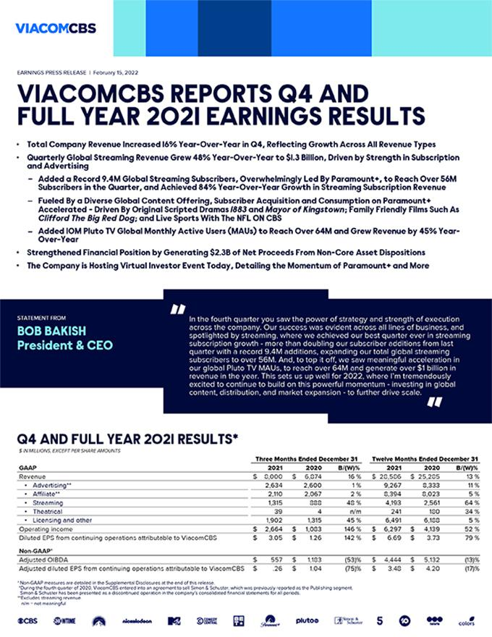

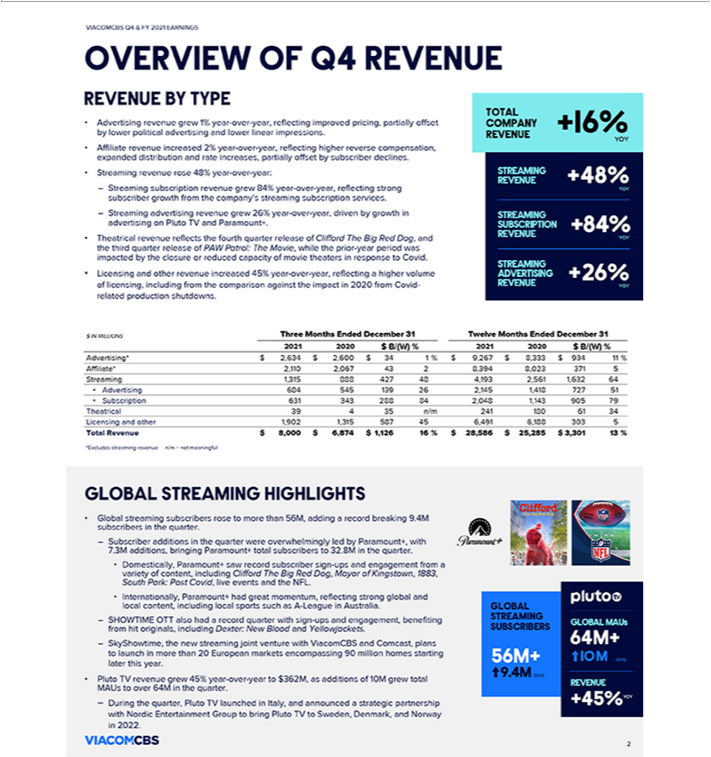

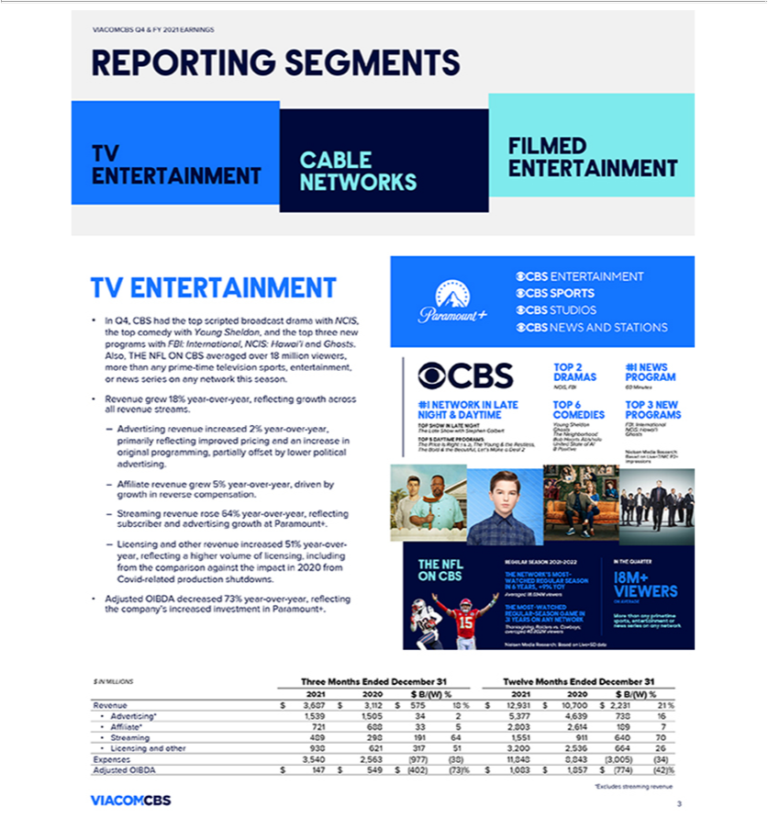

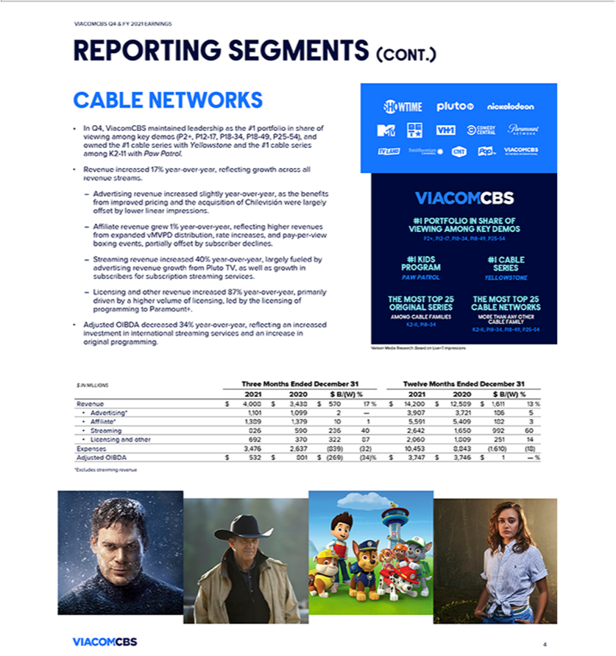

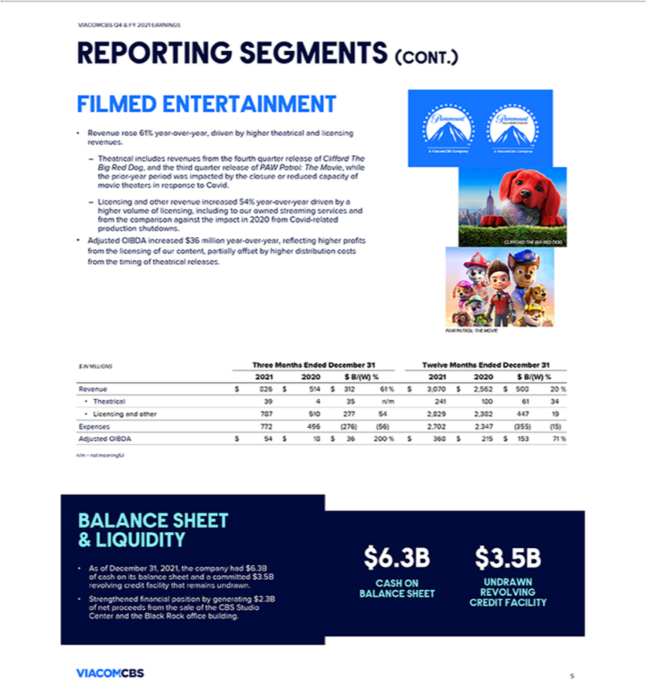





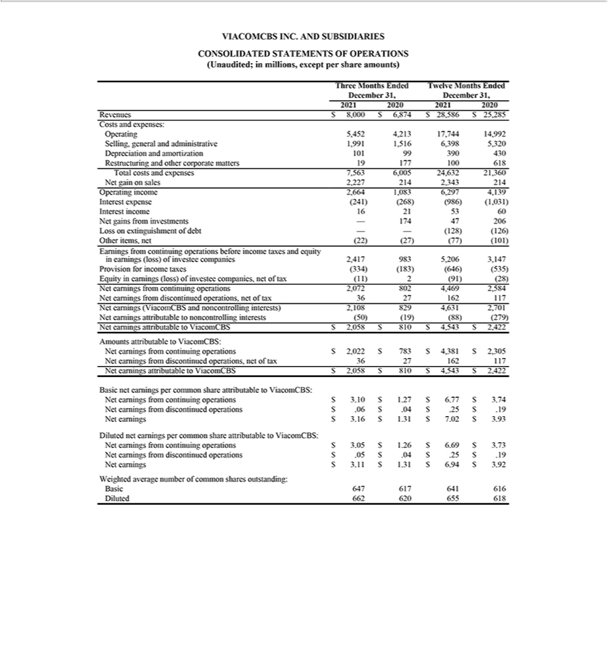

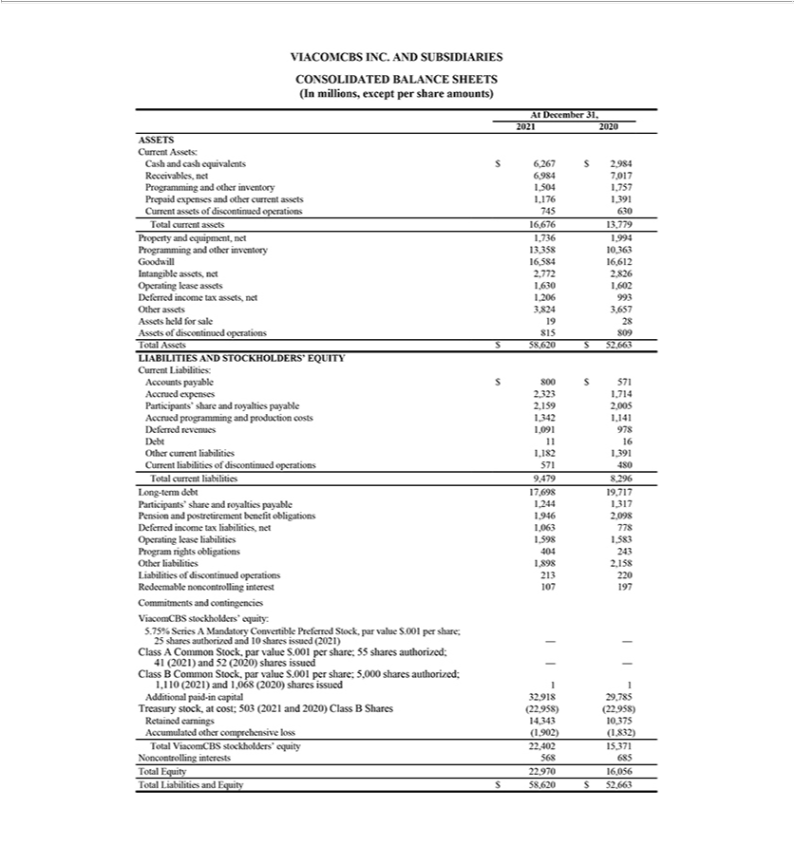

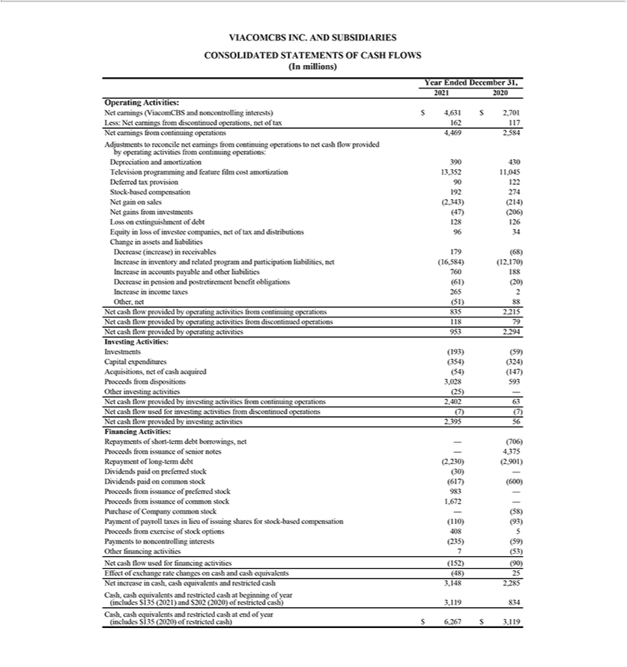

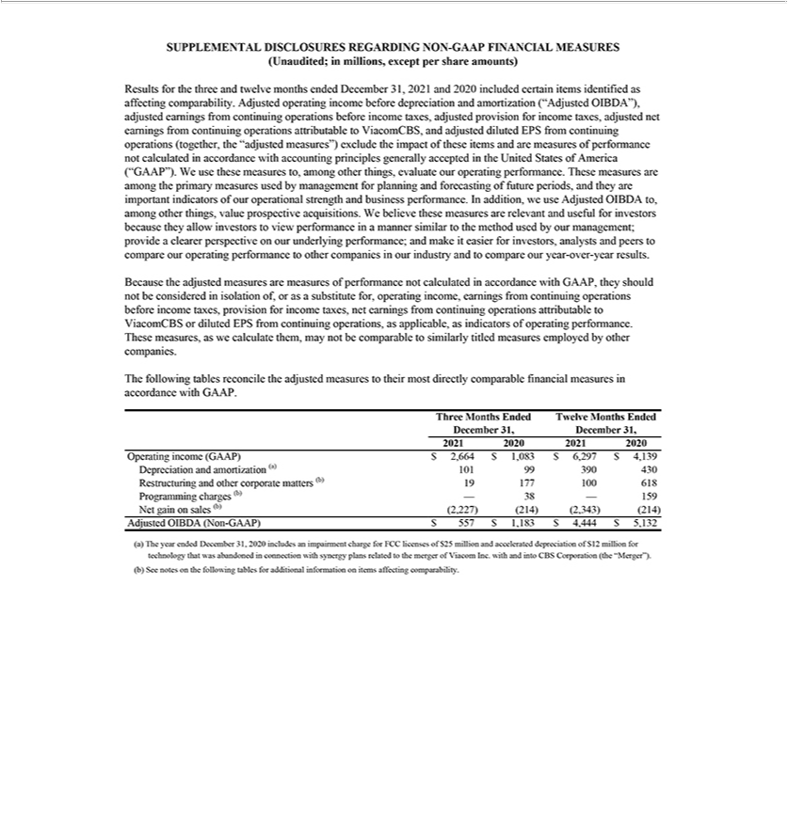

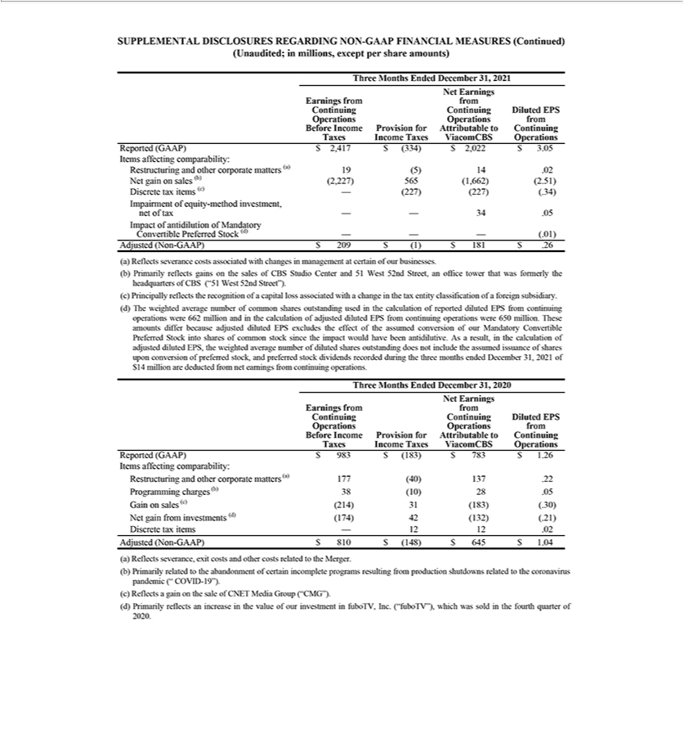

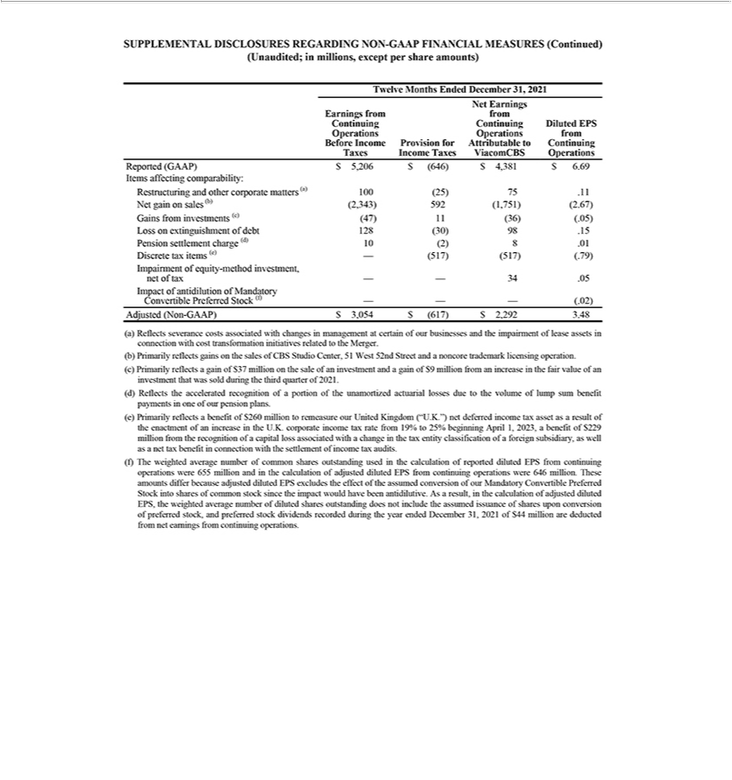

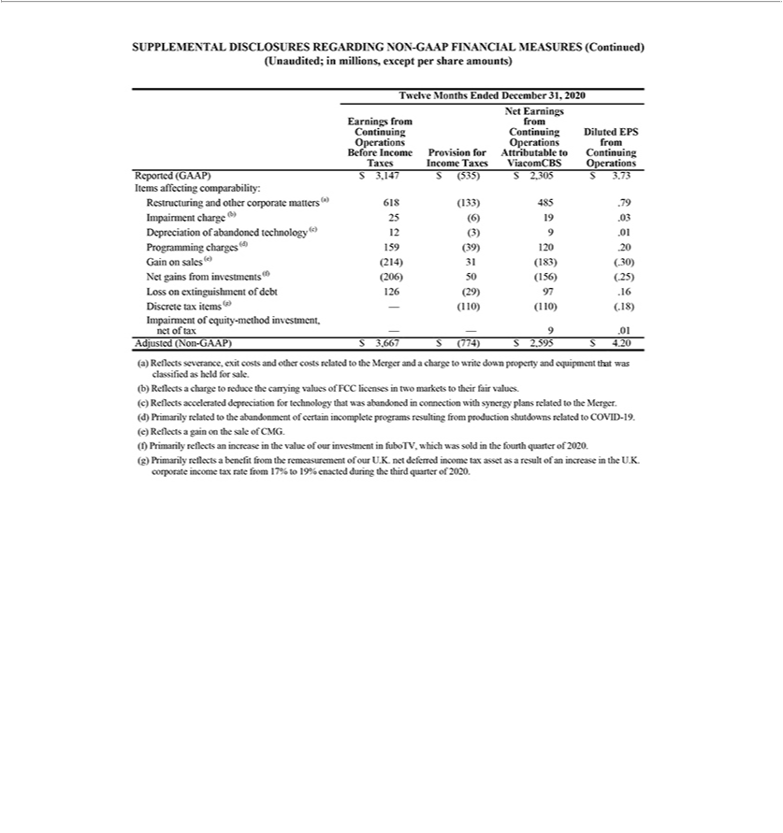

Exhibit 99.2

Beginning in 2022, primarily as a result of our increased strategic focus on our direct-to-consumer businesses, we made certain changes to how we manage our businesses and allocate resources that resulted in the changes described below. Prior period results have been recast to conform to these presentation changes. References to “ViacomCBS,” the “Company,” “we,” “us” and “our” refer to ViacomCBS Inc. and its consolidated subsidiaries, unless the context otherwise requires.

Management Structure Change

Our management structure has been reorganized to focus on managing our business as the combination of three parts: a traditional media business, a portfolio of global direct-to-consumer streaming services, and a film studio. As a result, we realigned our operating segments, which through the fourth quarter of 2021 were TV Entertainment, Cable Networks and Filmed Entertainment, into the following three segments:

TV Media – Our TV Media segment consists of our domestic and international broadcast networks, including the CBS Television Network, Network 10, Channel 5 and Telefe; our premium and basic cable networks, including Showtime, BET, Nickelodeon, MTV, Comedy Central, Paramount Network, Smithsonian Channel, international extensions of these brands, and CBS Sports Network; our television production operations, including CBS Studios, Paramount Television Studios and CBS Media Ventures, which primarily produces or distributes first-run syndicated programming; and our owned broadcast television stations, CBS Stations.

Direct-to-Consumer – Our Direct-to-Consumer segment consists of our portfolio of pay, free and premium worldwide direct-to-consumer streaming services, including Paramount+, Pluto TV, Showtime Networks’ premium subscription streaming service (Showtime OTT), BET+ and Noggin.

Filmed Entertainment – Our Filmed Entertainment segment consists of Paramount Pictures, Paramount Players, Paramount Animation, the Nickelodeon Studio, and Miramax.

Revenue Disaggregation Categories

In the first quarter of 2022, we began disaggregating our revenues into the following four categories: Advertising, Affiliate and Subscription, Theatrical, and Licensing and Other. Previously, our revenue disaggregation categories were Advertising, Affiliate, Streaming (consisting of streaming advertising and streaming subscription), Theatrical, and Licensing and Other. Under the new disaggregation, revenue earned from advertisements on and subscriptions to our direct-to-consumer streaming services is included in our Direct-to-Consumer segment within advertising revenues and subscription revenues, respectively. Advertising from digital video advertisements on our websites and in our video content on third-party platforms as well as premium subscriptions to access certain video content on our websites is included in our TV Media segment within advertising revenues and affiliate and subscription revenues, respectively.

Intercompany License Fees

Concurrent with the change to our operating segments, we changed the way we record intersegment content licensing. Under our previous segment structure, management evaluated the results of our segments including intersegment content licensing at market value as if the sales were to third parties. Therefore, the licensor segment recorded intercompany license fee revenues and profits and the licensee segment recorded production costs in the amount of the license fee charged by the licensor, which generally reflected the cost to the Company plus a margin. The intercompany revenues and the margin embedded in the cost to the licensee were eliminated in consolidation.

Under our new segment structure, management evaluates the results of the segments using an allocation of the total cost of content (i.e. direct production costs, production overhead, participations and residuals) from the licensor segment to each licensee segment utilizing the content. As a result, content costs are allocated across the licensee segments based on the relative value of the distribution windows within each segment. The allocation is recorded by the licensor segment as a reduction of content cost and no intersegment revenues or profits are recorded.

The following tables present unaudited supplemental financial results for the years ended December 31, 2021 and 2020 and for each quarter of the year ended December 31, 2021, recast to reflect the above-mentioned presentation changes.

TRENDING SCHEDULES

Summarized Reported Results

(unaudited; in millions)

 | 12 Months |  |  |  |  | Quarter Ended |  |  |  |  |  |  | 12 Months
 |  | Ended |  |  |  |  |  |  |  |  |  |  |  | Ended
 | 12/31/20 |  |  | 3/31/21 |  | 6/30/21 |  | 9/30/21 |  | 12/31/21 |  |  | 12/31/21
Advertising | $ | 9,751 |  | $3,109 |  | $2,599 |  | $2,386 |  | $ 3,318 |  |  | $ | 11,412
Affiliate and subscription |  | 9,166 |  | 2,463 |  | 2,588 |  | 2,650 |  | 2,741 |  |  |  | 10,442
Theatrical |  | 180 |  | 1 |  | 134 |  | 67 |  | 39 |  |  |  | 241
Licensing and other |  | 6,188 |  | 1,839 |  | 1,243 |  | 1,507 |  | 1,902 |  |  |  | 6,491
Revenues | $ | 25,285 |  | $7,412 |  | $6,564 |  | $6,610 |  | $ 8,000 |  | $ |  | 28,586

TRENDING SCHEDULES

TV Media Financial Results

(unaudited; in millions)

 | 12 Months |  |  |  |  | Quarter Ended |  |  |  |  |  |  | 12 Months
 |  | Ended |  |  |  |  |  |  |  |  |  |  |  | Ended
 | 12/31/20 |  |  | 3/31/21 |  | 6/30/21 |  | 9/30/21 |  | 12/31/21 |  |  | 12/31/21
Advertising | $ | 9,062 |  | $2,888 |  | $2,303 |  | $2,039 |  | $ 2,875 |  |  | $ | 10,105
Affiliate and subscription |  | 8,037 |  | 2,083 |  | 2,112 |  | 2,108 |  | 2,110 |  |  |  | 8,413
Licensing and other |  | 4,021 |  | 1,022 |  | 804 |  | 1,073 |  | 1,317 |  |  |  | 4,216
Revenues | $ | 21,120 |  | $5,993 |  | $5,219 |  | $5,220 |  | $ 6,302 |  |  | $ | 22,734
Adjusted OIBDA | $ | 5,816 |  | $1,765 |  | $1,504 |  | $1,385 |  | $ 1,238 |  | $ |  | 5,892

TRENDING SCHEDULES

Direct-to-Consumer Financial Results

(unaudited; in millions)

 |  | 12 Months |  |  |  |  |  |  |  |  | Quarter Ended |  |  |  |  |  |  |  |  |  | 12 Months
 |  |  | Ended |  |  |  |  |  |  |  |  |  |  |  |  |  |  |  |  |  |  | Ended
 |  | 12/31/20 |  |  |  | 3/31/21 |  |  | 6/30/21 |  |  |  | 9/30/21 |  |  | 12/31/21 |  |  |  |  | 12/31/21
Advertising |  | $ | 686 |  |  | $ | 218 |  |  | $ | 291 |  | $ | 348 |  |  | $ | 441 |  |  | $ | 1,298
Subscription |  |  | 1,129 |  |  |  | 380 |  |  |  | 476 |  |  | 542 |  |  |  | 631 |  |  |  | 2,029
Revenues | $ |  | 1,815 |  |  | $ | 598 |  | $ |  | 767 |  | $ | 890 |  | $ |  | 1,072 |  | $ |  | 3,327
Adjusted OIBDA
Adjusted OIBDA |  | $ | (171 | ) |  | $ | (149 | ) |  | $ | (143 | ) | $ | (198 | ) |  | $ | (502 | ) |  | $ | (992 | )

TRENDING SCHEDULES

Filmed Entertainment Financial Results

(unaudited; in millions)

 |  | 12 Months |  |  |  |  |  |  |  |  | Quarter Ended |  |  |  |  |  |  |  |  |  | 12 Months
 |  |  | Ended |  |  |  |  |  |  |  |  |  |  |  |  |  |  |  |  |  |  | Ended
 |  | 12/31/20 |  |  |  | 3/31/21 |  |  | 6/30/21 |  |  |  | 9/30/21 |  |  |  | 12/31/21 |  |  |  | 12/31/21
Advertising |  | $ | 18 |  |  | $ | 6 |  |  | $ | 6 |  |  | $ | 2 |  | $ | 4 |  |  | $ | 18
Theatrical |  |  | 180 |  |  |  | 1 |  |  |  | 134 |  |  |  | 67 |  |  | 39 |  |  |  | 241
Licensing and other |  |  | 2,272 |  |  |  | 853 |  |  |  | 463 |  |  |  | 461 |  |  | 651 |  |  |  | 2,428
Revenues |  | $ | 2,470 |  |  | $ | 860 |  |  | $ | 603 |  |  | $ | 530 |  | $ | 694 |  |  | $ | 2,687
Adjusted OIBDA | $ |  | 158 |  | $ |  | 179 |  | $ |  | 52 |  | $ |  | (24) |  | $ | — |  | $ |  | 207

TRENDING SCHEDULES

Reconciliation of Adjusted OIBDA (Non-GAAP)

(unaudited; in millions)

 |  | 12 Months |  |  |  |  |  | Quarter Ended |  |  |  |  |  |  |  |  | 12 Months
 |  |  | Ended |  |  |  |  |  |  |  |  |  |  |  |  |  |  | Ended
 |  | 12/31/20 |  |  | 3/31/21 |  | 6/30/21 |  |  | 9/30/21 |  |  | 12/31/21 |  |  |  | 12/31/21
TV Media |  | $ | 5,816 |  | $1,765 |  |  | $1,504 |  | $ | 1,385 |  |  | $ 1,238 |  |  | $ | 5,892
Direct-to-Consumer |  |  | (171) |  | (149) |  | (143) |  |  |  | (198) |  | (502) |  |  |  |  | (992)
Filmed Entertainment |  |  | 158 |  | 179 |  | 52 |  |  |  | (24) |  |  | — |  |  |  | 207
Corporate/Eliminations |  |  | (485) |  | (116) |  | (124) |  |  |  | (111) |  | (140) |  |  |  |  | (491)
Stock-based compensation |  |  | (186) |  | (52) |  | (49) |  |  |  | (32) |  | (39) |  |  |  |  | (172)
Adjusted OIBDA |  |  | 5,132 |  | 1,627 |  |  | 1,240 |  |  | 1,020 |  |  | 557 |  |  |  | 4,444
Depreciation and amortization (1) |  |  | (430) |  | (99) |  | (95) |  |  |  | (95) |  | (101) |  |  |  |  | (390)
Restructuring and other corporate matters (2) |  |  | (618) |  | — |  | (35) |  |  |  | (46) |  | (19) |  |  |  |  | (100)
Programming charges (3) |  |  | (159) |  | — |  |  | — |  |  | — |  |  | — |  |  |  | —
Net gain on sales (4) |  |  | 214 |  | — |  |  | 116 |  |  | — |  | 2,227 |  |  |  |  | 2,343
Operating income |  | $ | 4,139 |  | $1,528 |  | $1,226 |  |  | $ | 879 |  | $ 2,664 |  |  | $ |  | 6,297

- For 2020, Depreciation and amortization includes an impairment charge of $25 million to reduce the carrying value of intangible assets and accelerated depreciation of $12 million for abandoned technology in connection with synergy plans related to the merger of Viacom Inc. with and into CBS Corporation.

- Primarily reflects severance and exit costs relating to restructuring activities as well as costs associated with other corporate matters.

- Charges primarily relate to the abandonment of certain incomplete programs resulting from production shutdowns relating to the coronavirus pandemic (COVID-19).
- The fourth quarter of 2021 primarily reflects gains on the sales of CBS Studio Center and 51 West 52nd Street, an office tower that was formerly the headquarters of CBS. The second quarter of 2021 primarily reflects a gain on the sale of a noncore trademark licensing operation. 2020 reflects a gain on the sale of CNET Media Group.

TRENDING SCHEDULES

Direct-to-Consumer Streaming Subscribers and Monthly Active Users (1)

(unaudited; in millions)

 |  |  | 12 Months |  |  |  |  | Quarter Ended |  |  |  |  |  |  |  | 12 Months
 |  |  |  | Ended |  |  |  |  |  |  |  |  |  |  |  |  | Ended
 |  |  | 12/31/20 |  |  | 3/31/21 |  | 6/30/21 |  | 9/30/21 |  | 12/31/21 |  |  |  | 12/31/21
Paramount+ (Global)
Subscribers |  |  |  | 11.7 |  | 16.5 |  | 21.4 |  | 25.5 |  |  | 32.8 |  |  |  | 32.8
Revenues |  |  | $ | 627 |  | $ 236 |  | $ 305 |  | $ 363 |  | $ | 443 |  | $ |  | 1,347
Pluto TV (Global)
MAUs |  |  |  | 43.1 |  | 49.5 |  | 52.3 |  | 54.4 |  |  | 64.4 |  |  |  | 64.4
Revenues |  |  | $ | 562 |  | $ 167 |  | $ 241 |  | $ 289 |  | $ | 362 |  | $ |  | 1,059
Global Direct-to-Consumer Streaming Subscribers (2) |  |  |  | 29.9 |  | 35.9 |  | 42.4 |  | 46.7 |  |  | 56.1 |  |  |  | 56.1

- Direct-to-consumer streaming subscribers include customers with access to our domestic or international direct-to-consumer services, either directly through our owned and operated apps and websites, or through third-party distributors. Our subscribers include paid subscriptions and those customers registered in a free trial, and subscribers are considered unique to each of our services, whether offered individually or as part of a bundle. The Monthly Active Users (“MAUs”) count reflects the number of unique devices interacting with the Pluto TV service in a calendar month, and for the periods above reflects the MAU count for the last month of the applicable period.

- Includes subscribers for Paramount+, Showtime OTT and all other direct-to-consumer subscription streaming services.

