UNITED STATES

SECURITIES AND EXCHANGE COMMISSION

Washington, DC 20549

SCHEDULE 14A

PROXY STATEMENT PURSUANT TO SECTION 14(a) OF THE SECURITIES EXCHANGE ACT OF 1934 (Amendment No. )

Filed by the Registrant ☐ Filed by a party other than the Registrant ☒

Check the appropriate box:

- Preliminary Proxy Statement

- Confidential, for Use of the Commission Only (as permitted by Rule 14a-6(e)(2))

- Definitive Proxy Statement

- Definitive Additional Materials

- Soliciting Material under §240.14a-12

Warner Bros. Discovery, Inc.

(Name of Registrant as Specified In Its Charter)

Paramount Skydance Corporation

(Name of Person(s) Filing Proxy Statement, if other than the Registrant)

Payment of Filing Fee (Check all boxes that apply):

- No fee required

- Fee paid previously with preliminary materials

- Fee computed on table in exhibit required by Item 25(b) per Exchange Act Rules 14a-6(i)(1) and 0-11

Filed by Paramount Skydance Corporation

Pursuant to Rule 14a-12 under the

Securities and Exchange Act of 1934, as amended

Subject Company: Warner Bros. Discovery, Inc.

Commission File No.: 001-34177

Date: January 9, 2026

The following is a Fortune article posted by Paramount Skydance Corporation to www.StrongerHollywood.com on January 9, 2026.
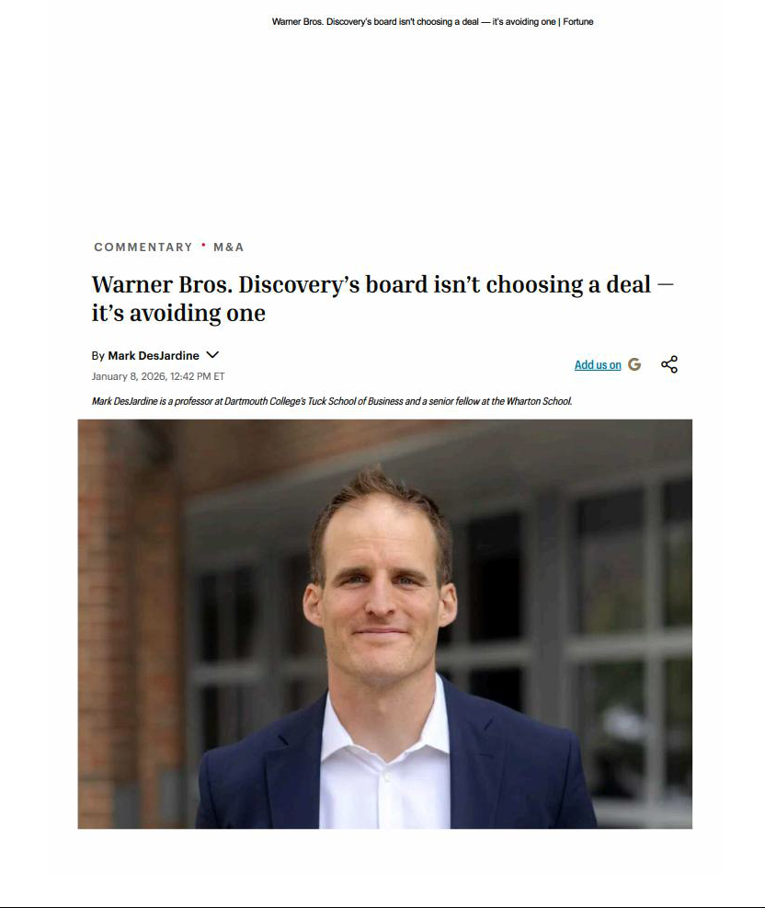

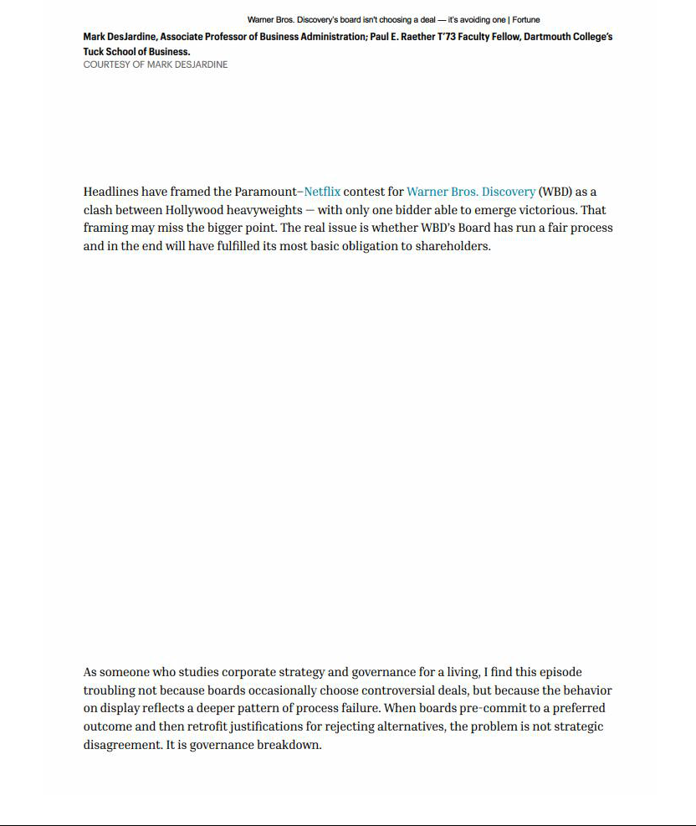

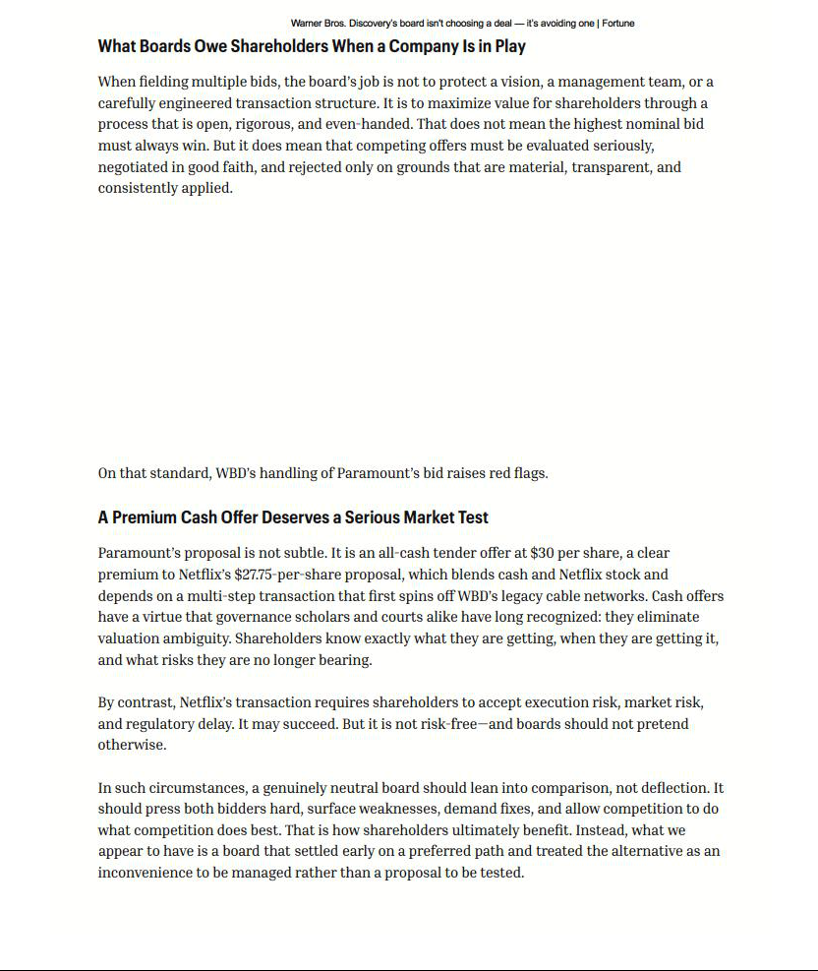

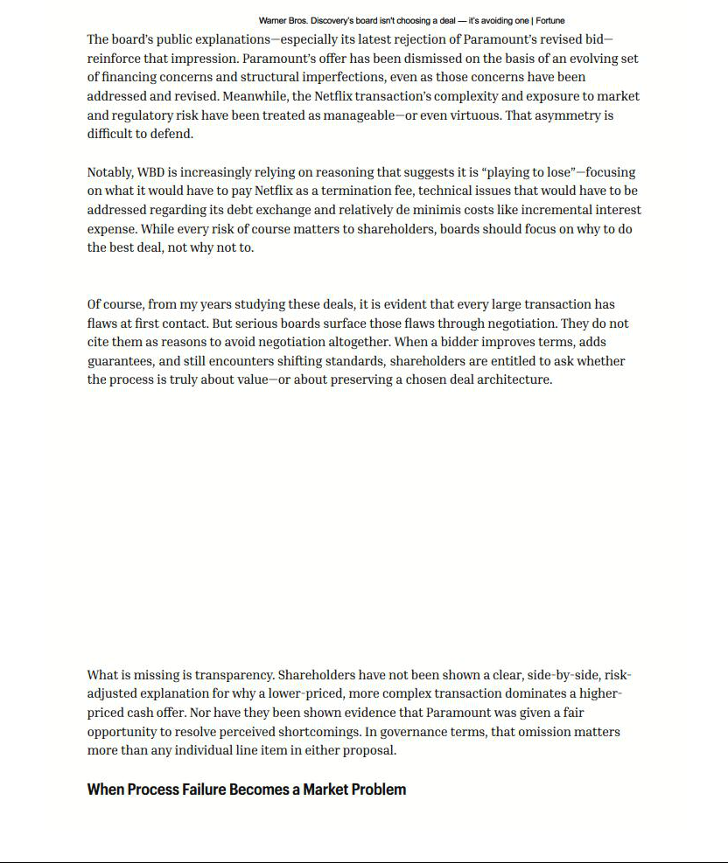

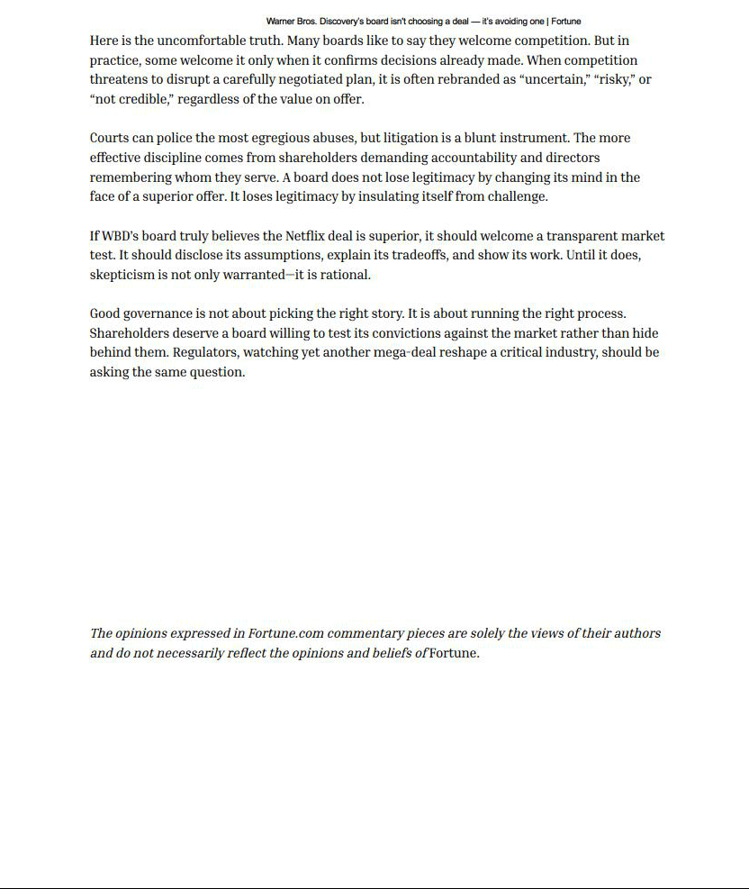

Cautionary Note Regarding Forward-Looking Statements

This communication contains both historical and forward-looking statements, including statements related to Paramount Skydance Corporation’s (“Paramount”) future financial results and performance, potential achievements, anticipated reporting segments and industry changes and developments. All statements that are not statements of historical fact are, or may be deemed to be, “forward-looking statements”. Similarly, statements that describe Paramount’s objectives, plans or goals are or may be forward-looking statements. These forward-looking statements reflect Paramount’s current expectations concerning future results and events; generally can be identified by the use of statements that include phrases such as “believe,” “expect,” “anticipate,” “intend,” “plan,” “foresee,” “likely,” “will,” “may,” “could,” “estimate” or other similar words or phrases; and involve known and unknown risks, uncertainties and other factors that are difficult to predict and which may cause Paramount’s actual results, performance or achievements to be different from any future results, performance or achievements expressed or implied by these statements. These risks, uncertainties and other factors include, among others: the outcome of the tender offer by Paramount and Prince Sub Inc. (the “Tender Offer”) to purchase for cash all of the outstanding Series A common stock of Warner Bros. Discovery, Inc. (“WBD”) or any discussions between Paramount and WBD with respect to a possible transaction (including, without limitation, by means of the Tender Offer, the “Potential Transaction”), including the possibility that the Tender Offer will not be successful, that the parties will not agree to pursue a business combination transaction or that the terms of any such transaction will be materially different from those described herein, the conditions to the completion of the Potential Transaction or the previously announced transaction between Warner Bros. and Netflix, Inc. (“Netflix”) pursuant to the Agreement and Plan of Merger, dated December 4, 2025, among Netflix, Nightingale Sub, Inc., WBD and New Topco 25, Inc. (the “Proposed Netflix Transaction”), including the receipt of any required stockholder and regulatory approvals for either transaction, the proposed financing for the Potential Transaction, the indebtedness Paramount expects to incur in connection with the Potential Transaction and the total indebtedness of the combined companies, the possibility that Paramount may be unable to achieve expected synergies and operating efficiencies within the expected timeframes or at all and to successfully integrate the operations of WBD with those of Paramount, and the possibility that such integration may be more difficult, time-consuming or costly than expected or that operating costs and business disruption (including, without limitation, disruptions in relationships with employees, customers or suppliers) may be greater than expected in connection with the Potential Transaction; risks related to Paramount’s streaming business; the adverse impact on Paramount’s advertising revenues as a result of changes in consumer behavior, advertising market conditions and deficiencies in audience measurement; risks related to operating in highly competitive and dynamic industries, including cost increases; the unpredictable nature of consumer behavior, as well as evolving technologies and distribution models; risks related to Paramount’s decisions to make investments in new businesses, products, services and technologies, and the evolution of Paramount’s business strategy; the potential for loss of carriage or other reduction in or the impact of negotiations for the distribution of Paramount’s content; damage to Paramount’s reputation or brands; losses due to asset impairment charges for goodwill, intangible assets, FCC licenses and content; liabilities related to discontinued operations and former businesses; increasing scrutiny of, and evolving expectations for, sustainability initiatives; evolving business continuity, cybersecurity, privacy and data protection and similar risks; content infringement; domestic and global political, economic and regulatory factors affecting Paramount’s businesses generally, including tariffs and other changes in trade policies; the inability to hire or retain key employees or secure creative talent; disruptions to Paramount’s operations as a result of labor disputes; the risks and costs associated with the integration of, and Paramount’s ability to integrate, the businesses of Paramount Global and Skydance Media, LLC successfully and to achieve anticipated synergies; volatility in the prices of Paramount’s Class B Common Stock; potential conflicts of interest arising from Paramount’s ownership structure with a controlling stockholder; and other factors described in Paramount’s news releases and filings with the Securities and Exchange Commission (the “SEC”), including but not limited to Paramount’s most recent Annual Report on Form 10-K and Paramount’s reports on Form 10-Q and Form 8-K. There may be additional risks, uncertainties and factors that Paramount does not currently view as material or that are not necessarily known. The forward-looking statements included in this communication are made only as of the date of this report, and Paramount does not undertake any obligation to publicly update any forward-looking statements to reflect subsequent events or circumstances.

Additional Information

This communication does not constitute an offer to buy or a solicitation of an offer to sell securities. This communication relates to a proposal that Paramount has made for an acquisition of WBD and the Tender Offer that Paramount, through Prince Sub Inc., its wholly owned subsidiary, has made to WBD stockholders. The Tender Offer is being made pursuant to a tender offer statement on Schedule TO (including the offer to purchase, the letter of transmittal and other related offer documents), filed with the SEC on December 8, 2025. These materials, as may be amended from time to time, contain important information, including the terms and conditions of the offer. Subject to future developments, Paramount (and, if a negotiated transaction is agreed, WBD) may file additional documents with the SEC. This communication is not a substitute for any proxy statement, tender offer statement, or other document Paramount and/or WBD may file with the SEC in connection with the proposed transaction.

Investors and security holders of WBD are urged to read the tender offer statement(s) (including the offer to purchase, the letter of transmittal and other related offer documents), and any other documents filed with the SEC carefully in their entirety if and when they become available as they will contain important information about the proposed transaction. Any definitive proxy statement(s) (if and when available) will be mailed to stockholders of WBD. Investors and security holders will be able to obtain free copies of these documents (if and when available) and other documents filed with the SEC by Paramount through the website maintained by the SEC at http://www.sec.gov.

This communication is neither a solicitation of a proxy nor a substitute for any proxy statement or other filings that may be made with the SEC. Nonetheless, Paramount and its directors and executive officers and other members of management and employees may be deemed to be participants in the solicitation of proxies against the Proposed Netflix Transaction. You can find information about Paramount’s executive officers and directors in Paramount’s Current Reports on Form 8-K filed with the SEC on August 7, 2025, and September 16, 2025, and Paramount’s Quarterly Report on Form 10-Q filed with the SEC on November 10, 2025. Additional information regarding the interests of such potential participants will be included in one or more proxy statements or other documents filed with the SEC if and when they become available. These documents (if and when available) may be obtained free of charge from the SEC’s website at http://www.sec.gov.

