UNITED STATES

SECURITIES AND EXCHANGE COMMISSION

Washington, DC 20549

SCHEDULE 14A

PROXY STATEMENT PURSUANT TO SECTION 14(a) OF THE SECURITIES EXCHANGE ACT OF 1934 (Amendment No. )

Filed by the Registrant ☐ Filed by a party other than the Registrant ☒

Check the appropriate box:

- Preliminary Proxy Statement

- Confidential, for Use of the Commission Only (as permitted by Rule 14a-6(e)(2))

- Definitive Proxy Statement

- Definitive Additional Materials

- Soliciting Material under §240.14a-12

Warner Bros. Discovery, Inc.

(Name of Registrant as Specified In Its Charter)

Paramount Skydance Corporation

(Name of Person(s) Filing Proxy Statement, if other than the Registrant)

Payment of Filing Fee (Check all boxes that apply):

- No fee required

- Fee paid previously with preliminary materials

- Fee computed on table in exhibit required by Item 25(b) per Exchange Act Rules 14a-6(i)(1) and 0-11

Filed by Paramount Skydance Corporation

Pursuant to Rule 14a-12 under the

Securities and Exchange Act of 1934, as amended

Subject Company: Warner Bros. Discovery, Inc.

Commission File No.: 001-34177

Date: March 2, 2026

The following is a transcript of an investor presentation from Paramount Skydance Corporation presented on March 2, 2026
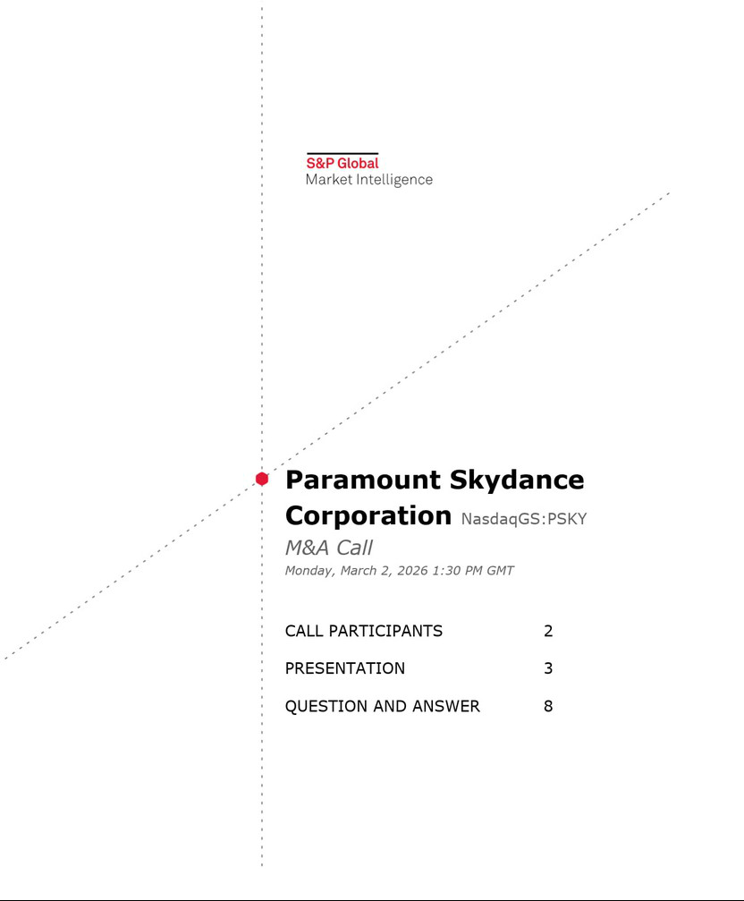

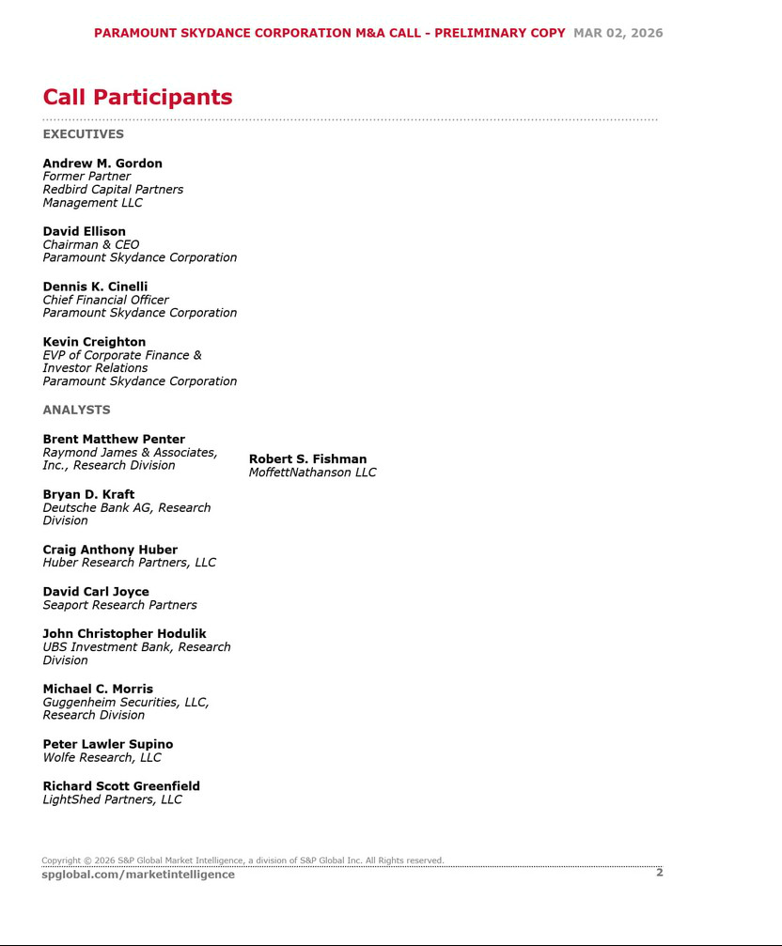

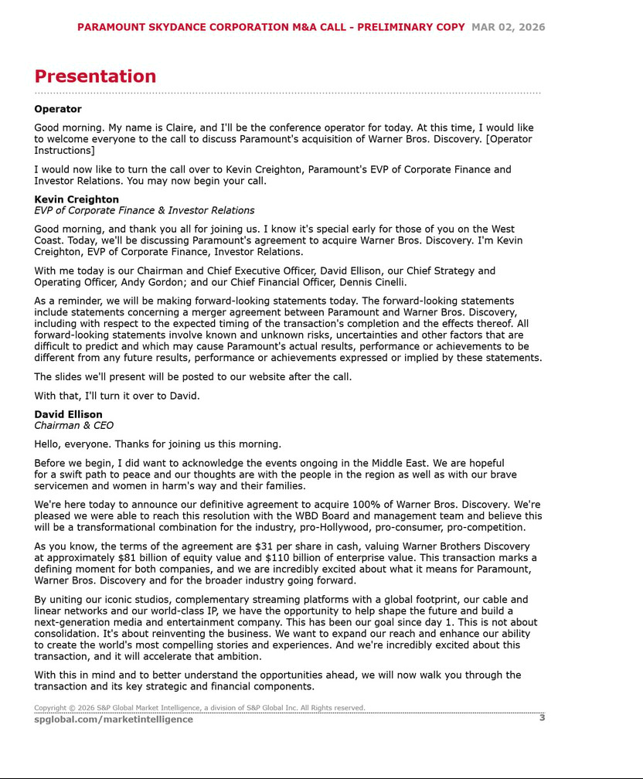

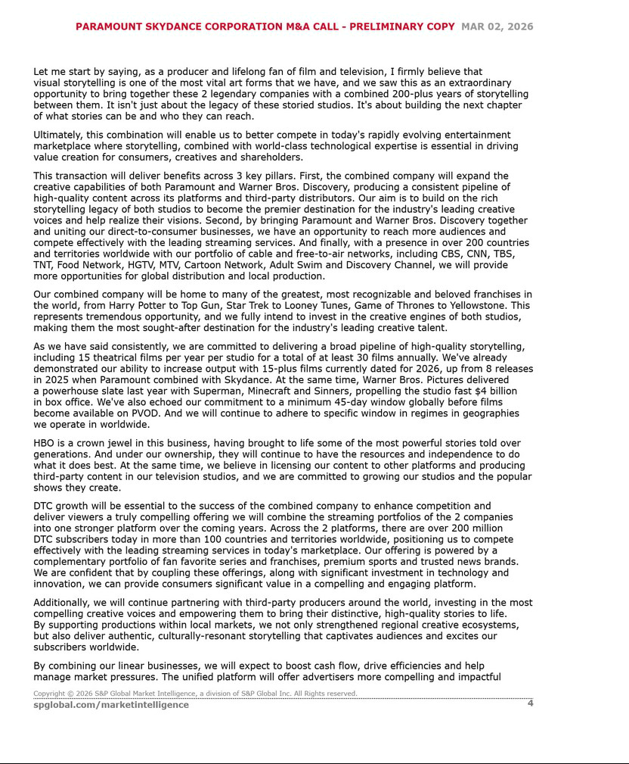

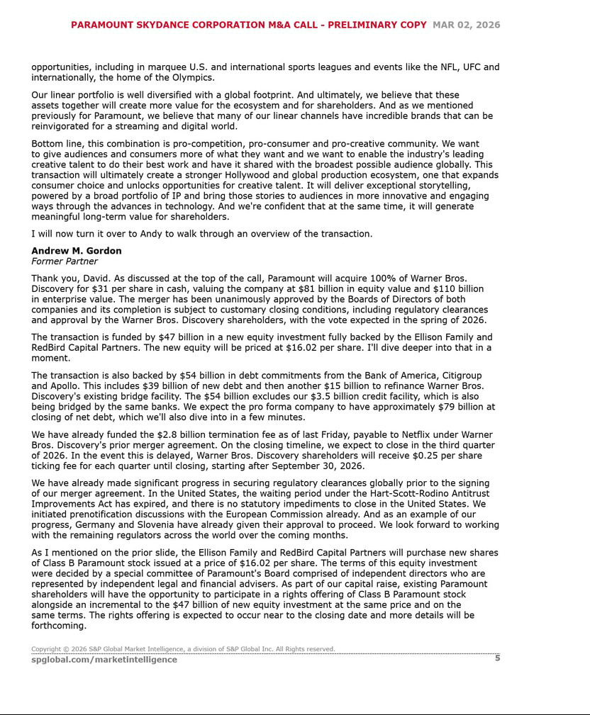

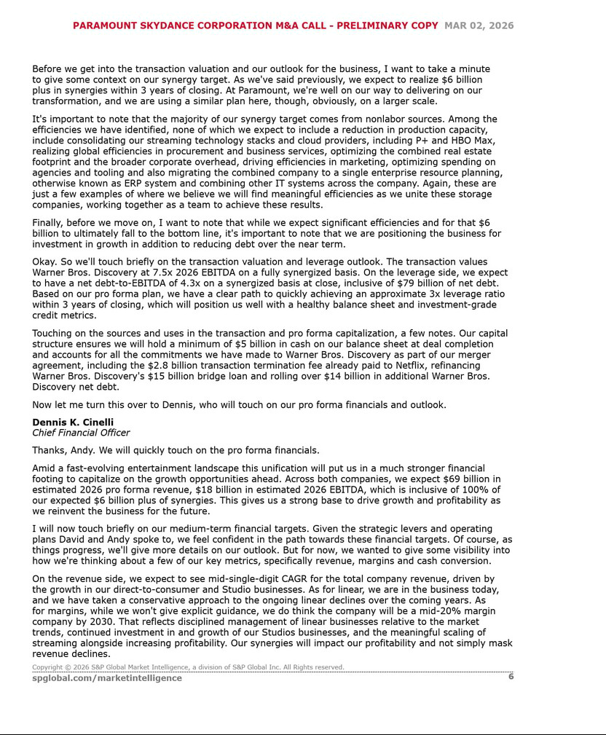

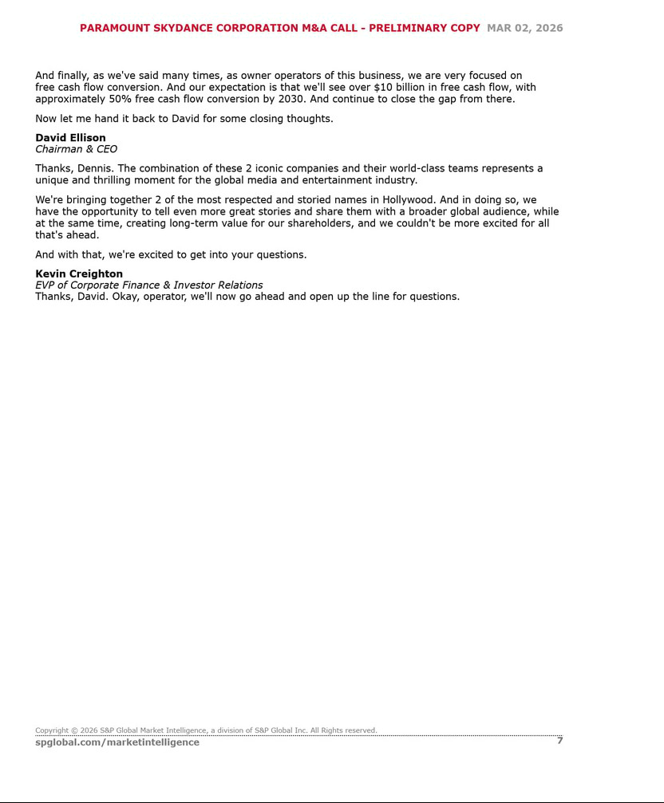

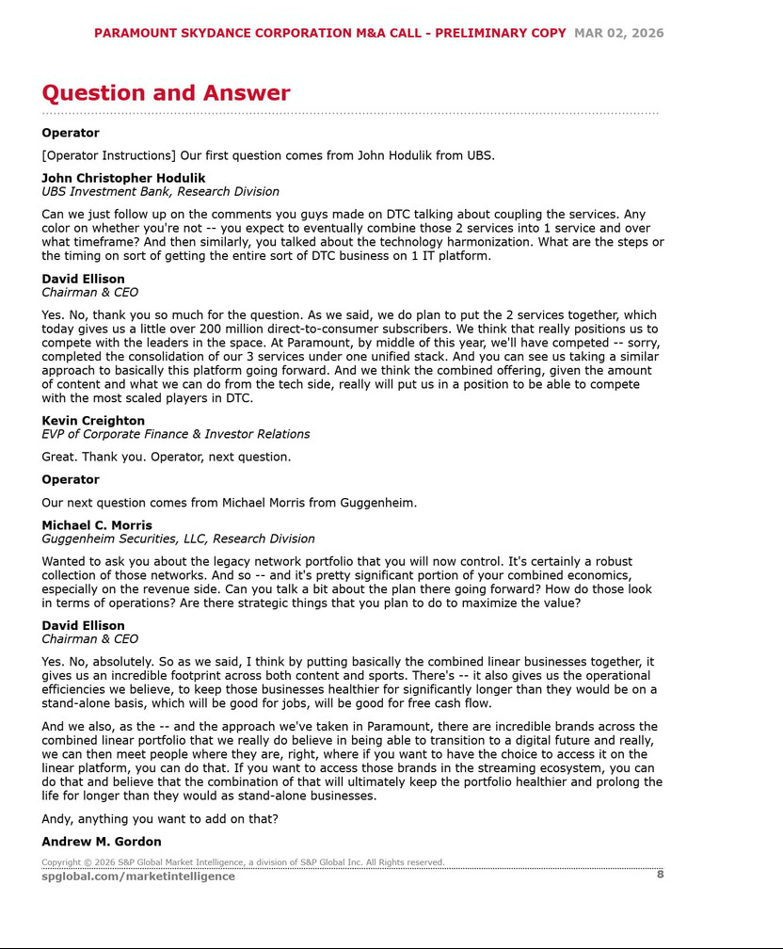

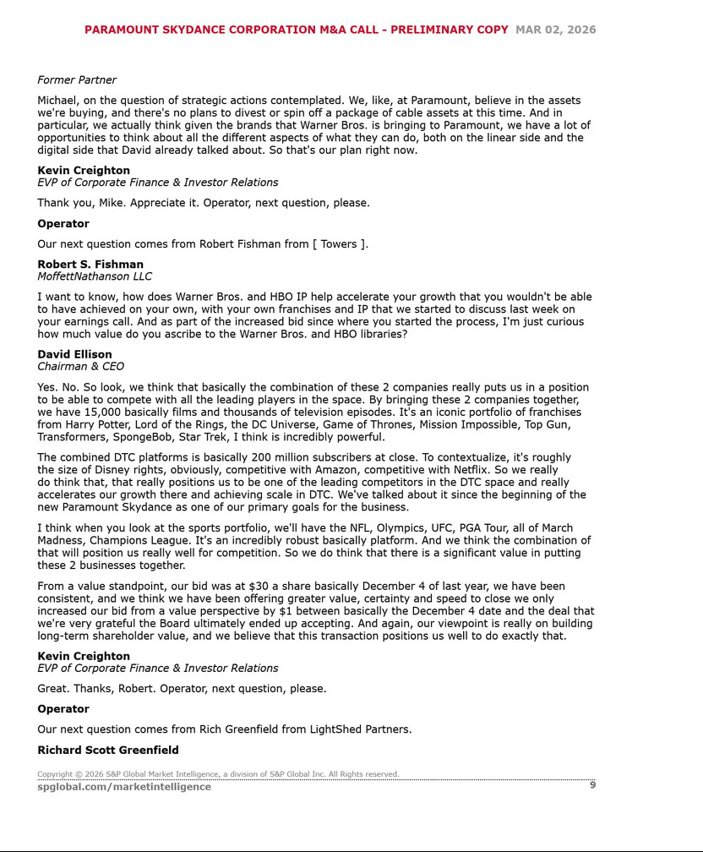

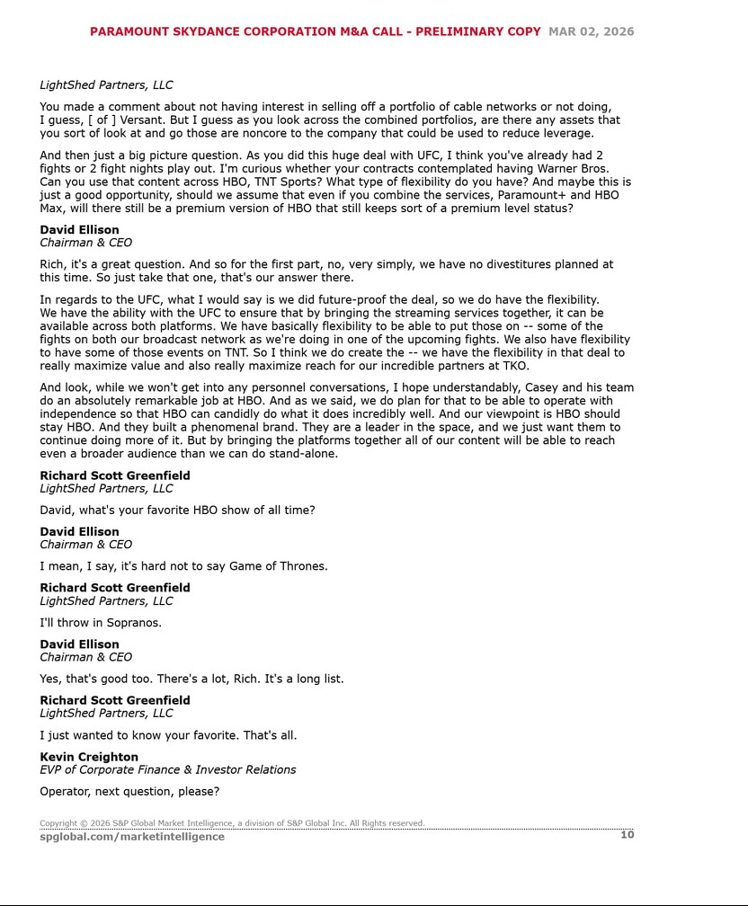

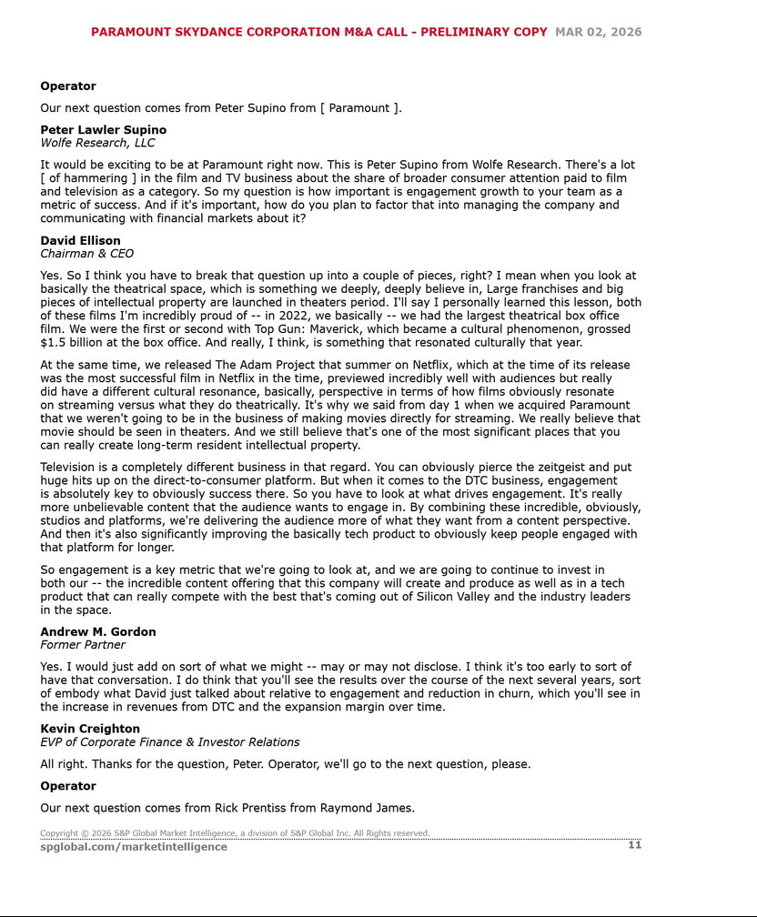

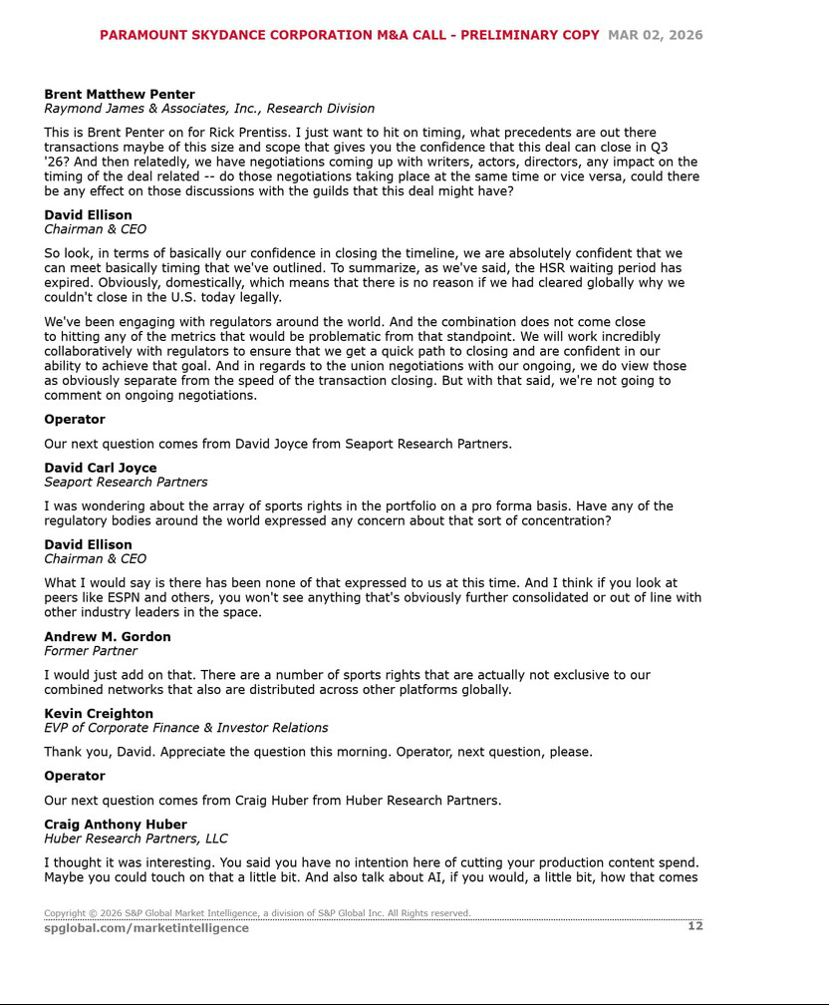

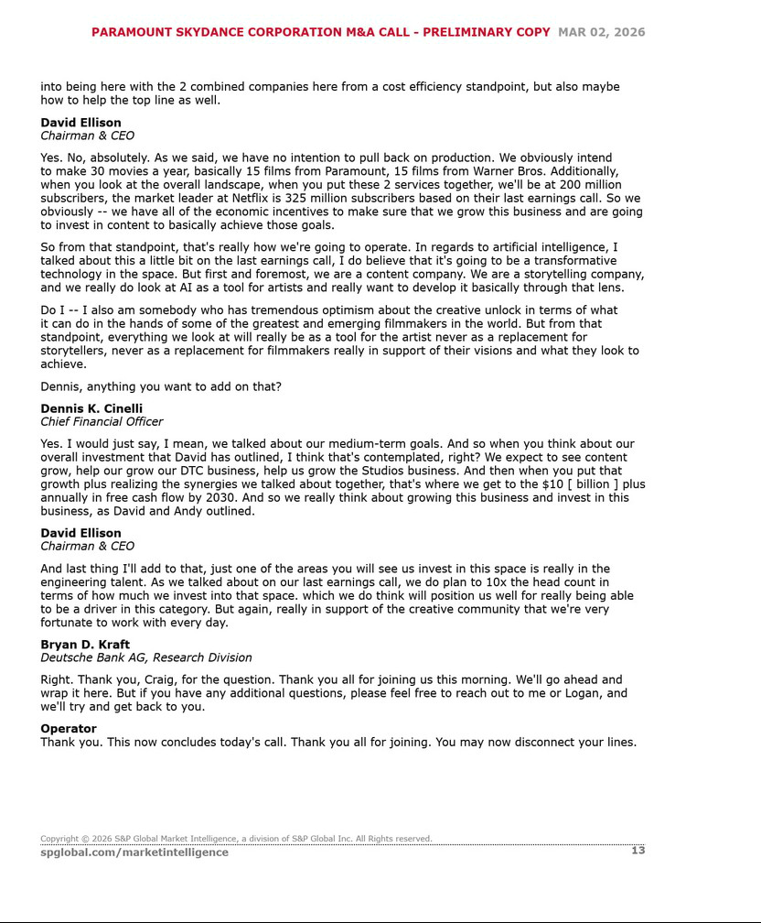

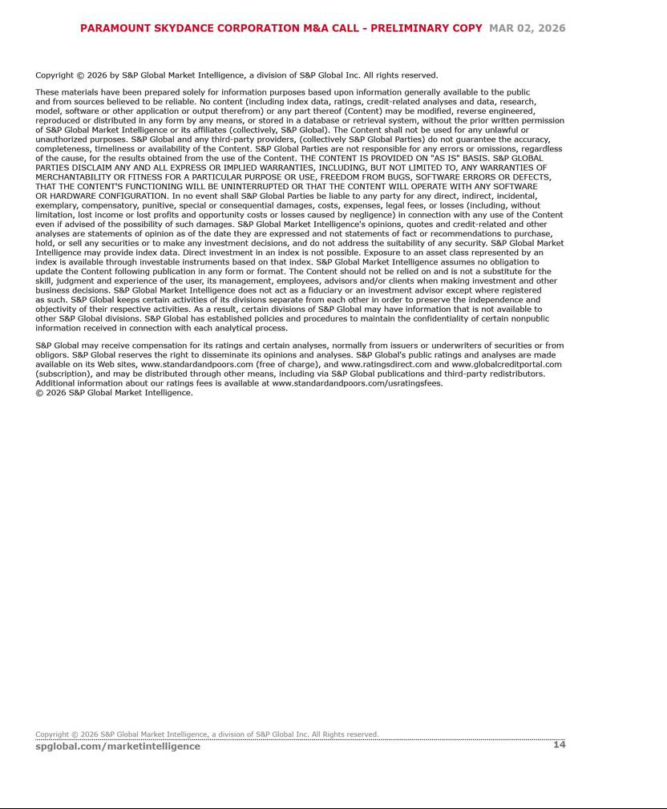

Additional Information and Where to Find It

This communication may be deemed to be solicitation material in respect of the proposed acquisition of Warner Bros. Discovery, Inc. (“WBD”) by Paramount Skydance Corporation (“Paramount”). In connection with the proposed transaction, WBD intends to file relevant materials with the Securities and Exchange Commission (the “SEC”), including WBD’s proxy statement in preliminary and definitive form. INVESTORS AND STOCKHOLDERS OF WBD ARE URGED TO READ ALL RELEVANT DOCUMENTS FILED WITH THE SEC, INCLUDING WBD’S PROXY STATEMENT (WHEN IT IS AVAILABLE), BECAUSE THEY CONTAIN OR WILL CONTAIN IMPORTANT INFORMATION ABOUT THE PROPOSED TRANSACTION AND THE PARTIES TO THE PROPOSED TRANSACTION. Investors and stockholders of WBD are or will be able to obtain these documents (when they are available) free of charge from the SEC’s website at www.sec.gov, or free of charge from WBD under the “SEC Filings” section of WBD’s website at https://ir.wbd.com

Participants in the Solicitation

Paramount and WBD and certain of their respective directors and executive officers, under SEC rules, may be deemed to be “participants” in the solicitation of proxies from security holders of WBD in connection with the proposed transaction. Information about the directors and executive officers of Paramount is set forth in its Current Reports on Form 8-K filed with the SEC on August 7, 2025, September 16, 2025 and January 14, 2026 and in its Annual Report on Form 10-K for the year ended December 31, 2025, filed with the SEC on February 25, 2026. Information about WBD’s directors and executive officers is available in its definitive proxy statement filed with the SEC on April 23, 2025, under the heading “Proposal 1: Election of Directors,” and in its Annual Report on Form 10-K for the year ended December 31, 2025, filed with the SEC on February 27, 2026, under the heading “Executive Officers of Warner Bros. Discovery, Inc.” To the extent holdings of WBD’s securities by its directors or executive officers has changed since the amounts set forth in such 2025 proxy statement, such changes have been or will be reflected on Initial Statements of Beneficial Ownership of Securities on Form 3 or Statements of Changes of Beneficial Ownership of Securities on Form 4 filed with the SEC. Investors and stockholders of Paramount or WBD are or will be able to obtain these documents free of charge from the SEC’s website at www.sec.gov, from Paramount on Paramount’s website at https://ir.paramount.com/sec-filings/paramount, from WBD on WBD’s website at https://ir.wbd.com or on request from Paramount or WBD, as applicable. Additional information concerning the interests of WBD’s participants in the solicitation, which may, in some cases, be different than those of WBD’s stockholders generally, will be set forth in WBD’s proxy statement relating to the proposed transaction when it becomes available.

Cautionary Note Concerning Forward-Looking Statements

This communication contains “forward-looking statements” regarding the potential acquisition of WBD. The reader is cautioned not to rely on these forward-looking statements. These statements are based on current expectations of future events. If underlying assumptions prove inaccurate or known or unknown risks or uncertainties materialize, actual results could vary materially from the expectations and projections of Paramount or WBD. Risks and uncertainties include, but are not limited to: the risk that the closing conditions for the acquisition will not be satisfied, including the risk that clearances under applicable antitrust or regulatory laws will not be obtained; uncertainty as to the percentage of WBD stockholders that will vote to approve the proposed transaction at the applicable WBD stockholder meeting; the possibility that the transaction will not be completed in the expected timeframe or at all; potential adverse effects to the businesses of Paramount or WBD during the pendency of the transaction, such as employee departures or distraction of management from business operations; the risk of stockholder litigation relating to the transaction, including resulting expense or delay; the potential that the expected benefits and opportunities of the acquisition, if completed, may not be realized or may take longer to realize than expected; risks related to Paramount’s streaming business; the adverse impact on Paramount’s advertising revenues as a result of changes in consumer behavior, advertising market conditions and deficiencies in audience measurement; risks related to operating in highly competitive and dynamic industries; the unpredictable nature of consumer behavior, as well as evolving technologies and distribution models; risks related to Paramount’s decisions to invest in new businesses, products, services and technologies, and the evolution of Paramount’s business strategy; the potential for loss of carriage or other reduction in, or the impact of negotiations for, the distribution of Paramount’s content; damage to Paramount’s reputation or brands; losses due to asset impairment charges for goodwill, content and long-lived assets, including finite-lived intangible assets; liabilities related to discontinued operations and former businesses; increasing scrutiny of, and evolving expectations for, sustainability initiatives; evolving business continuity, cybersecurity, privacy and data protection and similar risks; challenges in protecting and maintaining Paramount’s intellectual property rights; domestic and global political, economic and regulatory factors affecting Paramount’s businesses generally; the inability to hire or retain key employees or secure creative talent; disruptions to Paramount’s operations as a result of labor disputes; risks and costs associated with the integration of, and Paramount’s ability to integrate, the businesses of Paramount Global and Skydance Media, LLC successfully and to achieve anticipated synergies; litigation relating to the transactions contemplated by the transaction agreement entered into on July 7, 2024, between Paramount Global and Skydance Media, LLC, potentially resulting in substantial costs; volatility in the price of Paramount’s Class B common stock; the effect Paramount’s dual-class capital structure and the concentrated ownership may have on the price of its Class B common stock or business; risks related to a private sale of a controlling interest in Paramount, including that Paramount’s stockholders may not realize any change of control premium on shares of Paramount’s Class B common stock and that Paramount may become subject to the control of a presently unknown third party; risks associated with Paramount’s status as a “controlled company” under Nasdaq rules, including its exemption from certain corporate governance requirements; risks associated with the lack of voting rights of Paramount’s Class B common stock; risks that anti-takeover provisions in Paramount’s amended and restated certificate of incorporation (“Charter”) and amended and restated bylaws, and under Delaware law, could deter, delay, or prevent a change of control; risks that exclusive forum provisions in Paramount’s Charter could limit a stockholder’s choice of forum for certain claims and discourage lawsuits against Paramount’s directors and officers; risks that corporate opportunity provisions in Paramount’s Charter could permit certain persons to pursue competitive opportunities that might otherwise be available to Paramount; and risks associated with Paramount’s holding company structure, including its dependence on distributions from its subsidiaries to meet tax obligations and other cash requirements; A further list and description of these risks, uncertainties and other factors and the general risks associated with the respective businesses of Paramount and WBD can be found in Paramount’s Annual Report on Form 10-K for the fiscal year ended December 31, 2025, filed with the SEC on February 25, 2026, including in the sections captioned “Cautionary Note Concerning Forward-Looking Statements” and “Item 1A. Risk Factors,” and Paramount’s subsequent filings with the SEC, and WBD’s Annual Report on Form 10-K for the fiscal year ended December 31, 2025, filed with the SEC on February 27, 2026, including in the section captioned “Item 1A. Risk Factors,” and WBD’s subsequent filings with the SEC. Copies of these filings, as well as subsequent filings, are available online at www.sec.gov, ir.wbd.com or on request from Paramount or WBD. Neither Paramount nor WBD undertakes to update any forward-looking statement as a result of new information or future events or developments, except as required by law.

