UNITED STATES
SECURITIES AND EXCHANGE COMMISSION
Washington, D.C. 20549

FORM 8-K

CURRENT REPORT
Pursuant to Section 13 or 15(d)
of the Securities Exchange Act of 1934
Date of Report (Date of earliest event reported): May 8, 2025

Paramount Global
(Exact name of registrant as specified in its charter)

Delaware |  | 001-09553 |  | 04-2949533
(State or other jurisdiction  of incorporation) |  | (Commission  File Number) |  | (IRS Employer  Identification Number)

1515 Broadway
New York, New York |  |  |  | 10036
(Address of principal executive offices) |  |  |  | (Zip Code)
Registrant’s telephone number, including area code: (212) 258-6000
Not Applicable
(Former name or former address, if changed since last report)

Check the appropriate box below if the Form 8-K filing is intended to simultaneously satisfy the filing obligation of the registrant under any of the following provisions:

☐ | Written communications pursuant to Rule 425 under the Securities Act (17 CFR 230.425)

☐ | Soliciting material pursuant to Rule 14a-12 under the Exchange Act (17 CFR 240.14a-12)

☐ | Pre-commencement communications pursuant to Rule 14d-2(b) under the Exchange Act (17 CFR 240.14d-2(b))

☐ | Pre-commencement communications pursuant to Rule 13e-4(c) under the Exchange Act (17 CFR 240.13e-4(c))
Securities registered pursuant to Section 12(b) of the Act:

Title of each class |  | Trading  Symbols |  | Name of each exchange  on which registered
Class A Common Stock, $0.001 par value |  | PARAA |  | The Nasdaq Stock Market LLC
Class B Common Stock, $0.001 par value |  | PARA |  | The Nasdaq Stock Market LLC
Indicate by check mark whether the registrant is an emerging growth company as defined in Rule 405 of the Securities Act of 1933 (§230.405 of this chapter) or Rule 12b-2 of the Securities Exchange Act of 1934 (§240.12b-2 of this chapter).
Emerging growth company ☐
If an emerging growth company, indicate by check mark if the registrant has elected not to use the extended transition period for complying with any new or revised financial accounting standards provided pursuant to Section 13(a) of the Exchange Act. ☐

Item 2.02 | Results of Operations and Financial Condition.
On May 8, 2025, Paramount Global issued a press release announcing earnings for the first quarter ended March 31, 2025. A copy of the press release is furnished herewith as Exhibit 99 and is incorporated by reference herein in its entirety.
The information furnished pursuant to this Item 2.02, including Exhibit 99, shall not be deemed “filed” for purposes of Section 18 of the Securities Exchange Act of 1934, as amended (the “Exchange Act”), or otherwise subject to the liabilities under that Section and shall not be deemed to be incorporated by reference into any filings under the Securities Act of 1933, as amended, or the Exchange Act.

Item 9.01 | Financial Statements and Exhibits.
(d) Exhibits.

Exhibit  Number |  | Description of Exhibit
99 |  | Press release of Paramount Global, dated May 8, 2025, announcing earnings for the first quarter ended March 31, 2025.
104 |  | Cover Page Interactive Data File (embedded within the Inline XBRL document).

SIGNATURE
Pursuant to the requirements of the Securities Exchange Act of 1934, as amended, the registrant has duly caused this report to be signed on its behalf by the undersigned hereunto duly authorized.

PARAMOUNT GLOBAL
By: |  | /s/ Caryn K. Groce
Name: |  | Caryn K. Groce
Title: |  | Executive Vice President, Acting General Counsel and Secretary
Date: May 8, 2025
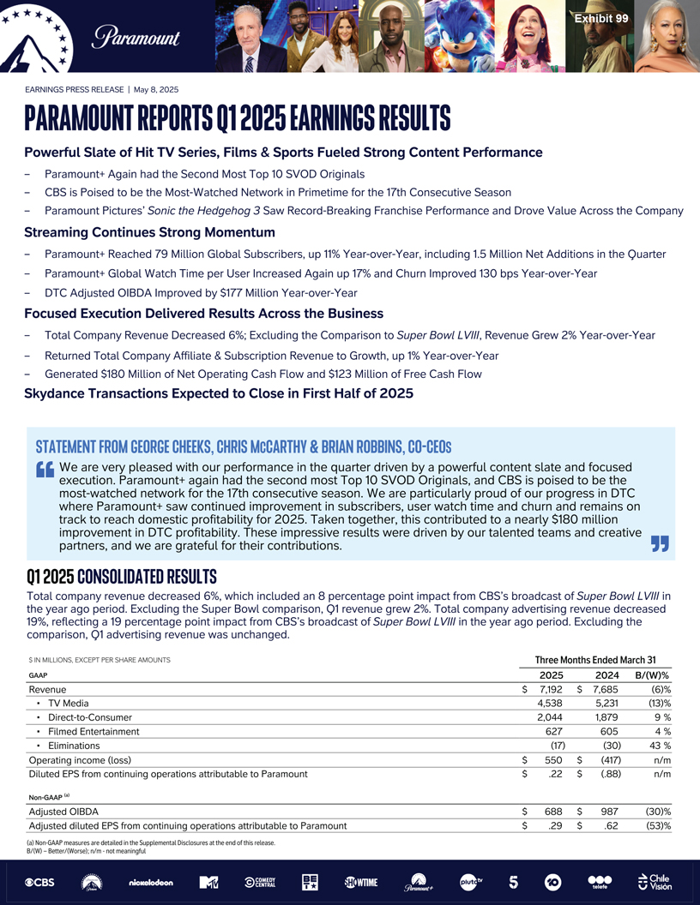
Exhibit 99 PARAMOUNT EARNINGS PRESS RELEASE | May 8, 2025 PARAMOUNT REPORTS Q1 2025 EARNINGS RESULTS Powerful Slate of Hit TV Series, Films & Sports Fueled Strong Content Performance  Paramount+ Again had the Second Most Top 10 SVOD Originals  CBS is Poised to be the Most-Watched Network in Primetime for the 17th Consecutive Season  Paramount Pictures Sonic the Hedgehog 3 Saw Record-Breaking Franchise Performance and Drove Value Across the Company Streaming Continues Strong Momentum  Paramount+ Reached 79 Million Global Subscribers, up 11% Year-over-Year, including 1.5 Million Net Additions in the Quarter  Paramount+ Global Watch Time per User Increased Again up 17% and Churn Improved 130 bps Year-over-Year  DTC Adjusted OIBDA Improved by $177 Million Year-over-Year Focused Execution Delivered Results Across the Business  Total Company Revenue Decreased 6%; Excluding the Comparison to Super Bowl LVIII, Revenue Grew 2% Year-over-Year  Returned Total Company Affiliate & Subscription Revenue to Growth, up 1% Year-over-Year  Generated $180 Million of Net Operating Cash Flow and $123 Million of Free Cash Flow Skydance Transactions Expected to Close in First Half of 2025 STATEMENT FROM GEORGE CHEEKS, CHRIS MCCARTHY & BRIAN ROBBINS, CO-CEOS We are very pleased with our performance in the quarter driven by a powerful content slate and focused execution. Paramount+ again had the second most Top 10 SVOD Originals, and CBS is poised to be the most-watched network for the 17th consecutive season. We are particularly proud of our progress in DTC where Paramount+ saw continued improvement in subscribers, user watch time and churn and remains on track to reach domestic profitability for 2025. Taken together, this contributed to a nearly $180 million improvement in DTC profitability. These impressive results were driven by our talented teams and creative partners, and we are grateful for their contributions. Q1 2025 CONSOLIDATED RESULTS Total company revenue decreased 6%, which included an 8 percentage point impact from CBSs broadcast of Super Bowl LVIII in the year ago period. Excluding the Super Bowl comparison, Q1 revenue grew 2%. Total company advertising revenue decreased 19%, reflecting a 19 percentage point impact from CBSs broadcast of Super Bowl LVIII in the year ago period. Excluding the comparison, Q1 advertising revenue was unchanged. $ IN MILLIONS, EXCEPT PER SHARE AMOUNTS Three Months Ended March 31 GAAP 2025 2024 B/(W)% Revenue $ 7,192 $7,685 (6)%  TV Media 4,538 5,231 (13)%  Direct-to-Consumer 2,044 1,879 9%  Filmed Entertainment 627 605 4%  Eliminations (17) (30) 43% Operating income (loss) $ 550 $(417) n/m Diluted EPS from continuing operations attributable to Paramount $ .22 $(.88) n/m Non-GAAP (a) Adjusted OIBDA $ 688 $987 (30)% Adjusted diluted EPS from continuing operations attributable to Paramount $ .29 $.62 (53)% (a) Non-GAAP measures are detailed in the Supplemental Disclosures at the end of this release. B/(W)  Better/(Worse); n/mnot meaningful

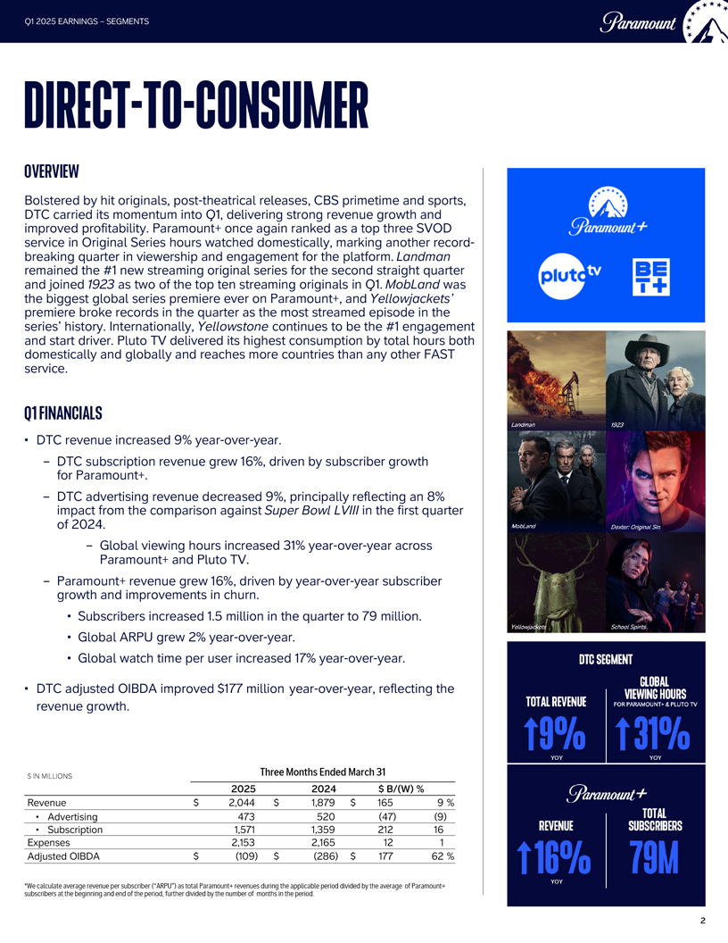
Q1 2025 EARNINGS  SEGMENTS PARAMOUNT DIRECT-TO-CONSUMER OVERVIEW Bolstered by hit originals, post-theatrical releases, CBS primetime and sports, DTC carried its momentum into Q1, delivering strong revenue growth and improved profitability. Paramount+ once again ranked as a top three SVOD service in Original Series hours watched domestically, marking another record-breaking quarter in viewership and engagement for the platform. Landman remained the #1 new streaming original series for the second straight quarter and joined 1923 as two of the top ten streaming originals in Q1. MobLand was the biggest global series premiere ever on Paramount+, and Yellowjackets premiere broke records in the quarter as the most streamed episode in the series history. Internationally, Yellowstone continues to be the #1 engagement and start driver. Pluto TV delivered its highest consumption by total hours both domestically and globally and reaches more countries than any other FAST service. Q1 FINANCIALS ª DTC revenue increased 9% year-over-year.  DTC subscription revenue grew 16%, driven by subscriber growth for Paramount+.  DTC advertising revenue decreased 9%, principally reflecting an 8% impact from the comparison against Super Bowl LVIII in the first quarter of 2024.  Global viewing hours increased 31% year-over-year across Paramount+ and Pluto TV.  Paramount+ revenue grew 16%, driven by year-over-year subscriber growth and improvements in churn. ª Subscribers increased 1.5 million in the quarter to 79 million. ª Global ARPU grew 2% year-over-year. ª Global watch time per user increased 17% year-over-year. ª DTC adjusted OIBDA improved $177 million year-over-year, reflecting the revenue growth. $ IN MILLIONS Three Months Ended March 31 2025 2024 $ B/(W) % Revenue $2,044 $1,879 $165 9% Advertising 473 520 (47) (9) Subscription 1,571 1,359 212 16 Expenses 2,153 2,165 12 1 Adjusted OIBDA $(109) $(286) $177 62% *We calculate average revenue per subscriber (ARPU) as total Paramount+ revenues during the applicable period divided by the average of Paramount+ subscribers at the beginning and end of the period, further divided by the number of months in the period. Paramount+ DTC SEGMENT TOTAL REVENUE 9% YOY GLOBAL VIEWING HOURS FOR PARAMOUNT + & PLUTO TV 31% YOY Paramount+ REVENUE 16% YOY TOTAL SUBSCRIBERS 79M 2

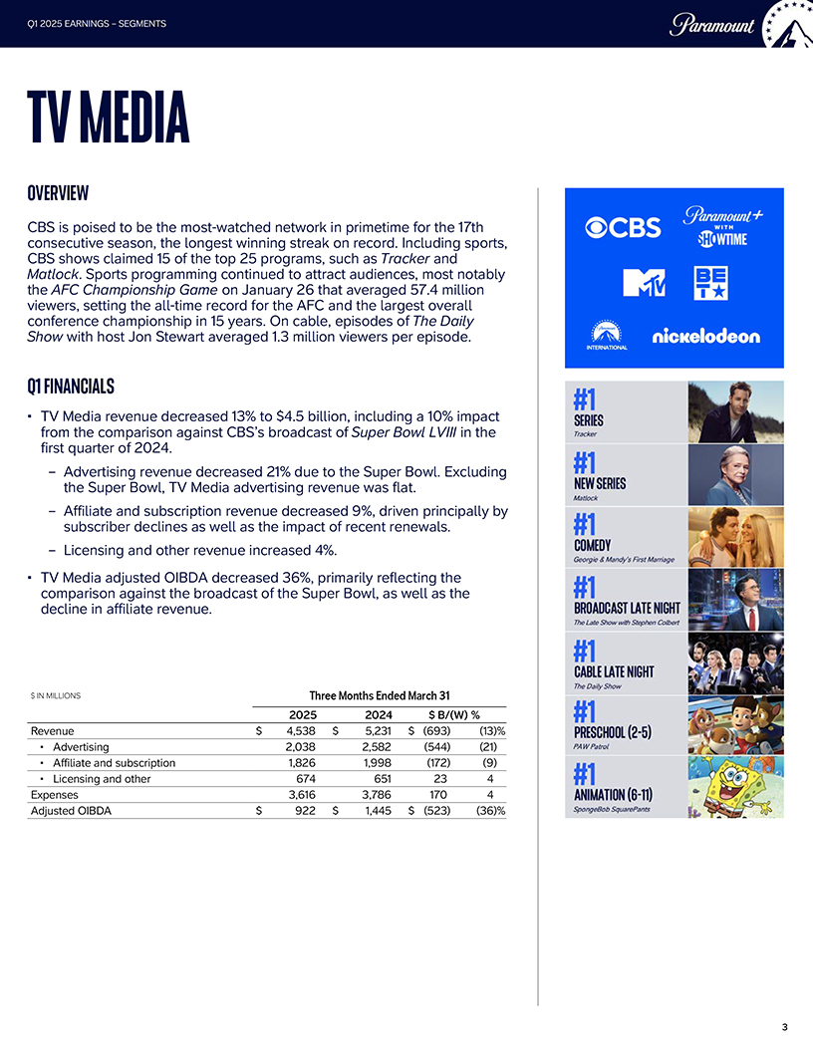
Q1 2025 EARNINGS  SEGMENTS TV MEDIA OVERVIEW CBS is poised to be the most-watched network in primetime for the 17th consecutive season, the longest winning streak on record. Including sports, CBS shows claimed 15 of the top 25 programs, such as Tracker and Matlock. Sports programming continued to attract audiences, most notably the AFC Championship Game on January 26 that averaged 57.4 million viewers, setting the all-time record for the AFC and the largest overall conference championship in 15 years. On cable, episodes of The Daily Show with host Jon Stewart averaged 1.3 million viewers per episode. Q1 FINANCIALS TV Media revenue decreased 13% to $4.5 billion, including a 10% impact from the comparison against CBSs broadcast of Super Bowl LVIII in the first quarter of 2024.  Advertising revenue decreased 21% due to the Super Bowl. Excluding the Super Bowl, TV Media advertising revenue was flat.  Affiliate and subscription revenue decreased 9%, driven principally by subscriber declines as well as the impact of recent renewals.  Licensing and other revenue increased 4%. TV Media adjusted OIBDA decreased 36%, primarily reflecting the comparison against the broadcast of the Super Bowl, as well as the decline in affiliate revenue. $ IN MILLIONS Three Months Ended March 31 2025 2024 $ B/(W) % Revenue $ 4,538 $ 5,231 $ (693) (13)% Advertising 2,038 2,582 (544) (21) Affiliate and subscription 1,826 1,998 (172) (9) Licensing and other 674 651 23 4 Expenses 3,616 3,786 170 4 Adjusted OIBDA $ 922 $ 1,445 $ (523) (36)% 3

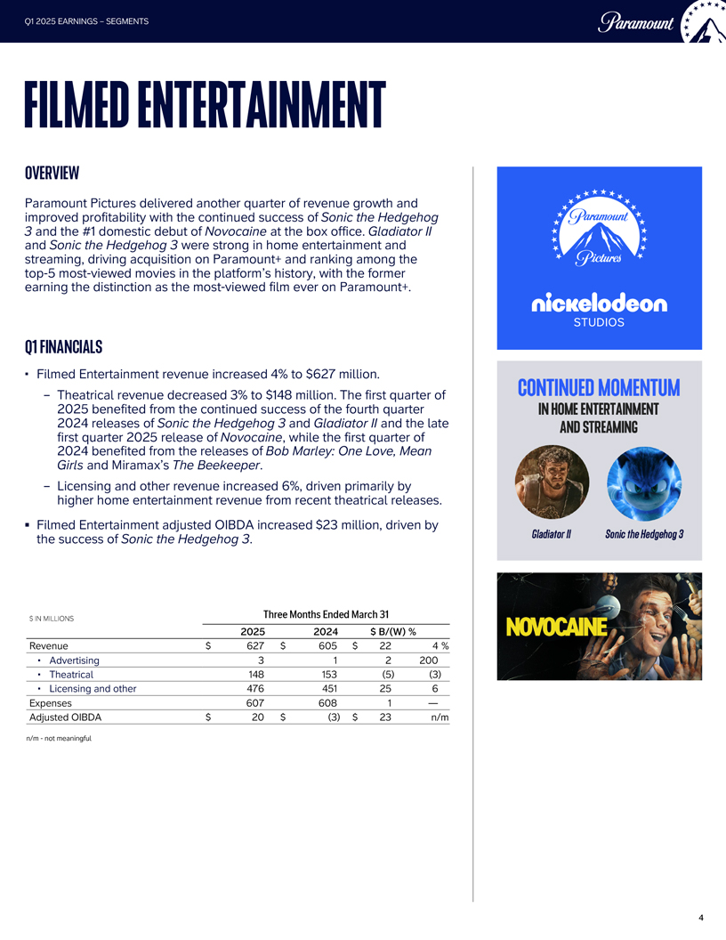
Q1 2025 EARNINGS  SEGMENTS PARAMOUNT FILMED ENTERTAINMENT OVERVIEW Paramount Pictures delivered another quarter of revenue growth and improved profitability with the continued success of Sonic the Hedgehog 3 and the #1 domestic debut of Novocaine at the box office. Gladiator II and Sonic the Hedgehog 3 were strong in home entertainment and streaming, driving acquisition on Paramount+ and ranking among the top-5 most-viewed movies in the platforms history, with the former earning the distinction as the most-viewed film ever on Paramount+. Q1 FINANCIALS  Filmed Entertainment revenue increased 4% to $627 million.  Theatrical revenue decreased 3% to $148 million. The first quarter of 2025 benefited from the continued success of the fourth quarter 2024 releases of Sonic the Hedgehog 3 and Gladiator II and the late first quarter 2025 release of Novocaine, while the first quarter of 2024 benefited from the releases of Bob Marley: One Love, Mean Girls and Miramaxs The Beekeeper.  Licensing and other revenue increased 6%, driven primarily by higher home entertainment revenue from recent theatrical releases.  Filmed Entertainment adjusted OIBDA increased $23 million, driven by the success of Sonic the Hedgehog 3. $ IN MILLIONS Three Months Ended March 31 2025 2024 $ B/(W)% Revenue $627 $605 $ 22 4%  Advertising 3 1 2 200  Theatrical 148 153 (5) (3)  Licensing and other 476 451 25 6 Expenses 607 608 1  Adjusted OIBDA $20 $(3) $ 23 n/m n/m - not meaningful Paramount Pictures nickelodeon STUDIOS CONTINUED MOMENTUM IN HOME ENTERTAINMENT AND STREAMING Gladiator II Sonic the Hedgehog 3 NOVOCAINE 4


Q1 2025 EARNINGS - SKYDANCE TRANSACTIONS Paramount SKYDANCE TRANSACTIONS Completion of the Skydance transactions is subject to regulatory approvals and customary closing conditions. The transactions are anticipated to close in the first half of 2025. Until then, Paramount continues to operate in the normal course of business. 5


Paramount CBS Paramount Pictures nickelodeon MTV COMEDY CENTRAL BET SHOWTIME plutotv 5 telefe Chile Vision ABOUT PARAMOUNT Paramount (NASDAQ: PARA; PARAA) is a leading global media, streaming and entertainment company that creates premium content and experiences for audiences worldwide. Driven by iconic consumer brands, its portfolio includes CBS, Paramount Pictures, Nickelodeon, MTV, Comedy Central, BET, Paramount+ and Pluto TV. The company holds one of the industrys most extensive libraries of TV and film titles. In addition to offering innovative streaming services and digital video products, Paramount provides powerful capabilities in production, distribution and advertising solutions. For more information about Paramount, please visit www.paramount.com and follow @ParamountCo on social platforms. PARA-IR CAUTIONARY NOTE CONCERNING FORWARD-LOOKING STATEMENTS This communication contains both historical and forward-looking statements, including statements related to our future results, performance and achievements. All statements that are not statements of historical fact are, or may be deemed to be, forward-looking statements within the meaning of the Private Securities Litigation Reform Act of 1995. Similarly, statements that describe our objectives, plans or goals are or may be forward-looking statements. These forward-looking statements reflect our current expectations concerning future results and events; generally can be identified by the use of statements that include phrases such as believe, expect, anticipate, intend, plan, foresee, likely, will, may, could, estimate or other similar words or phrases; and involve known and unknown risks, uncertainties and other factors that are difficult to predict and which may cause our actual results, performance or achievements to be different from any future results, performance or achievements expressed or implied by these statements. These risks, uncertainties and other factors include, among others: risks related to our streaming business; the adverse impact on our advertising revenues as a result of changes in consumer behavior, advertising market conditions and deficiencies in audience measurement; risks related to operating in highly competitive and dynamic industries, including cost increases; the unpredictable nature of consumer behavior, as well as evolving technologies and distribution models; risks related to our decisions to make investments in new businesses, products, services and technologies, and the evolution of our business strategy; the potential for loss of carriage or other reduction in or the impact of negotiations for the distribution of our content; damage to our reputation or brands; losses due to asset impairment charges for goodwill, intangible assets, FCC licenses and content; liabilities related to discontinued operations and former businesses; increasing scrutiny of, and evolving expectations for, sustainability initiatives; evolving business continuity, cybersecurity, privacy and data protection and similar risks; content infringement; domestic and global political, economic and regulatory factors affecting our businesses generally, including tariffs and other changes in trade policies; the inability to hire or retain key employees or secure creative talent; disruptions to our operations as a result of labor disputes; challenges realizing synergies and other anticipated benefits expected from the Transactions, including integrating the Companys and Skydances businesses successfully; the dilution to the earnings per share of New Paramount which may negatively affect the price of New Paramount Class B Common Stock; any negative effects following the completion of the Transactions on the market price of New Paramount Class B Common Stock; the uncertainty of the Companys stockholders with respect to the value of the stock consideration they will receive; the risks that holders of our Class B Common Stock may not receive all merger consideration in the form they elect; the reduced ownership and economic interest of our existing stockholders in New Paramount; the cutbacks the PIPE Transaction is subject to in the event that stock elections exceed specified thresholds; the risks that the Transactions may be prevented or delayed or the anticipated benefits of the Transactions could be reduced if we do not obtain certain regulatory approvals; the conditions to the closing to which the Transactions are subject; our and New Paramounts continued incurrence of significant transaction and merger-related transaction costs in connection with the Transactions; business uncertainties, including the effect of the Transactions on the Companys employees, commercial partners, clients and customers, and contractual restrictions while the Transactions are pending; the Transaction Agreements limitation on our ability to pursue alternatives to the Transactions; tax consequences of the Transactions that may adversely affect holders of our Common Stock; the imposition of a new U.S. federal excise tax on us or on New Paramount in connection with redemptions by us or New Paramount of our respective shares; interests of our executive officers, directors and affiliates of Paramount that are different from, or in addition to, the rights of our stockholders; risks related to a failure to complete the Transactions which could negatively impact our businesses or financial results and the stock price of our Common Stock; lawsuits relating to the Transactions potentially preventing or delaying the closing of the Transactions and/or resulting in substantial costs; the waiver of one or more of the conditions to closing without re-obtaining stockholder approval; difficulties retaining, motivating and recruiting executives and other key employees before and following the completion of the Transactions in light of uncertainty regarding the Transactions; the Transactions triggering change of control or other provisions in certain agreements which may allow third parties to terminate or alter existing contracts or relationships; our stockholders not being entitled to appraisal rights in connection with the Transactions; changes and uncertainties with respect to taxes in the jurisdictions in which New Paramount will operate which may have an adverse effect on New Paramounts business; volatility in the prices of our Common Stock; potential conflicts of interest arising from our ownership structure with a controlling stockholder; and other factors described in our news releases and filings with the Securities and Exchange Commission, including but not limited to our most recent Annual Report on Form 10-K and reports on Form 10-Q and Form 8-K. There may be additional risks, uncertainties and factors that we do not currently view as material or that are not necessarily known. The forward-looking statements included in this communication are made only as of the date of this report, and we do not undertake any obligation to publicly update any forward-looking statements to reflect subsequent events or circumstances. 6


CONTACTS PRESS Justin Dini Executive Vice President Acting Chief Communications Officer (212) 846-2724 justin.dini@paramount.com Allison McLarty Senior Vice President Corporate Communications (323)) 376-7903 allison.mclarty@paramount.com INVESTORS Jaime Morris Executive Vice President Investor Relations (646) 824-5450 jaime.morris@paramount.com Paramount

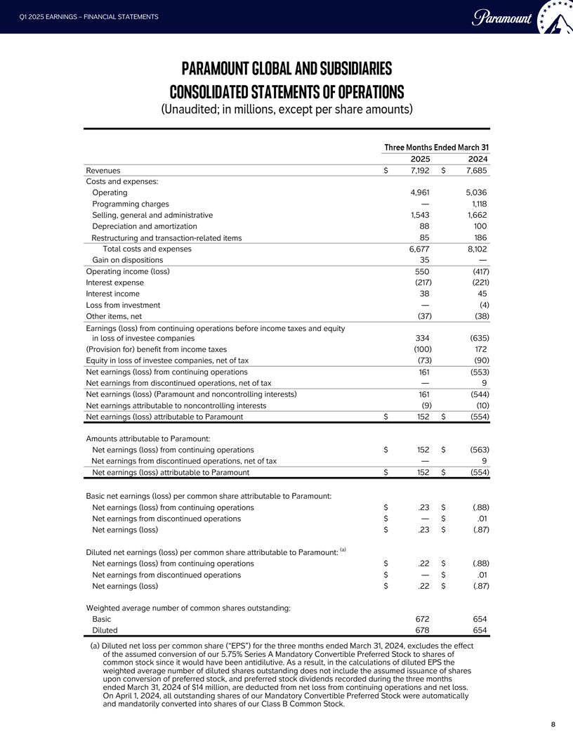
Q1 2025 EARNINGS - FINANCIAL STATEMENTS Paramount PARAMOUNT GLOBAL AND SUBSIDIARIES CONSOLIDATED STATEMENTS OF OPERATIONS (Unaudited; in millions, except per share amounts) Three Months Ended March 31 2025 2024 Revenues $7,192 $7,685 Costs and expenses: Operating 4,961 5,036 Programming charges  1,118 Selling, general and administrative 1,543 1,662 Depreciation and amortization 88 100 Restructuring and transaction-related items 85 186 Total costs and expenses 6,677 8,102 Gain on dispositions 35  Operating income (loss) 550 (417) Interest expense (217) (221) Interest income 38 45 Loss from investment  (4) Other items, net (37) (38) Earnings (loss) from continuing operations before income taxes and equity in loss of investee companies 334 (635) (Provision for) benefit from income taxes (100) 172 Equity in loss of investee companies, net of tax (73) (90) Net earnings (loss) from continuing operations 161 (553) Net earnings from discontinued operations, net of tax  9 Net earnings (loss) (Paramount and noncontrolling interests) 161 (544) Net earnings attributable to noncontrolling interests (9) (10) Net earnings (loss) attributable to Paramount $152 $(554) Amounts attributable to Paramount: Net earnings (loss) from continuing operations $152 $(563) Net earnings from discontinued operations, net of tax  9 Net earnings (loss) attributable to Paramount $152 $(554) Basic net earnings (loss) per common share attributable to Paramount: Net earnings (loss) from continuing operations $.23 $(.88) Net earnings from discontinued operations $ $.01 Net earnings (loss) $.23 $(.87) Diluted net earnings (loss) per common share attributable to Paramount: (a) Net earnings (loss) from continuing operations $.22 $(.88) Net earnings from discontinued operations $ $.01 Net earnings (loss) $.22 $(.87) Weighted average number of common shares outstanding: Basic 672 654 Diluted 678 654 (a) Diluted net loss per common share (EPS) for the three months ended March 31, 2024, excludes the effect of the assumed conversion of our 5.75% Series A Mandatory Convertible Preferred Stock to shares of common stock since it would have been antidilutive. As a result, in the calculations of diluted EPS the weighted average number of diluted shares outstanding does not include the assumed issuance of shares upon conversion of preferred stock, and preferred stock dividends recorded during the three months ended March 31, 2024 of $14 million, are deducted from net loss from continuing operations and net loss. On April 1, 2024, all outstanding shares of our Mandatory Convertible Preferred Stock were automatically and mandatorily converted into shares of our Class B Common Stock. 8

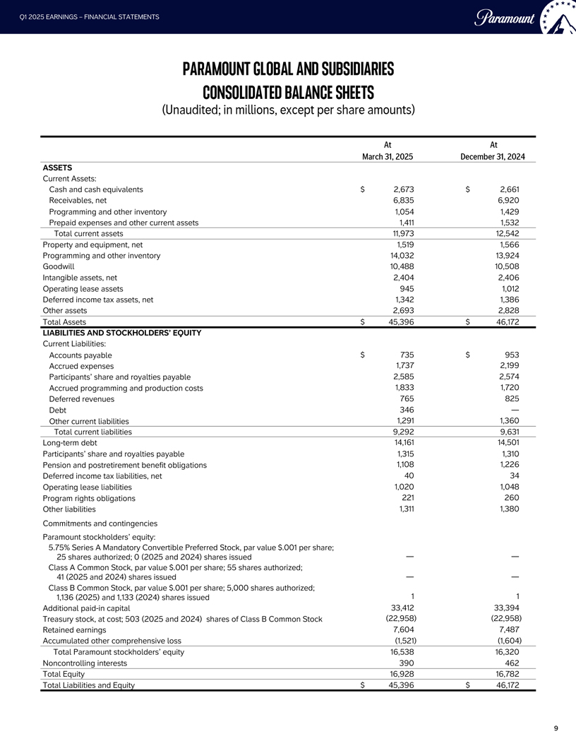
Q1 2025 EARNINGS - FINANCIAL STATEMENTS Paramount PARAMOUNT GLOBAL AND SUBSIDIARIES CONSOLIDATED BALANCE SHEETS (Unaudited; in millions, except per share amounts) At At March 31, 2025 December 31, 2024 ASSETS Current Assets: Cash and cash equivalents $2,673 $2,661 Receivables, net 6,835 6,920 Programming and other inventory 1,054 1,429 Prepaid expenses and other current assets 1,411 1,532 Total current assets 11,973 12,542 Property and equipment, net 1,519 1,566 Programming and other inventory 14,032 13,924 Goodwill 10,488 10,508 Intangible assets, net 2,404 2,406 Operating lease assets 945 1,012 Deferred income tax assets, net 1,342 1,386 Other assets 2,693 2,828 Total Assets $45,396 $46,172 LIABILITIES AND STOCKHOLDERS EQUITY Current Liabilities: Accounts payable $735 $953 Accrued expenses 1,737 2,199 Participants share and royalties payable 2,585 2,574 Accrued programming and production costs 1,833 1,720 Deferred revenues 765 825 Debt 346  Other current liabilities 1,291 1,360 Total current liabilities 9,292 9,631 Long-term debt 14,161 14,501 Participants share and royalties payable 1,315 1,310 Pension and postretirement benefit obligations 1,108 1,226 Deferred income tax liabilities, net 40 34 Operating lease liabilities 1,020 1,048 Program rights obligations 221 260 Other liabilities 1,311 1,380 Commitments and contingencies Paramount stockholders equity: 5.75% Series A Mandatory Convertible Preferred Stock, par value $.001 per share; 25 shares authorized; 0 (2025 and 2024) shares issued   Class A Common Stock, par value $.001 per share; 55 shares authorized; 41 (2025 and 2024) shares issued   Class B Common Stock, par value $.001 per share; 5,000 shares authorized; 1,136 (2025) and 1,133 (2024) shares issued 1 1 Additional paid-in capital 33,412 33,394 Treasury stock, at cost; 503 (2025 and 2024) shares of Class B Common Stock (22,958) (22,958) Retained earnings 7,604 7,487 Accumulated other comprehensive loss (1,521) (1,604) Total Paramount stockholders equity 16,538 16,320 Noncontrolling interests 390 462 Total Equity 16,928 16,782 Total Liabilities and Equity $45,396 $46,172 9

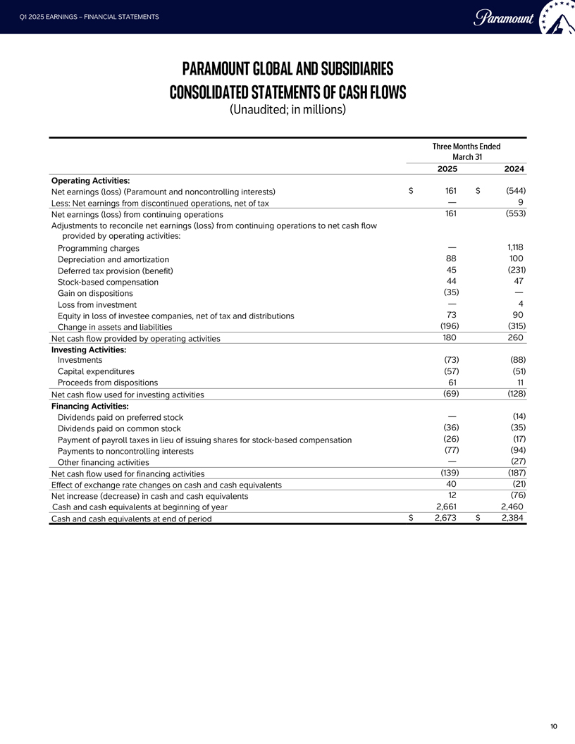
Q1 2025 EARNINGS - FINANCIAL STATEMENTS Paramount PARAMOUNT GLOBAL AND SUBSIDIARIES CONSOLIDATED STATEMENTS OF CASH FLOWS (Unaudited; in millions) Three Months Ended March 31 2025 2024 Operating Activities: Net earnings (loss) (Paramount and noncontrolling interests) $ 161 $ (544) Less: Net earnings from discontinued operations, net of tax  9 Net earnings (loss) from continuing operations 161 (553) Adjustments to reconcile net earnings (loss) from continuing operations to net cash flow provided by operating activities: Programming charges  1,118 Depreciation and amortization 88 100 Deferred tax provision (benefit) 45 (231) Stock-based compensation 44 47 Gain on dispositions (35)  Loss from investment  4 Equity in loss of investee companies, net of tax and distributions 73 90 Change in assets and liabilities (196) (315) Net cash flow provided by operating activities 180 260 Investing Activities: Investments (73) (88) Capital expenditures (57) (51) Proceeds from dispositions 61 11 Net cash flow used for investing activities (69) (128) Financing Activities: Dividends paid on preferred stock  (14) Dividends paid on common stock (36) (35) Payment of payroll taxes in lieu of issuing shares for stock-based compensation (26) (17) Payments to noncontrolling interests (77) (94) Other financing activities  (27) Net cash flow used for financing activities (139) (187) Effect of exchange rate changes on cash and cash equivalents 40 (21) Net increase (decrease) in cash and cash equivalents 12 (76) Cash and cash equivalents at beginning of year 2,661 2,460 Cash and cash equivalents at end of period $ 2,673 $2,384 10

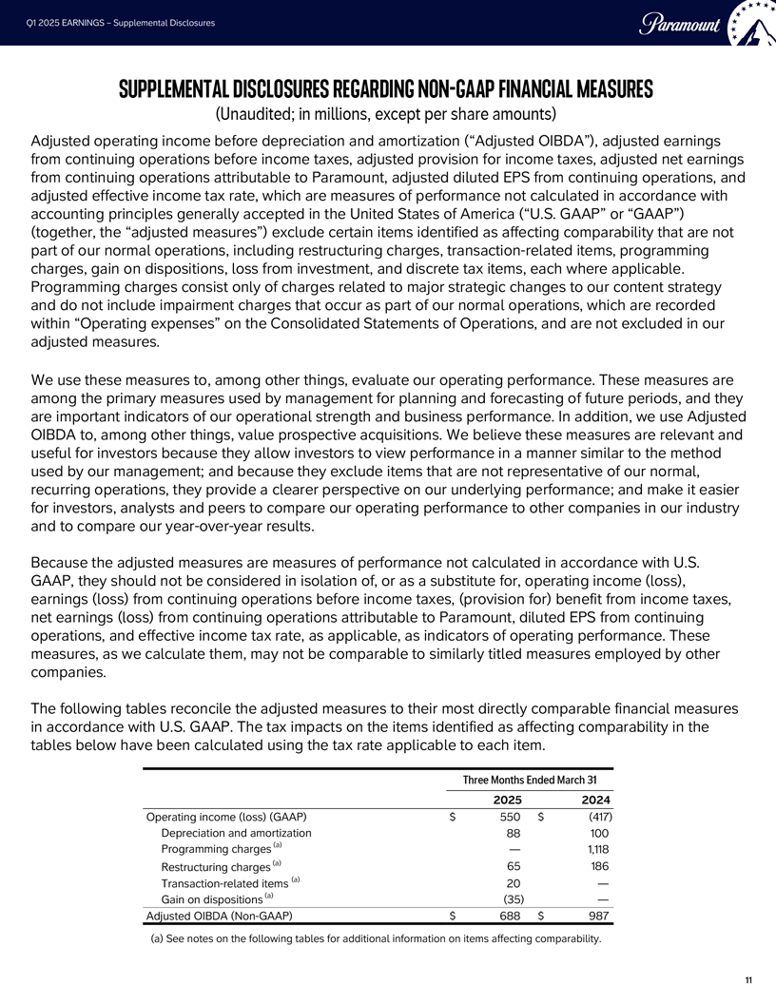
Q1 2025 EARNINGS - Supplemental Disclosures Paramount SUPPLEMENTAL DISCLOSURES REGARDING NON-GAAP FINANCIAL MEASURES (Unaudited; in millions, except per share amounts) Adjusted operating income before depreciation and amortization (Adjusted OIBDA), adjusted earnings from continuing operations before income taxes, adjusted provision for income taxes, adjusted net earnings from continuing operations attributable to Paramount, adjusted diluted EPS from continuing operations, and adjusted effective income tax rate, which are measures of performance not calculated in accordance with accounting principles generally accepted in the United States of America (U.S. GAAP or GAAP) (together, the adjusted measures) exclude certain items identified as affecting comparability that are not part of our normal operations, including restructuring charges, transaction-related items, programming charges, gain on dispositions, loss from investment, and discrete tax items, each where applicable. Programming charges consist only of charges related to major strategic changes to our content strategy and do not include impairment charges that occur as part of our normal operations, which are recorded within Operating expenses on the Consolidated Statements of Operations, and are not excluded in our adjusted measures. We use these measures to, among other things, evaluate our operating performance. These measures are among the primary measures used by management for planning and forecasting of future periods, and they are important indicators of our operational strength and business performance. In addition, we use Adjusted OIBDA to, among other things, value prospective acquisitions. We believe these measures are relevant and useful for investors because they allow investors to view performance in a manner similar to the method used by our management; and because they exclude items that are not representative of our normal, recurring operations, they provide a clearer perspective on our underlying performance; and make it easier for investors, analysts and peers to compare our operating performance to other companies in our industry and to compare our year-over-year results. Because the adjusted measures are measures of performance not calculated in accordance with U.S. GAAP, they should not be considered in isolation of, or as a substitute for, operating income (loss), earnings (loss) from continuing operations before income taxes, (provision for) benefit from income taxes, net earnings (loss) from continuing operations attributable to Paramount, diluted EPS from continuing operations, and effective income tax rate, as applicable, as indicators of operating performance. These measures, as we calculate them, may not be comparable to similarly titled measures employed by other companies. The following tables reconcile the adjusted measures to their most directly comparable financial measures in accordance with U.S. GAAP. The tax impacts on the items identified as affecting comparability in the tables below have been calculated using the tax rate applicable to each item. Three Months Ended March 31 2025 2024 Operating income (loss) (GAAP) $ 550 $ (417) Depreciation and amortization 88 100 Programming charges (a)  1,118 Restructuring charges (a) 65 186 Transaction-related items (a) 20  Gain on dispositions (a) (35)  Adjusted OIBDA (Non-GAAP) $688 $987 (a) See notes on the following tables for additional information on items affecting comparability. 11

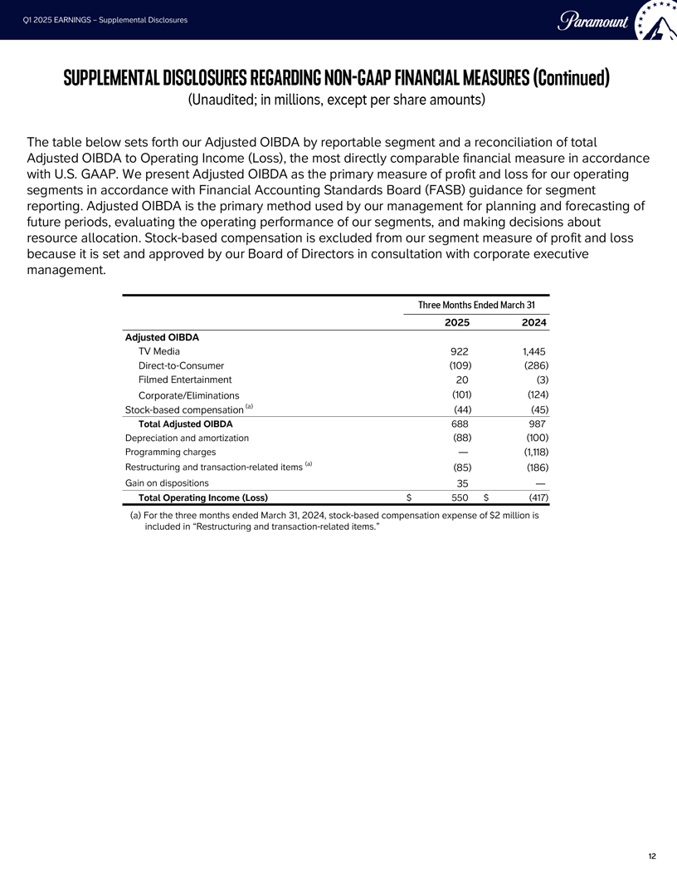
Q1 2025 EARNINGS - Supplemental Disclosures Paramount SUPPLEMENTAL DISCLOSURES REGARDING NON-GAAP FINANCIAL MEASURES (Continued) (Unaudited; in millions, except per share amounts) The table below sets forth our Adjusted OIBDA by reportable segment and a reconciliation of total Adjusted OIBDA to Operating Income (Loss), the most directly comparable financial measure in accordance with U.S. GAAP. We present Adjusted OIBDA as the primary measure of profit and loss for our operating segments in accordance with Financial Accounting Standards Board (FASB) guidance for segment reporting. Adjusted OIBDA is the primary method used by our management for planning and forecasting of future periods, evaluating the operating performance of our segments, and making decisions about resource allocation. Stock-based compensation is excluded from our segment measure of profit and loss because it is set and approved by our Board of Directors in consultation with corporate executive management. Three Months Ended March 31 2025 2024 Adjusted OIBDA TV Media 922 1,445 Direct-to-Consumer (109) (286) Filmed Entertainment 20 (3) Corporate/Eliminations (101) (124) Stock-based compensation (a) (44) (45) Total Adjusted OIBDA 688 987 Depreciation and amortization (88) (100) Programming charges  (1,118) Restructuring and transaction-related items (a) (85) (186) Gain on dispositions 35  Total Operating Income (Loss) $ 550 $ (417) (a) For the three months ended March 31, 2024, stock-based compensation expense of $2 million is included in Restructuring and transaction-related items. 12

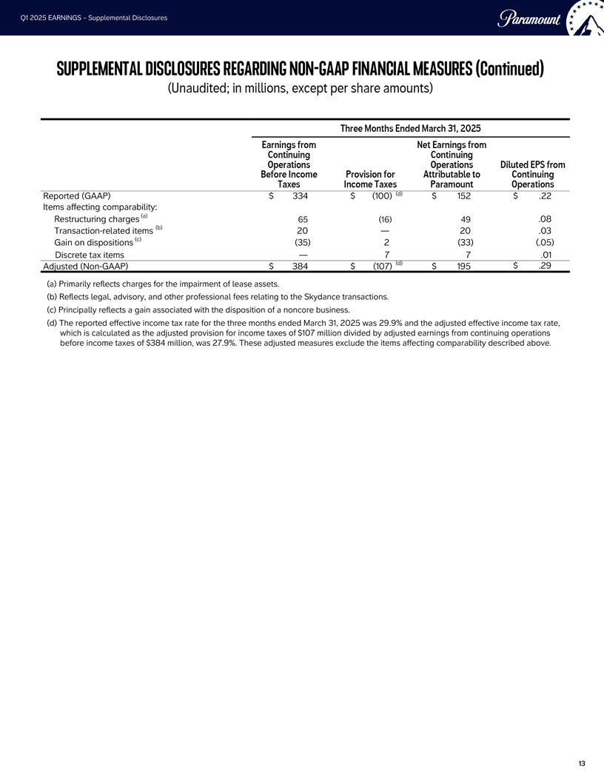
Q1 2025 EARNINGS - Supplemental Disclosures Paramount SUPPLEMENTAL DISCLOSURES REGARDING NON-GAAP FINANCIAL MEASURES (Continued) (Unaudited; in millions, except per share amounts) Three Months Ended March 31, 2025 Earnings from Net Earnings from Continuing Continuing Operations Operations Diluted EPS from Before Income Provision for Attributable to Continuing Taxes Income Taxes Paramount Operations Reported (GAAP) $ 334 $ (100) (d) $ 152 $ .22 Items affecting comparability: Restructuring charges (a) 65 (16) 49 .08 Transaction-related items (b) 20  20 .03 Gain on dispositions (c) (35) 2 (33) (.05) Discrete tax items  7 7 .01 Adjusted (Non-GAAP) $ 384 $ (107) (d) $ 195 $ .29 (a) Primarily reflects charges for the impairment of lease assets. (b) Reflects legal, advisory, and other professional fees relating to the Skydance transactions. (c) Principally reflects a gain associated with the disposition of a noncore business. (d) The reported effective income tax rate for the three months ended March 31, 2025 was 29.9% and the adjusted effective income tax rate, which is calculated as the adjusted provision for income taxes of $107 million divided by adjusted earnings from continuing operations before income taxes of $384 million, was 27.9%. These adjusted measures exclude the items affecting comparability described above. 13

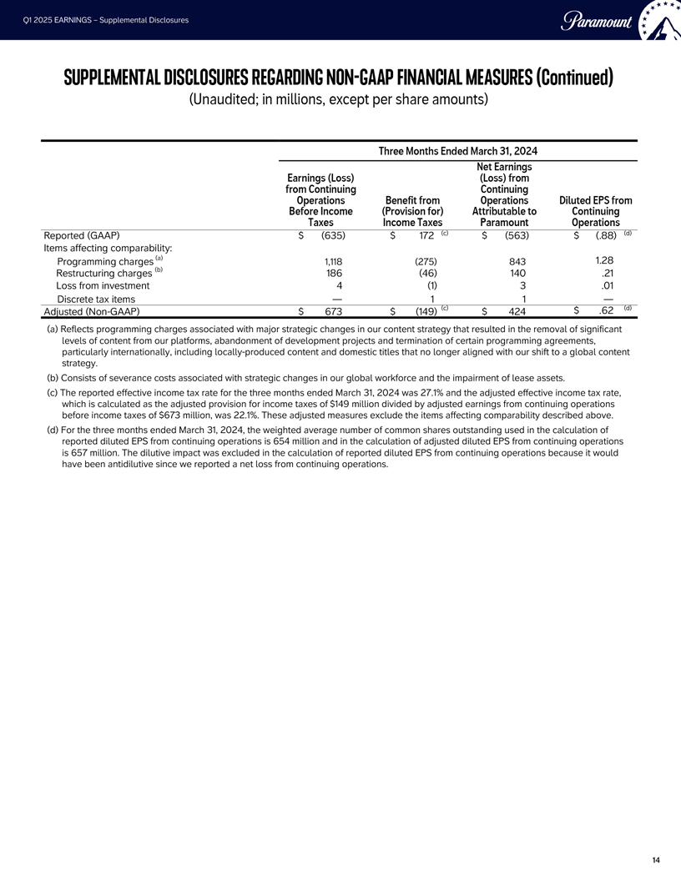
Q1 2025 EARNINGS - Supplemental Disclosures Paramount SUPPLEMENTAL DISCLOSURES REGARDING NON-GAAP FINANCIAL MEASURES (Continued) (Unaudited; in millions, except per share amounts) Three Months Ended March 31, 2024 Net Earnings Earnings (Loss) (Loss) from from Continuing Continuing Operations Benefit from Operations Diluted EPS from Before Income (Provision for) Attributable to Continuing Taxes Income Taxes Paramount Operations Reported (GAAP) $ (635) $ 172 (c) $ (563) $ (.88) (d) Items affecting comparability: Programming charges (a) 1,118 (275) 843 1.28 Restructuring charges (b) 186 (46) 140 .21 Loss from investment 4 (1) 3 .01 Discrete tax items  1 1  Adjusted (Non-GAAP) $ 673 $ (149) (c) $ 424 $ .62 (d) (a) Reflects programming charges associated with major strategic changes in our content strategy that resulted in the removal of significant levels of content from our platforms, abandonment of development projects and termination of certain programming agreements, particularly internationally, including locally-produced content and domestic titles that no longer aligned with our shift to a global content strategy. FBI (b) Consists of severance costs associated with strategic changes in our global workforce and the impairment of lease assets. (c) The reported effective income tax rate for the three months ended March 31, 2024 was 27.1% and the adjusted effective income tax rate, which is calculated as the adjusted provision for income taxes of $149 million divided by adjusted earnings from continuing operations before income taxes of $673 million, was 22.1%. These adjusted measures exclude the items affecting comparability described above. (d) For the three months ended March 31, 2024, the weighted average number of common shares outstanding used in the calculation of reported diluted EPS from continuing operations is 654 million and in the calculation of adjusted diluted EPS from continuing operations is 657 million. The dilutive impact was excluded in the calculation of reported diluted EPS from continuing operations because it would have been antidilutive since we reported a net loss from continuing operations. 14

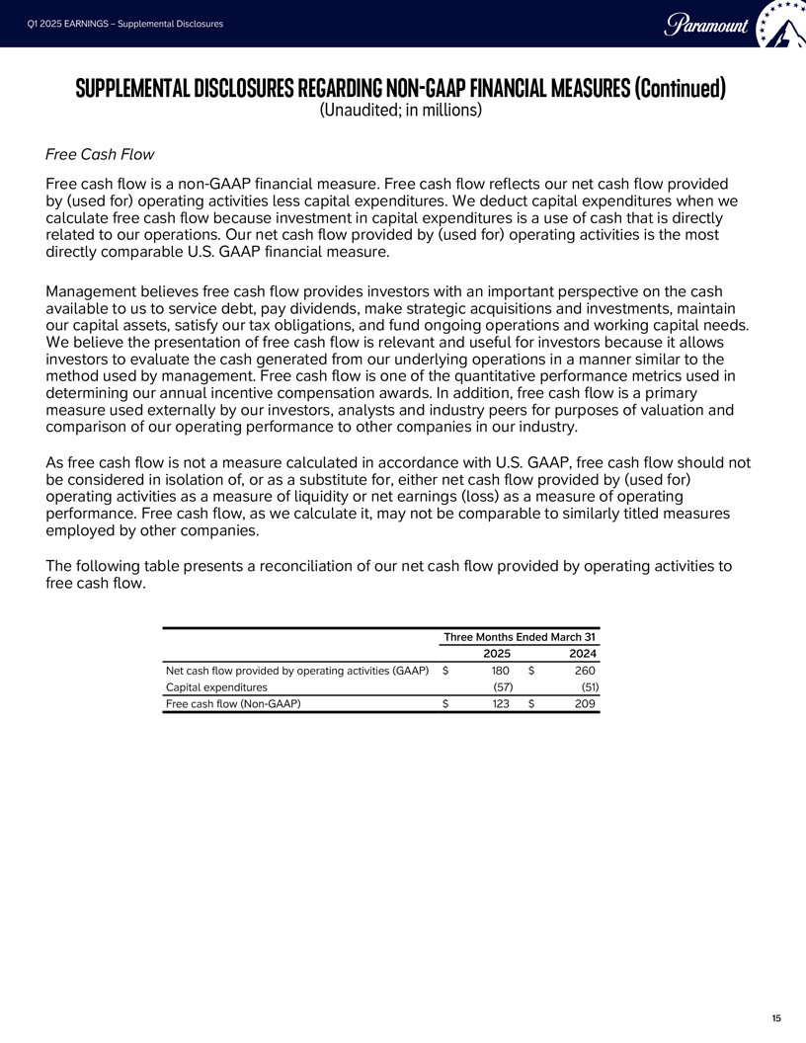
Q1 2025 EARNINGS - Supplemental Disclosures Paramount SUPPLEMENTAL DISCLOSURES REGARDING NON-GAAP FINANCIAL MEASURES (Continued) (Unaudited; in millions) Free Cash Flow Free cash flow is a non-GAAP financial measure. Free cash flow reflects our net cash flow provided by (used for) operating activities less capital expenditures. We deduct capital expenditures when we calculate free cash flow because investment in capital expenditures is a use of cash that is directly related to our operations. Our net cash flow provided by (used for) operating activities is the most directly comparable U.S. GAAP financial measure. Management believes free cash flow provides investors with an important perspective on the cash available to us to service debt, pay dividends, make strategic acquisitions and investments, maintain our capital assets, satisfy our tax obligations, and fund ongoing operations and working capital needs. We believe the presentation of free cash flow is relevant and useful for investors because it allows investors to evaluate the cash generated from our underlying operations in a manner similar to the method used by management. Free cash flow is one of the quantitative performance metrics used in determining our annual incentive compensation awards. In addition, free cash flow is a primary measure used externally by our investors, analysts and industry peers for purposes of valuation and comparison of our operating performance to other companies in our industry. As free cash flow is not a measure calculated in accordance with U.S. GAAP, free cash flow should not be considered in isolation of, or as a substitute for, either net cash flow provided by (used for) operating activities as a measure of liquidity or net earnings (loss) as a measure of operating performance. Free cash flow, as we calculate it, may not be comparable to similarly titled measures employed by other companies. The following table presents a reconciliation of our net cash flow provided by operating activities to free cash flow. Three Months Ended March 31 2025 2024 Net cash flow provided by operating activities (GAAP) $180 $260 Capital expenditures (57) (51) Free cash flow (Non-GAAP) $123 $209 15

